*Florida International University*

*School of Computing and Information Sciences*

Software Engineering Focus

Final Deliverable

Project Title: Vocabulary in Reading Study

VIRS 4.0

**Team Members:** Samantha Magrans, Monica Rodriguez, Jessica Fernandez-Rubio, Pablo Arista, Chelsey Benony, Taufiq Islam

**Product Owner(s)**: Eric Dwyer

**Mentor(s)**: Seyedjafar Ehsanzadehsorati

**Instructor**: Masoud Sadjadi

The MIT License (MIT)

Copyright (c) *2018 Florida International University*

Permission is hereby granted, free of charge, to any person obtaining a copy of this software and associated documentation files (the "Software"), to deal in the Software without restriction, including without limitation the rights to use, copy, modify, merge, publish, distribute, sublicense, and/or sell copies of the Software, and to permit persons to whom the Software is furnished to do so, subject to the following conditions:

The above copyright notice and this permission notice shall be included in all copies or substantial portions of the Software.

THE SOFTWARE IS PROVIDED "AS IS", WITHOUT WARRANTY OF ANY KIND, EXPRESS OR IMPLIED, INCLUDING BUT NOT LIMITED TO THE WARRANTIES OF MERCHANTABILITY, FITNESS FOR A PARTICULAR PURPOSE AND NON INFRINGEMENT. IN NO EVENT SHALL THE AUTHORS OR COPYRIGHT HOLDERS BE LIABLE FOR ANY CLAIM, DAMAGES OR OTHER LIABILITY, WHETHER IN AN ACTION OF CONTRACT, TORT OR OTHERWISE, ARISING FROM, OUT OF OR IN CONNECTION WITH THE SOFTWARE OR THE USE OR OTHER DEALINGS IN THE SOFTWARE.

***Abstract***

*This document presents the information necessary to gain a good understanding of Vocabulary in Reading Study (VIRS 4.0). VIRS is a web app which facilitates learning of new languages through analysis of text and gathering of data which is then displayed to the user. This data is important to the user as it categorizes words in the text and gives priority to more popular words. The user then knows which words to use more and makes it easier to use these in conversation. The user can now test their knowledge of the Essential Word List, a user can delete their account, a user can update their account information, a user can now get a better reading from images uploaded, and a user can reset their password via email or username.*

**Introduction** 10

Current System 10

Purpose of New System 11

**User Stories** 12

Implemented User Stories 12

**Delete Account** 12

**Read Images** 14

**Update Account** 16

**OCR Localized** 18

**Change Current Password** 19

**Enter Username to Start Reset Password Process** 20

**The User Receive an Email with a Link to Reset Password** 22

**Enter Password and a Copy to Reset Password** 23

**Start Reset Password Process using Email** 24

**The User Receive an Email with a Link to Reset Password** 25

**Display a Form to Start Reset Password By Username or By Email** 27

**Login After Registration** 28

**Invalid Username** 29

**EWL Access** 30

**EWL Categories** 30

**EWL Search** 31

**EWL Word Definition** 32

**Output Text Only** 33

**Invalid Password** 34

**Statistics Improvement** 35

**EWL** 35

**Enhanced Text Improvement** 36

**Dictionary Reference Update** 37

Pending User Stories 38

**Paid Subscription** 38

**Project Plan** 39

Hardware and Software Resources 39

Sprints Plan 41

**Sprint 2** 41

**Sprint 3** 41

**Sprint 4** 43

**Sprint 5** 44

**Sprint 6** 45

**System Design** 47

Architectural Patterns 47

System and Subsystem Decomposition 50

Deployment Diagram 50

Design Patterns 53

**System Validation** 54

Delete Account - Bad Data Request 54

Delete Account - Delete User 55

OCR Localized - Localize Image Results 56

OCR Localized - Localize Blank/Empty 57

Read Images - Read Image Text 57

Read Images - Read Empty Image 59

Update Account - Empty Username 60

Update Account - Username Does Not Exist 61

Update Account - Existing Email 61

Update Account - Update User 62

Invalid Username 63

EWL Access 64

EWL Categories 64

EWL Search 66

EWL Definition 67

Output Text Only - Word Document 68

Output Text Only - PDF 69

Displays Page to Change Password 70

Correct Data in Change Password Form 71

Update User Password in API 72

New Password Invalid 73

Password Copy Do Not Match 74

Display Page to Enter Username 76

Email Request by Username 76

Find User By Username and Create Recovery 77

Username does not exist 78

Email with a Link (Username) 79

Link to the Reset Password Modal 80

Password Updated (by Username) 80

Delete recovery From Database 81

Token Already Used 82

Password Less Than 6 Characters Long. 83

Copy Do Not Match the Password 84

Display Page to Enter Email 85

Email Request by Email 85

Find User Using Email and Create Recovery 86

Email does not exist 87

Invalid Email 88

Email with a Link (Email) 89

Link to the Reset Password Modal 90

Password Updated (by Email) 90

Delete recovery From Database 91

Token Already Used (Email case) 92

Password Is Not Long Enough. 93

Password and Copy Did Not Match 94

Enter Username or Email Modal 95

Username Sent to the Backend 95

Username Sent to the Backend 96

Invalid Email in the Form 96

Cleaned Word Definitions 97

Word Definition and Pronunciation Return 98

Email Required to Register 99

Email Required to Register 99

Email Required to Register 100

Login After Registration 101

Login After Registration 102

**Glossary** 103

**Appendix** 104

Appendix A - UML Diagrams 104

**Static UML Diagrams** 104

**User Account Management Use Case Diagram** 104

**User Account Management Class Diagram** 105

**OCR Image Reading Use Case Diagram** 106

**OCR Image Reading Class Diagram** 107

**Invalid Username Use Case Diagram** 107

**EWL Access, Category, Search, Definition Use Case Diagram** 108

**EWL Access, Category, Search, Definition UML Class Diagram** 108

**Login After Registration Use Case Diagram** 109

**Login After Registration Class Diagram** 110

**Change Password** 111

**UML Class Diagram for Backend: Change Password** 111

**UML Class Diagram for Frontend: Change Password** 112

**Enter Username Use Case** 113

**Enter Username Class Diagram** 113

**Enter Username to Star Reset password Class Diagram** 114

**Email Link Use Case** 115

**Email Link Class Diagram** 116

**Submit Password Use Case** 116

**Submit Password Class Diagram** 117

**Submit New Password & Copy UML Class Diagram for Frontend** 118

**Enter Email Use Case Diagram** 119

**Enter Email & Start Reset Password UML Class Diagram for Frontend** 120

**Enter Email & Start Reset Password UML Class Diagram for backend** 121

**Email Use Case** 122

**UML Class Diagram for Backend: Clicks Link & Enter Password with Copy** 122

**UML Class Diagram for Frontend: Clicks Link & Enter password with Copy** 123

**UML Use Case Diagram** 123

**UML Class Diagram for Frontend: Enter Username or Email to Star Reset Password** 124

**Dictionary Reference Update Use Case Diagram** 125

**UML Class Diagram for Backend: Dictionary Reference Update** 125

**Invalid Password Use Case Diagram** 126

**Statistics Improvement Use Case Diagram** 126

**EWL Use Case Diagram** 127

**Statistics Class Diagram** 127

**EWL Class Diagrams** 127

**Enhanced Text Use Case Diagram** 128

**Enhanced Text Class Diagram** 128

**Dynamic UML Diagrams** 129

**Delete Account Sequence Diagram** 129

**OCR Localization Sequence Diagram** 130

**OCR Image Reading Sequence Diagram** 131

**Update Account Sequence Diagram** 132

**Invalid Username Sequence Diagram** 133

**EWL Access, Category, Search, Definition Sequence Diagram** 134

**Invalid Password Sequence Diagram** 134

**Statistics Sequence Diagram** 135

**EWL Sequence Diagram** 135

**Enhanced Text Sequence Diagram** 135

**Change Password Sequence Diagram** 136

**Enter Username Sequence Diagram** 136

**Click Link Sequence Diagram** 137

**New Password Sequence Diagram** 137

**Email Password Reset Sequence Diagram** 138

**Click Link Sequence Diagram** 138

**Enter Username Sequence Diagram** 139

**Login After Registration Sequence Diagram** 139

**Dictionary Reference Update Sequence Diagram** 140

**Dictionary Reference Update Sequence Diagram** 140

Appendix B - User Interface Design 141

**Delete Account** 141

**OCR Localization** 142

**OCR Image Reading** 144

**Update Account** 147

**Invalid Username** 148

**EWL Access** 149

**EWL Categories** 149

**EWL Search** 150

**EWL Definition** 151

**Output Text Only** 152

**Login error** 153

**Statistics** 154

**Login After Registration** 155

**Email Required Screenshot** 157

**Password Reset** 158

**Dictionary Definition** 164

Appendix C - Sprint Review Reports 166

**Sprint 2 Review Meeting Minutes** 166

**Sprint 3 Review Meeting Minutes** 166

**Sprint 4 Review Meeting Minutes** 167

**Sprint 5 Review Meeting Minutes** 168

**Sprint 6 Review Meeting Minutes** 169

Appendix D - User Manuals, Installation/Maintenance Document, Shortcomings/Wishlist Document and other documents 172

Manuals 172

Creating AWS Environment From Scratch 172

**Building and Deploying the application** 175

**Installation/Maintenance** 175

**Shortcomings/Wishlist** 176

References 177

# 

# **Introduction**

One of the major challenges that English Language learners (ELL) as well as mainstream students face is the lack of a reliable source to improve their academic words. There is no easy way to validate the easiness of text, which allows professors to select the appropriate materials for class. A challenging text is a wonderful way to propel students forward, yet something too hard to read can cause the opposite effect. Vocabulary in Reading Study(VIRS) is the solution to all these problems.

## Current System

This is the fourth iteration of the application. The current system consists of using MySQL, Spring MVC and Angular hosted in Amazon web servers. The system can currently analyze a text, word document, pdf and even images to give a readability score. The web application currently also displays a dictionary that is clickable for definitions. The application includes administrative tools for the product owners to add and remove words from the dictionary. The text analyzer also has a text. The application has a cohesive theme that is present throughout the site.

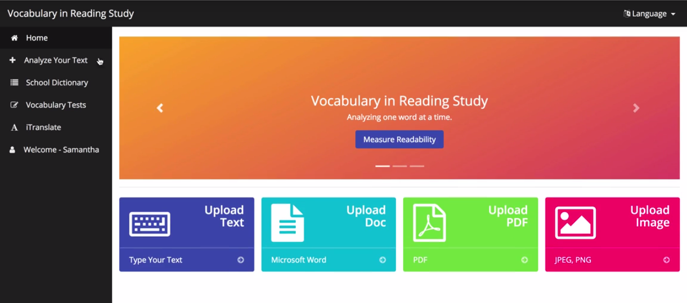

*Figure 1-VIRS 3.0 dashboard*

## Purpose of New System

The imperative task of the new system is to add features to make this a well rounded website, that achieves the purpose of helping those seeking to learn English as their new language. The updates must maintain the theme currently in the system and be in the vein of the purpose of this project.

Features must be accessible on both desktop and mobile platform, the features must enrich the website so as to ensure user satisfaction with not only the main feature of text analysis, but also the new features added in this version.

The features must be created to maintain the current system, while adding unto it. Therefore, maintaining the current backend API. The features to be included are a new “Essential Word List” (EWL) page for users to develop their vocabulary, an improvement to the image reading to handle strange fonts, formatting fixes for files uploaded to remove excessive white spacing, a password update so users can update their password while logged on, a password reset so users can change their password if they forgot using their email or their username, an update to the user’s profile, the option to permanently delete a user account, an improvement to show more detailed error messages when users encounter errors either due to their actions or due to a system error, an update to the statistics output and enhanced results page to show the new words/categories from the “EWL”, and an update to the statistics user interface so that the colors are coherent with the “Dictionary” and “EWL” pages respectively.

# 

# **User Stories**

The following section provides the detailed user stories that were implemented in this iteration of the VIRS project. These user stories served as the basis for the implementation of the project’s features. This section also shows the user stories that are to be considered for future development.

## Implemented User Stories

### **Delete Account**

User Story

|  |  |
| --- | --- |
| **Description** | **Acceptance Criteria** |
| As a user I would like to be able to delete my account so that I have full control of my data | 1. The user must enter their password in order to delete their account 2. The user password must be the correct one in the datastore 3. The user must acknowledge that they understand that their account will NOT be recoverable after deletion |

#### 

Use Case

## 

|  |  |
| --- | --- |
| **Name** | Delete Account |
| **Actors** | Website User, VIR Site |
| **Preconditions** | 1. The Website User has an active account in the system 2. The system is up and running |
| **Description** | 1. The use case begins when the Website User then clicks on the "delete account" button 2. The VIR Site will then open the delete account window 3. The Website User will then enter their password in the password textbox and the confirmation textbox 4. The Website User will then click on the "I understand" checkbox confirming that they understand that their account will NOT be recoverable    1. If the Website User closes the deletion window       1. The VIR Site will then close the deletion window       2. The use case ends when the VIR Site closes the delete account window 5. The Website User will then click on the "delete account" button 6. The VIR Site will then validate that the passwords entered are correct and that the checkbox "I understand" was checked    1. If the Website User does not enter 2 matching passwords       1. The VIR Site will then display a message that the passwords do not match and that it needs to be correct       2. The use case resumes on step 3 of normal flow    2. If the Website User does not check the "I understand" checkbox       1. The VIR Site will then display a message that the checkbox must be checked       2. The use case resumes on step 4 of the normal flow 7. The VIR Site will then retrieve the user name from the browser local storage    1. If the local storage does NOT have the user name       1. The VIR Site will clear any remaining user information from the local storage       2. The VIR Site will show a message that they must login again       3. The VIR Site will then close the deletion window       4. The use case ends when the VIR Site opens the login window 8. The VIR Site will then send the user name and the password to the system    1. If the VIR Site has a network connection error       1. The VIR Site will show a message that there was an error deleting the account       2. The use case resume on step 5 of the normal flow 9. The system will then validate that the user's password is correct    1. If the system finds a password mismatch from the datastore       1. The system will then respond that the password was wrong       2. The VIR Site will show a message that the password was wrong       3. The use case resumes on step 3 of the normal flow 10. The system will then delete any corresponding data related to the user and the user from the datastore     1. If the system has an error deleting the user account        1. The system will then respond that there was an error deleting the account        2. The VIR Site will show a message that the deletion did not complete        3. The use case resumes on step 5 of the normal flow 11. The system will then respond that the account has been deleted from the system 12. The VIR Site will then delete all local storage data of the user 13. The VIR Site will then show a the confirmation window 14. The use case ends when the VIR Site redirects to the main page. |

## 

### **Read Images**

User Story

|  |  |
| --- | --- |
| **Description** | **Acceptance Criteria** |
| As a user, I would like to upload images of any type of font or with low lighting so that I can search any of the text of the image | 1. The user will upload images with fonts that are not rare 2. The user will upload images that actually have text 3. The user will upload images that are NOT completely black 4. The user will upload images that have text that is readable by a human 5. The system is NOT intended to do too much pre-processing of the image files to make many fixes |

#### 

Use Case

|  |  |
| --- | --- |
| **Name** | Read Images |
| **Actors** | Website User, VIR Site |
| **Preconditions** | 1. The Website User has an image file with text 2. The system is up and running |
| **Description** | 1. The use case begins when the Website User clicks on the image selection button 2. The VIR Site will then show the Website User the image selection window 3. The Website User will then select an image 4. The Website User will then click on the "Enhance Text" button    1. If no image file is selected       1. The VIR Site won't make a connection to the system       2. The use case resumes on step 3 5. The VIR Site will then send the image to the system    1. If there is a connection error       1. The VIR Site will show an error message that it was unable to process       2. The use case resumes on step 4 6. The system will then set the DPI of the image to 300    1. If there is an error setting the DPI of the image       1. The system will report an error       2. The VIR Site will show an error message that there was an error       3. The use case resumes on step 4 7. The system will then create a black and white image    1. If there is an error creating the first image       1. The use case resumes on step 9 8. The system will then read all of the words of the first image 9. The system will then create a black and white image that is blurred with noise removed    1. If there is an error creating the second image       1. The use case resumes on step 11    2. If there is an error creating the second image and the first image also had a problem       1. The system will report an error       2. The VIR Site will show an error message that there was an error       3. The use case resumes on step 4 10. The system will then read all of the words of the second image 11. The system will then find which which list has the most words 12. The system will return the text of words 13. The use case ends when the VIR Site shows the Enhanced Text window with all of the words read from the image |

### 

### **Update Account**

User Story

|  |  |
| --- | --- |
| **Description** | **Acceptance Criteria** |
| As a user I would like to be able to update my full name and username so that I can update my account profile at will | 1. The full name must enter a non null/empty value 2. The user must enter a unique username 3. The system will ensure that no 2 users have the same username |

#### 

Use Case

|  |  |
| --- | --- |
| **Name** | Update Account |
| **Actors** | Website User, VIR Site |
| **Preconditions** | 1. The Website User has an active account in the system 2. The system is up and running |
| **Description** | 1. The use case begins when the Website User clicks on the “Edit” button 2. The VIR Site will then show the Edit Profile Details window 3. The Website User will then edit their full name in the text field 4. The Website User will then edit their email in the text field 5. The Website User will then edit their user name in the text field 6. The Website User will then select their user level from the list 7. The Website User will then click the “Update” button 8. The VIR Site will then validate the data    1. If the Website User has any empty text field       1. The VIR Site display a window that all text fields are required       2. The use case resumes on step 3 9. The VIR Site will then send the data to the system    1. If there is a connection problem       1. The VIR Site will display a window that there was a problem updating       2. The use case resumes on step 7 10. The system will then validate the data     1. If the data has empty values for all except for the user level        1. The system will then respond with an error        2. The VIR Site will display a window that all text fields are required     2. If the user does not exist in the system        1. The system will respond an error        2. The use case ends when the VIR Site displays a window that the user does not exist and to check if it wasn’t already deleted on another browser     3. If the new user user name or email already exist        1. The system will respond with an error        2. The VIR Site will display a window that the email and/or the user name is already taken        3. The use case resumes on step 4 11. The system will then update the user’s information     1. If there is an error saving        1. The system will respond with an error        2. The VIR Site will display a window that there was a problem updating        3. The use case resumes on step 7 12. The system will then respond that it successfully completed the update 13. The use case ends when the VIR Site shows a confirmation window |

### 

### **OCR Localized**

User Story

|  |  |
| --- | --- |
| **Description** | **Acceptance Criteria** |
| As a user I would like to have the uploaded images to be localized so that I can read them in the default language | 1. Image uploaded is in a non-English language 2. Text should use Roman characters 3. Image should be readable and NOT black or too dark that even a human can’t read it |

#### 

Use Case

|  |  |
| --- | --- |
| **Name** | OCR Localized |
| **Actors** | Website User, VIR Site |
| **Preconditions** | 1. The system is up and running 2. The system has already processed an image with text to be localized |
| **Description** | 1. The use case begins when the system returns results of a processed image 2. The VIR Site will then send the results to the Google System to be localized automatically    1. If the Google System is down       1. The use case ends when VIR Site displays an error message    2. If the Google System responds with no text       1. The use case ends when the VIR Site displays an error message 3. The Google System will then process the text 4. The Google System will then return the results 5. The VIR Site will then send the text result to the system 6. The system will then process the text statistics 7. The use case ends when the VIR Site displays the statistical data |

### 

### **Change Current Password**

User Story

|  |
| --- |
| **Acceptance Criteria** |
| 1. Once you Click on the button Reset password located in the account dashboard page, a new page displays a form to enter my current password, my new password and a copy of this new password. 2. Save the information updated in the profile    1. Display a successful message once the user password is changed in the app.    2. Display an error message if the user password was not changed in the app. 3. Be able to login with the new password. |
|  |

#### 

Use Case

|  |  |
| --- | --- |
| **Name** | Change password when the user is logged in his account. |
| **Actors** | User |
| **Preconditions** | 1. The user must have an account in the VIRS app 2. The user must be logged in this account. 3. The user must remember his/her current password. |
| **Description** | 1. Click in the reset password button that is located in the dashboard. 2. The App should display a new page where the user should enter the user current password, the new password, and a copy of this new password.    1. The new page should have the same style of the rest of the app pages.    2. The current password entered should match the password saved in his account.    3. The new password entered should match the copy entered.    4. The new password should be at least 6 characters long.    5. The password should be occulted when is entered by the user in the form. 3. User click submit button in the form to update the password.    1. Display successful message if the password was changed successfully.    2. Display an error message if any of the requirements are not meet and the password was not changed. 4. The old password cannot be used for login in the user account. 5. User should be able to logout and login with the new password. |

### 

### **Enter Username to Start Reset Password Process**

User Story

|  |  |
| --- | --- |
| **Description** | **Acceptance Criteria** |
| As a user I would like to open the application and find a button to reset password account, by entering my username to start the reset password process | 1. Once you click on the button reset password located in the account dashboard page, a new page displays a form to enter the user username. 2. Once the correct username is entered is sent to the back end to find the user a create an email request with a link to click for reset the password. |

#### 

Use Case

|  |  |
| --- | --- |
| **Name** | Start reset password process by username. |
| **Actors** | User |
| **Preconditions** | 1. The user needs to have an account in VIRS app.  2. The user forgot his password.  3. The user enters a correct username. |
| **Description** | 1. Click in the reset password button that is located in the dashboard. 2. The App should display a new form where the user can enter his username. 3. The form should have the same style as the rest of the app pages. 4. The User clicks the submit button in the form after enter the username to request for email with the link to reset the password.    1. The form is linked to the back end of the app.    2. The system will find the user email in his account.    3. The system will generate a token for this username.       1. The token should be unique.       2. The token will be saved until used.    4. The system will create a new recovery in the recovery table with the user id, the user email and the token generated for this user only.    5. Now this user has a unique identification number or token associated to his account. 5. This process generates a user email request from this user to the app. 6. The user can start and cancel this process as many times as he wants. |

### 

### **The User Receive an Email with a Link to Reset Password**

User Story

|  |  |
| --- | --- |
| **Description** | **Acceptance Criteria** |
| As a user I want to receive an email with a link for reset my VIRS app password. I want only to click a link and enter my new password without entering any security question or code. | 1. Once you Click on the button summit username the system will send an email to this user with a link for rest his password. 2. If you click this link a page of VIRS app will be displayed, to enter the new password and the copy. |

#### 

Use Case

|  |  |
| --- | --- |
| **Name** | Send an email to the user with a URL to reset password |
| **Actors** | User |
| **Preconditions** | 1. User must have an account in the VIRS app. 2. The user has a working email account registered in his account. |
| **Description** | 1. The system sent an email to the user with a link to reset password. 2. The user received a notification that an email was sent to his email account. 3. The user entered to this email and click on the link. 4. This link will display a page of VIRS app asking for the user new password and a confirmation of this password. 5. The new page should have the same style of the rest of the app pages. |

### 

### **Enter Password and a Copy to Reset Password**

User Story

|  |  |
| --- | --- |
| **Description** | **Acceptance Criteria** |
| As a user I would like to enter only my new password and a confirmation and change the password in my account. | 1. Once the user enters the new password and a copy and clicked on the submit button the password will be updated in his account. 2. The page will display a change password confirmation. |

#### 

Use Case

|  |  |
| --- | --- |
| **Name** | Enter password and a copy and reset the password account. |
| **Actors** | User |
| **Preconditions** | 1. The page asking for the password and the copy was displayed. |
| **Description** | 1. The user enters a password and a copy of the password 2. The user submits the form with both password    1. The system check if the two passwords entered match before send a request.    2. The system checks if the password enter has at least 6 characters long before send a request.    3. The password should be occulted when is entered by the user in the form    4. The new page should have the same style of the rest of the app pages 3. User click submit button in the form to update the password.    1. Display an error message if any of the requirements are not meet and the password was not changed. 4. The system gets the token in the link clicked and find the user, eliminate the user from recovery table and reset the user password.    1. The old password cannot be used for login in the user account. 5. Display successful message once the password was changed successfully. 6. User should be able to logout and login with the new password. |

### 

### **Start Reset Password Process using Email**

User Story

|  |  |
| --- | --- |
| **Description** | **Acceptance Criteria** |
| As a user I would like to open the application and find a button to reset password account. Where I can start reset password by entering my email register in my account, in case I forgot my password and username as well. | 1. Once you Click on the button Reset password located in the account dashboard page, a new page displays a form to enter the user registered email. 2. This user is requesting an email with a link for reset his password by entering the email linked to his account. |

#### 

Use Case

|  |  |
| --- | --- |
| **Name** | Start Reset password process by enter the email associated with the VIRS account. |
| **Actors** | User |
| **Preconditions** | 1. The user needs to have an account in VIRS app.  2. The user forgot the password.  3. The user forgot or don’t want to use his username.  4. The user needs to remember his email associated with his VIRS account. |
| **Description** | 1. Click in the reset password button that is located in the dashboard. 2. The App should display a new form where the user can enter his email.    1. The form should have the same style as the rest of the app pages. 3. The User clicks the submit button referent to the email in the form after enter the email to request for email with the link to reset the password.    1. This form is linked to the back end of the app.    2. The system will find the user email in his account.    3. The system will generate a token for this username.       1. The token should be unique and will be saved until used. 4. The system will create a new recovery in the recovery table with the user id, the user email and the token generated for this user only. Now this user has a unique identification number associated to his account. 5. This process generates a user email request from this user to the app. 6. The user can start and cancel this process as many times as he wants. |

### 

### **The User Receive an Email with a Link to Reset Password**

User Story

|  |  |
| --- | --- |
| **Description** | **Acceptance Criteria** |
| As user I want to receive an email in his account with a link for reset my password, that I can click to enter my new password and a copy of the password to change the password in my account. | 1. Once you Click on the button summit username the system will send an email to this user with a link for rest his password. 2. Once you click this link received by email, a page of VIRS app will be displayed to enter new password and a copy of the new password 3. Once the user enters the new password and a copy and clicked on the submit button the password will be updated in his account. 4. The page will display a change password confirmation. |

#### 

Use Case

|  |  |
| --- | --- |
| **Name** | User Receives an email with a link to display a form to enter a new password and a copy to reset his password. |
| **Actors** | User |
| **Preconditions** | 1. User must have an account in the VIRS app.  2. The user has a working email account registered in his account. |
| **Description** | 1. The system sent an email to the user with a link to reset password. 2. The user received a notification that an email was sent to his email account. 3. The user entered to this email and click on the link. 4. If the token hasn’t been used. 5. This link will display a page of VIRS app asking for the user new password and a confirmation of this password. 6. If the token was already used a message is displayed in the page.    1. The new page should have the same style of the rest of the app pages 7. The user enters a password and a copy of the password. 8. The user submits the form with both password.    1. The system check if the two passwords entered match before send a request.    2. The system checks if the password enter has at least 6 characters long before send a request.    3. The password should be occulted when is entered by the user in the form.    4. The new page should have the same style of the rest of the app pages. 9. User click submit button in the form to update the password.    1. Display an error message if any of the requirements are not meet and the password was not changed. 10. The system gets the token in the link clicked and find the user, eliminate the user from recovery table and reset the user password. 11. The old password cannot be used for login in the user account. 12. Display successful message once the password was changed successfully. 13. User should be able to logout and login with the new password. |

### 

### **Display a Form to Start Reset Password By Username or By Email**

User Story

|  |  |
| --- | --- |
| **Description** | **Acceptance Criteria** |
| As user I want to click in the reset Password button and has the choice of Reset the password by using either the username or the email associated with his VIRS account. | 1. the user name or the email associated with the user account. 2. The user enters either his username or his email address and will start the process to receive an email to reset his password. |

#### 

Use Case

|  |  |
| --- | --- |
| **Name** | User clicks reset password button and a form is displayed to reset the password by either using email or username. |
| **Actors** | User |
| **Preconditions** | 1. User must have an account in the VIRS app.  2. The user has a working email account registered in his account. |
| **Description** | 1. The user clicks the reset password button located in the dashboard. 2. The system displays a form where the user can either enter the username or the email associated to his VIRS account to reset his password. 3. The user entered either the username or the email and click submit. 4. The form will request to the API to locate this user and send an email with a link to reset the password.    1. From here the procedure is already implemented is previous user stories . |

### 

### **Login After Registration**

User Story

|  |  |
| --- | --- |
| **Description** | **Acceptance Criteria** |
| As a user I want to login to my account after registering | 1. User has successfully registered into the system by entering a valid username, password, first name, last name, and email |

#### 

Use Case

|  |  |
| --- | --- |
| **Name** | Login After Registration |
| **Actors** | VIRS system, Web User |
| **Preconditions** | 1. The system is up and running 2. The user has entered valid username, password, first name, last name, email into the registration form 3. The user has clicked submit 4. The user enters a valid username and password into the login form |
| **Description** | 1. The web user enters the VIRS dashboard page 2. The web user clicks the register link in the sidebar 3. The web user enters a valid username, password, email, first name, last name 4. The web user clicks the “Register” button 5. The web user is redirected to the login modal 6. The web user enters a valid username and password 7. The web user clicks login button 8. The web user is redirected to the dashboard. |

### **Invalid Username**

User Story

|  |  |
| --- | --- |
| **Description** | **Acceptance Criteria** |
| As a user, I want to see an error message if my username is not registered so that I will know to register or that I mistyped my username. | 1. The user will be allowed to use this feature only when trying to log in 2. The use must enter the username and password information to login |

#### 

Use Case

|  |  |
| --- | --- |
| **Name** | Invalid Username |
| **Actors** | Web User |
| **Preconditions** | 1. The system must be up and running  2. User can not be logged in yet |
| **Description** | 1. Website user clicks on the Profile option on the sidebar menu. 2. Website user clicks on login 3. Website user enters the username and password prompted in the dialog window opened 4. After entering the username and password website user clicks login   4.1. If message pops up because username is wrong click login again  and do steps 3 and 4 as needed  4.2. If no error pops up then user has access to his/her profile |

### 

### **EWL Access**

User Story

|  |  |
| --- | --- |
| **Description** | **Acceptance Criteria** |
| As a user, I would like to access the "EWL so that I can easily review the essential words list. | 1. System must be up and running. 2. User must click on the "Essential Word List" button on the side bar menu. |

#### 

Use Case

|  |  |
| --- | --- |
| **Name** | EWL Access |
| **Actors** | Web User |
| **Preconditions** | The system must be up and running |
| **Description** | 1. Website User clicks on the "Essential Word List” button on the sidebar menu. 2. User should have access to a page with words |

### 

### **EWL Categories**

User Story

|  |  |
| --- | --- |
| **Description** | **Acceptance Criteria** |
| As a user, I would like to view the EWL lists based on a category selected at the top of the page, so when a category is clicked subset of the list is created | 1. User has to see three categories at the top of the page after accessing EWL. 2. User has to be able to see the first list of words corresponding to category K1, displayed in the page by default. 3. User has to be able to click on any of the categories and a list of words for that category has to be displayed. |

#### 

Use Case

|  |  |
| --- | --- |
| **Name** | EWL Categories |
| **Actors** | Web User |
| **Preconditions** | 1. The system must be up and running 2. User should have clicked first in the “Essential Words List” button at the side |
| **Description** | 1. Website User clicks on the "EWL" button on the sidebar menu 2. The VIRS site will show the EWL page with the Categories next to each other at the top of the page. 3. Website User will either stay in K1 category (default category) or click in any of the other two categories ("K2", "Basic Academic Words"). 4. The VIRS site will retrieve all the words with such category and display them in a list. |

### 

### **EWL Search**

User Story

|  |  |
| --- | --- |
| **Description** | **Acceptance Criteria** |
| As a user, I would like to search any word using the search bar of the EWL feature so that I can find the word I am looking for faster, or to know the word is not on the list. | 1. The user has to type the word in the search bar of the EWL feature. 2. After the user clicked search, after having typed the word:   2.1. The desired word will appear with the category next to it.  2.2. The search won’t return anything which means the word was not in the EWL list. |

#### 

Use Case

|  |  |
| --- | --- |
| **Name** | EWL Search |
| **Actors** | Web User |
| **Preconditions** | 1. The system must be up and running. 2. User should have clicked first in the “Essential Words List” button at the side. |
| **Description** | 1. Website User clicks on the "EWL" button on the sidebar menu 2. The VIRS site will show the EWL page with the search bar in the middle. 3. Website User will enter the word desired in the search bar and click in search.   3.1. If the EWL has the word is being searched for, it will appear with the category next to it.  3.2. If the EWL doesn’t have the word, then no results will be shown. |

### 

### **EWL Word Definition**

User Story

|  |  |
| --- | --- |
| **Description** | **Acceptance Criteria** |
| As a user I would like to see a definition of a word when I click on a word in the list. | 1. The user has to click a word and a definition has to pop up. 2. The user has to click a word and if Wikipedia does not have definition a message will pop up. |

#### 

Use Case

|  |  |
| --- | --- |
| **Name** | EWL Word Definition |
| **Actors** | Web User |
| **Preconditions** | 1. System has to be up and running 2. Web User has to have access to the EWL feature 3. Web User has to click on a word |
| **Description** | 1. Website User clicks on the "EWL" button on the sidebar menu 2. Website User can either:   2.1 Click on a word that sees on the list  2.2 Search for a word and if found click on the word to get the definition  3. Once clicked on the word, a new windows should pop up in the  screen with the definition from Wikipedia. |

### 

### **Output Text Only**

User Story

|  |  |
| --- | --- |
| **Description** | **Acceptance Criteria** |
| As a user, I would like to upload word documents and PDFs and get an output of text with the right spaces between lines. | 1. After the user chooses the type of file it wants to analyze, whether is PDF or Word Document, and click enhance text, it should have an output text with the right space between the lines. |

#### 

Use Case

|  |  |
| --- | --- |
| **Name** | Output Text Only |
| **Actors** | Web User |
| **Preconditions** | 1. System has to be up and running. 2. User has to upload the correct type of file. 3. User has to upload the file with an acceptable size. |
| **Description** | 1. Website user clicks on "Analyze your Text" on the sidebar 2. Website user chooses from the 4 categories: Text, DOC, PDF, Images 3. Website user uploads the file according to the format chosen previously making sure the size is acceptable 4. Website user clicks on "Enhanced Text" 5. File should be processed and text should be shown with the correct spacing between the lines. |

### 

### **Invalid Password**

User Story

|  |  |
| --- | --- |
| **Description** | **Acceptance Criteria** |
| As a user, I want to see an error message if my password is incorrect. | 1. First I put an username and password 2. A display message that the password is incorrect will appear |

#### 

Use Case

|  |  |
| --- | --- |
| **Name** | Invalid password |
| **Actors** | User |
| **Preconditions** | Have an existing account. |
| **Description** | Display an error message that the password is incorrect. |

### 

### **Statistics Improvement**

User Story

|  |  |
| --- | --- |
| **Description** | **Acceptance Criteria** |
| As a User I would like to analyze the text so that I can see the correct percent of each category, see how many words per category. | 1. The user is able to see the statistics in 2 types of charts. 2. The user is able to see how many words in each category. |

#### 

Use Case

|  |  |
| --- | --- |
| **Name** | Text statistics colors |
| **Actors** | User |
| **Preconditions** | A text of more than 100 words. |
| **Description** | When you analyzed the text it give the amount of words of each categories and then calculate the percentage. |

### 

### **EWL**

User Story

|  |  |
| --- | --- |
| **Description** | **Acceptance Criteria** |
| As a User I would like to be able to sort from A through Z and Z to A, I would like to be able to go through different pages, also I would like to be able to choose how many words I would like to see in every page. | 1. Users see all different pages and choose from it where they want to go. 2. Users sort the words from A to Z and Z to A. 3. User choose how many words they want to see successfully. |

#### 

Use Case

|  |  |
| --- | --- |
| **Name** | EWL sorting,paging and entries per page |
| **Actors** | User |
| **Preconditions** | NONE |
| **Description** | Show all the data sorted, go through every page and choose to choose different quantity of words. |

### 

### **Enhanced Text Improvement**

User Story

|  |  |
| --- | --- |
| **Description** | **Acceptance Criteria** |
| As a User I would like to see the words categorized with the new categories K1 and K2 so that when I analyzed them I'll be able to see them. | 1. When I analyzed the text I'll be able to see K1 and K2. 2. When analyzed the text everything is being label with the colors assigned. |

#### 

Use Case

|  |  |
| --- | --- |
| **Name** | Enhanced text improvement |
| **Actors** | User |
| **Preconditions** | Have a text with more than 100 words |
| **Description** | When you analyzed the text, it will categorized each word with the color assigned. |

### 

### **Dictionary Reference Update**

User Story

|  |  |
| --- | --- |
| **Description** | **Acceptance Criteria** |
| As a user, I would like to get a definition from a good reference so I can better understand the word(s). | 1. Dictionary definitions must have a cleaner formatting. 2. Definition window must present the actual word definition. 3. Definition window must present the word pronunciation. |

#### 

Use Case

|  |  |
| --- | --- |
| **Name** | Dictionary Reference Update |
| **Actors** | User |
| **Preconditions** | User must have access to the dictionary. |
| **Description** | When users click on a word to see the definition, the application should show a clean definition and pronunciation. |

## 

## Pending User Stories

### **Paid Subscription**

**User Story**

|  |  |
| --- | --- |
| **Description** | **Acceptance Criteria** |
| As a user, I would like to have a paid subscription so that I can have more access to website features. | 1. The user can submit payment information. 2. The user has more access to limited features in the website. |

# 

# **Project Plan**

This section describes the planning that went into the realization of this project. This project incorporated the agile development techniques and as such required the sprints to be planned. These sprint planning are detailed in the section. This section also describes the components, both software and hardware, chosen for this project.

## Hardware and Software Resources

The following is a list of all hardware and software resources that were used in this project:

***Hardware:***

* Computer running Linux, Mac OS or windows.
* For the deployed application make sure you stay within the AWS server constraints
  + 64bit Amazon Linux 2017.03 v2.5.5 running Java 8.

***Software:***

The following list is the software used in the application. Note that it is quite extensive and includes all the development layers of the stack.

**Front end:**

* Angular 4.3.1
* Ng-Bootstrap 1.0.0
* Ng-Translate 7.0.0
* Chat.js 2.7.1
* Font-Awesome 4.7.0
* Ng2-Charts 1.6.0
* Rxjs 5.1.0
* Jasmine 2.5.45
* Karma 1.7
* Typescript 2.3.3

**Back end:**

* Maven 3.5
  + Commons-lang3 3.4
  + HikariCP 1.5.6.RELEASE
  + Jai-imageio-core 1.3.1
  + Jai-imageio-jpeg2000 1.3.0
  + Jasypt-spring-boot-starter 1.16
  + Levigo-jbig2-imageio 2.0
  + Mysql-connector-java 1.5.6.RELEASE
  + Opencsv 3.3
  + Opencv 3.2.0-1
  + Spring-boot-starter-data-jpa 1.5.6.RELEASE
  + Spring-boot-starter-security 1.5.6.RELEASE
  + Spring-boot-starter-test 1.5.6.RELEASE
  + Spring-boot-starter-web 1.5.6.RELEASE
  + Springfox-swagger-ui 2.7.0
  + Springfox-swagger2 2.7.0
  + Sqlite-jdbc 1.5.6.RELEASE
  + Tess4j 3.4.1
  + Thucydides-core 0.9.275
  + Tika-parsers 1.16
* Tesseract 3.05.01
* Leptonica 1.74.4
* Mysql 14.14
* Java 1.8.0
* Spring Developer Suite 3.9

**Android:**

* Android Studio 3.0
* Gradle 3.0
* Android sdk 23

**iOS:**

* Xcode 9.1
* Command line tools 9.2

**Other:**

* Git 2.14.1
* Bash 3.2.57

## Sprints Plan

### 

### **Sprint 2**

20180917

|  |  |
| --- | --- |
| **Start Time** | **End Time** |
| 20:00 | 20:46 |

|  |  |
| --- | --- |
| **Summary** | **Assignee** |
| Update Email | Taufiq |
| Add Email | Chelsea |
| Change Username | Pablo |
| Change Password | Monica |
| Invalid Password | Samantha |
| Invalid User | Jessica |

### **Sprint 3**

20180930

|  |  |
| --- | --- |
| **Start Time** | **End Time** |
| 21:20 | 22:20 |

|  |  |
| --- | --- |
| **Summary** | **Assignee** |
| Dictionary Reference Update | Taufiq |
| Login After Registration | Chelsea |
| Reset Account | Monica |
| Registration No Longer Works | Chelsea |
| Add EWL Data | Samantha |
| Access the EWL | Jessica |
| EWL Categories | Jessica |
| Search EWL | Jessica |
| EWL Word Definition | Jessica |
| EWL Paging | Samantha |
| EWL Sorting | Samantha |
| EWL Entries Per Page | Samantha |
| Delete Account | Pablo |

### **Sprint 4**

20181014

|  |  |
| --- | --- |
| **Start Time** | **End Time** |
| 20:00 | 20:45 |

|  |  |
| --- | --- |
| **Summary** | **Assignee** |
| EWL 3rd category | Samantha |
| Read Images with Any font | Pablo |
| Read Images with Low Light | Pablo |
| Train tesseract | Chelsea |
| Dictionary Reference Update | Taufiq |
| Fix browser quirks/compatibility problems | Samantha |
| Login After Registration | Chelsea |
| Add Security | Taufiq |
| Output Text Only | Jessica |
| Reset Account | Monica |

### **Sprint 5**

20181029

|  |  |
| --- | --- |
| **Start Time** | **End Time** |
| 20:30 | 21:00 |

|  |  |
| --- | --- |
| **Summary** | **Assignee** |
| Enhanced text Improvement | Samantha |
| Statistics Improvement | Samantha |
| Dictionary Reference Update | Taufiq |
| Fix browser quirks/compatibility problems | Chelsea |
| Read images that need correction | Pablo |
| Login After Registration | Chelsea |
| Create Proof of Concept | Pablo |
| Add Security | Taufiq |
| Application Security | Pablo |
| Output Text Only | Jessica |
| Reset Account | Monica |
| OCR Localized | Pablo |

### **Sprint 6**

20181113

|  |  |
| --- | --- |
| **Start Time** | **End Time** |
| 20:30 | 21:00 |

|  |  |
| --- | --- |
| **Summary** | **Assignee** |
| Display a form to Reset Password Either Using the Username or the Email | Monica |
| The User Receives an Email with a Link to clicked for Enter the New Password and Reset his Password | Monica |
| Start Reset Password Using Email | Monica |
| User Enters New Password a Copy and Reset Password | Monica |
| User receives an email with a link to reset password | Monica |
| Enter Username to Reset Password | Monica |
| Spacing on PDF alters the actual text | Jessica |
| Enhanced text is NOT showing the EWL changes | Samantha |
| Password reset email body should be fixed | Pablo |
| Token missing in datastore shows confusing error message | Monica |
| Popup displays when resetting by email | Monica |
| Password Reset hangs and gives no indication of work to user | Monica |
| Empty Modal When User Logged In | Monica |
| Create Proof of Concept | Pablo |
| Application Security | Pablo |
| Read images that need correction | Pablo |
| Fix browser quirks/compatibility problems | Chelsea |
| Dictionary Reference Update | Taufiq |
| Add Security | Taufiq |
| Statistics Improvement | Samantha |
| Login After Registration | Chelsea |

# **System Design**

This section contains information on the design decisions that went into this project. The architecture patterns are outlined and explained. The entire system is shown in a package diagram and the subsystems are explained. Finally, the design patterns used in the project are discussed.

## Architectural Patterns

Model View Controller is the main design for the architecture. We are separating the main three parts of the application: user interaction, processing of information and storage. The segregation of this concerns favors production since each of the developers work in a separate section. This separation of components makes the system easily modifiable in the future. With this design, we ensure that we have multiple views for a controller; the system produces APIs that can be consumed by any other application.

Client-Server is used in the system to deliver the application. A highly available system that can be consumed from several parties called for this design. It allows the centralization of the code logic and database. We had to access the application from the web, iOS and Android devices so this was a very good choice.

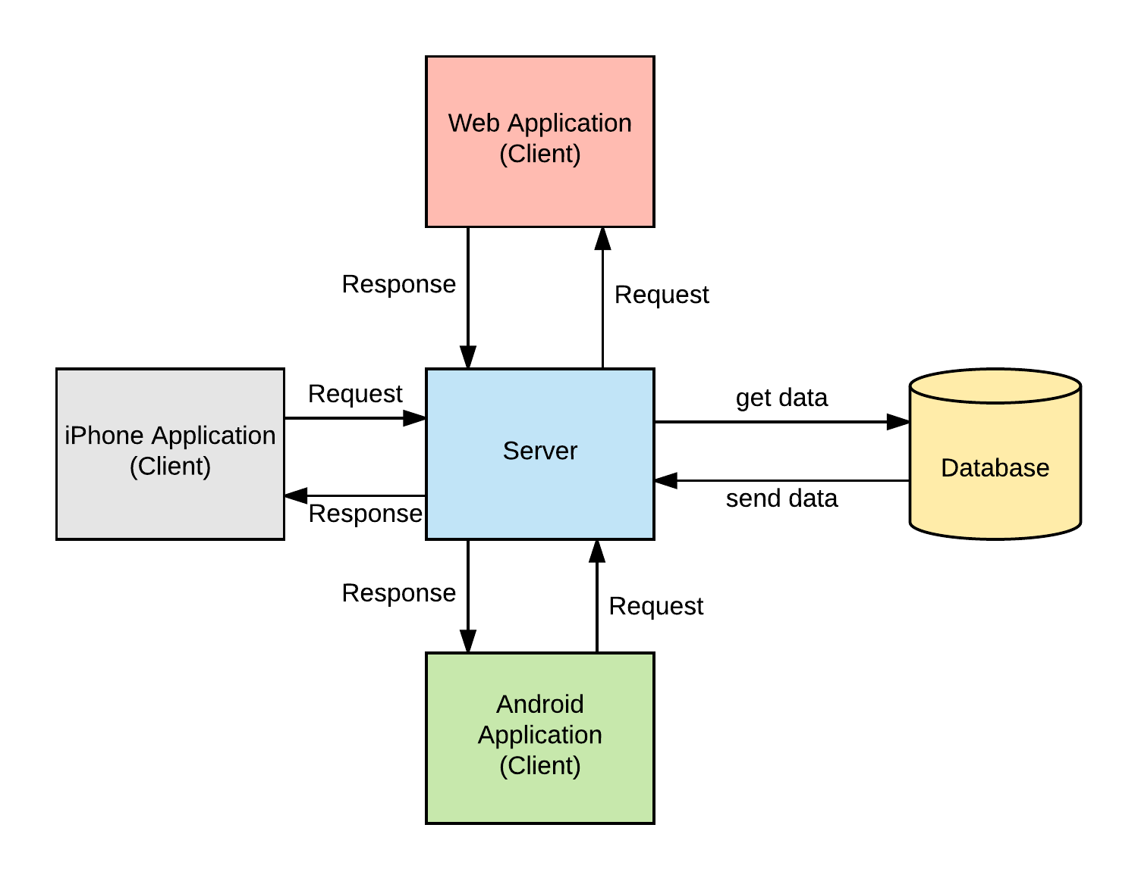

*Figure 2 Model View Controller*

Repository pattern is another design used in our system. It minimizes the amount of duplicate code in the system by abstracting the basic CRUD operations. It also ties the data entities to the domain model which favors development. The code would have to comply with the entity restrictions in order to even comply. It also helps maintain data integrity.

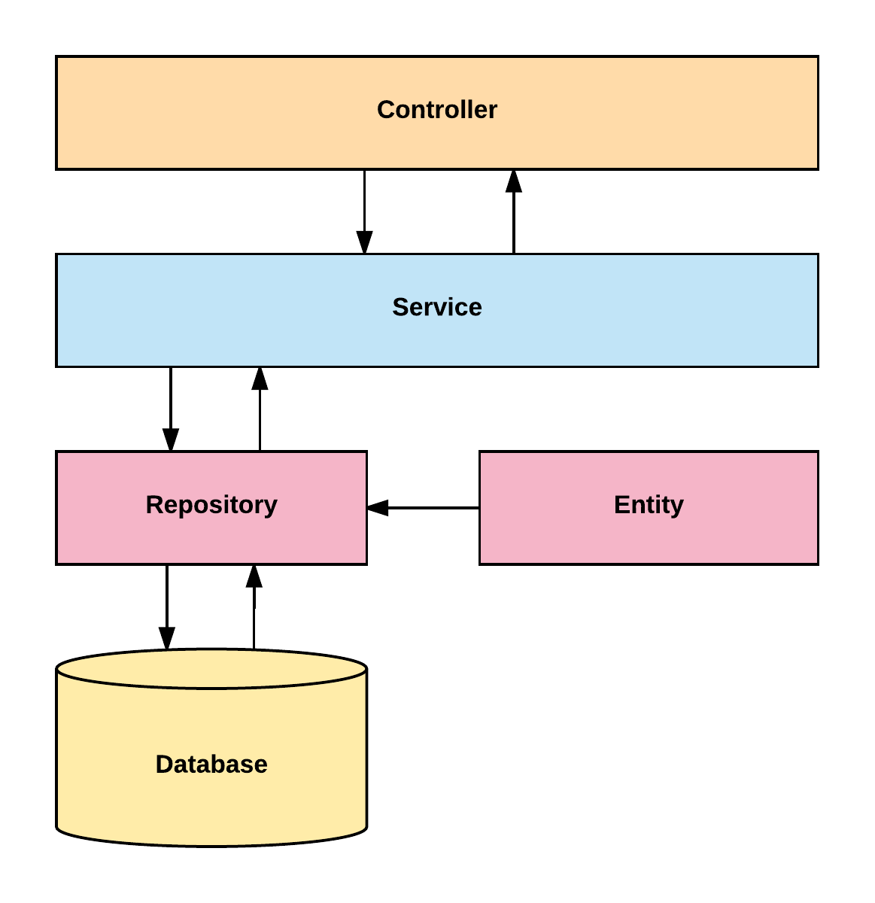

*Figure 3- Server System Design*

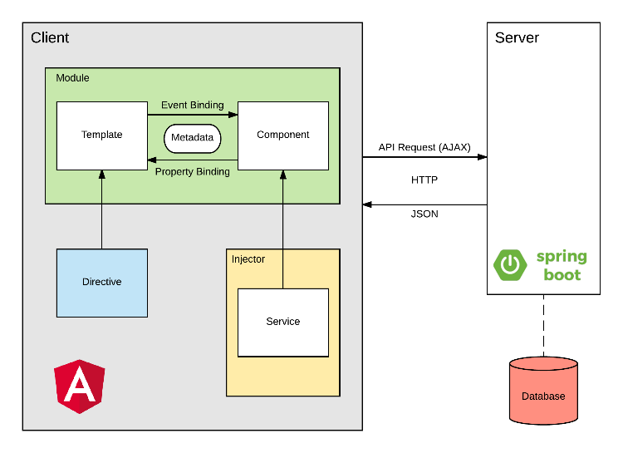

*Figure 4- Client System Design*

## System and Subsystem Decomposition

The system is made out of two major subsystems and two minor ones. They are broken down as follows according to its tasks and interactions.

Server Subsystem:

* Interacts with the database.
* Serves all the requests from the web
* Handles server side security.
* Analyzes the statistics of the text.
* Performs OCR.
* Optimizes images.

Client Subsystem:

* Displays the application.
* Routes server-side API calls.
* Contains the main boundaries for user interaction.
* Client side data validation.

Android Subsystem:

* Interacts with the web application to display in an Android device.
* Handles device data storage needed for the web.

iPhone Subsystem:

* Interacts with the web application to display it in an iOS device.

## Deployment Diagram

Deployment of the application consists in several steps run with a bash script. It starts in the front end and it propagates to the backend and eventually to the final product. We are building with ng for Angular products and Maven for the backend.

This is detailed explanation for the development pipeline.

* Angular
  + Clean and build the application
  + Run karma tests
  + Run e2e
* Copy resources to the backend
* Spring
  + Clean and build
  + Run Unit tests
  + Create jar executable

This is detailed explanation for the production pipeline.

* Angular
  + Clean and build the application
  + Run karma tests
  + Run e2e
* Copy resources to the backend
* Spring
  + Increase version number
  + Clean and build
  + Run Unit tests
  + Run Integration tests
  + Create jar executable
* Bundle the application for AWS
* Upload to AWS servers.

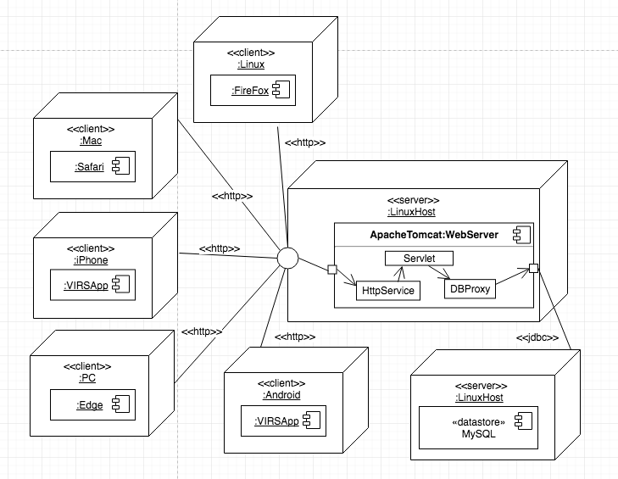

*Figure 5 - Deployment Diagram*

## Design Patterns

The following design patterns were used in the application.

**Dependency Injection:** This is a core design pattern for Spring and Angular 4. It allows the objects to be readily available and injected when needed rather than having to create them.

**Bridge:** This design pattern is used by the application to interact with libraries that are not native. Ex: tesseract and OpenCV

**Front controller:** Controllers are one of the main Components in the MVC design.

**Marker:** All components in Spring are annotated with markers to further specify the correct stereotype. This allows the initialization of the correct optimized components when the application runs.

**Module:** The application is divided in several modules according to functionality. This separation promotes organization and grouping of features.

# 

# **System Validation**

## Delete Account - Bad Data Request

### 

|  |  |
| --- | --- |
| **ID** | VIR-DELETE-001 |
| **Name** | Bad Data Request |
| **Category** | Rainy |
| **Description** | Testing empty, non-existing user, and invalid password request for deleting a user account. |
| **Preconditions** | Create 1 user in a mock datastore   1. userName = "pqsk0" 2. password = "test123" |

### 

### 

|  |  |  |  |  |
| --- | --- | --- | --- | --- |
| **Step** | **Data** | **Expected Result** | **Actual Result** | **Status** |
| call UserController.removeUser | userName = null  password = null | HTTP 400 | HTTP 400 | Pass |
| call UserController.removeUser | userName = "pqsk0"  password = null | HTTP 400 | HTTP 400 | Pass |
| call UserController.removeUser | userName = null  password = "test123" | HTTP 400 | HTTP 400 | Pass |
| call UserController.removeUser | userName = ""  password = "" | HTTP 400 | HTTP 400 | Pass |
| call UserController.removeUser | userName = "pqsk0"  password = "" | HTTP 400 | HTTP 400 | Pass |
| call UserController.removeUser | userName = ""  password = "test123" | HTTP 400 | HTTP 400 | Pass |
| call UserController.removeUser | userName = " "  password = " " | HTTP 400 | HTTP 400 | Pass |
| call UserController.removeUser | userName = "pqsk0"  password = " " | HTTP 400 | HTTP 400 | Pass |
| call UserController.removeUser | userName = " "  password = "test123" | HTTP 400 | HTTP 400 | Pass |
| call UserController.removeUser | userName= "doesNotExist" | HTTP 404 | HTTP 404 | Pass |
| call UserController.removeUser | userName = "pqsk0"  password = "invalidPassword" | HTTP 401 | HTTP 401 | Pass |

### 

## Delete Account - Delete User

### 

|  |  |
| --- | --- |
| **ID** | VIR-DELETE-002 |
| **Name** | Delete User |
| **Category** | Sunny |
| **Description** | Testing deleting a user account |
| **Preconditions** | Create 1 user in a mock datastore   1. userName = "pqsk0" 2. password = "test123" |

### 

### 

|  |  |  |  |  |
| --- | --- | --- | --- | --- |
| **Step** | **Data** | **Expected Result** | **Actual Result** | **Status** |
| call UserController.removeUser | userName = "pqsk0"  password = "test123" | * HTTP 204 * User is deleted from the mock datastore | * HTTP 204 * User is deleted from the mock datastore | Pass |

### 

## OCR Localized - Localize Image Results

### 

|  |  |
| --- | --- |
| **ID** | VIR-OCR-LOCALIZE-001 |
| **Name** | Localize image text results |
| **Category** | Sunny |
| **Description** | Testing localizing image text result by mocking the Google System. |
| **Preconditions** | Create a mock iTranslateService |

### 

### 

|  |  |  |  |  |
| --- | --- | --- | --- | --- |
| **Step** | **Data** | **Expected Result** | **Actual Result** | **Status** |
| call MockiTranslateService.getTranslation | Traduceme | Translate me | Translate me | Pass |

### 

## OCR Localized - Localize Blank/Empty

### 

|  |  |
| --- | --- |
| **ID** | VIR-OCR-LOCALIZE-002 |
| **Name** | Localize blank/empty image text results |
| **Category** | Rainy |
| **Description** | Testing localizing blank/empty image text result by mocking the Google System  Testing localizing an image without text |
| **Preconditions** | Create a mock iTranslateService |

### 

### 

|  |  |  |  |  |
| --- | --- | --- | --- | --- |
| **Step** | **Data** | **Expected Result** | **Actual Result** | **Status** |
| call MockiTranslateService.getTranslation | Null | Null | Null | Pass |

### 

## Read Images - Read Image Text

### 

|  |  |
| --- | --- |
| **ID** | VIR-OCR-READ-001 |
| **Name** | Read image text |
| **Category** | Sunny |
| **Description** | Testing reading an image by mocking the interface that handles the files and mocking an image file |
| **Preconditions** | 1. Create a mock OcrOptimizerService 2. Create a mock WordRepository with the following value/category    1. value: the category: cat1    2. value: word category: cat1    3. value: is category: cat1    4. value: something category: cat1    5. value: that category: cat1    6. value: exists category: cat1 |

### 

### 

|  |  |  |  |  |
| --- | --- | --- | --- | --- |
| **Step** | **Data** | **Expected Result** | **Actual Result** | **Status** |
| call AnalyzerController.analize | Mock file body contents:  The word is something that exists | * Words found: the,word,is,something,that,exists * Word count of no category: 6 * Total word count: 6 * No category percentage: 100% * Sentence count: 1 | * Words found: the,word,is,something,that,exists * Word count of no category: 6 * Total word count: 6 * No category percentage: 100% * Sentence count: 1 | Pass |

### 

## Read Images - Read Empty Image

### 

|  |  |
| --- | --- |
| **ID** | VIR-OCR-READ-002 |
| **Name** | Read image without text |
| **Category** | Rainy |
| **Description** | Testing reading an image without text |
| **Preconditions** | 1. Create a mock OcrOptimizerService 2. Create a mock WordRepository with the following value/category    1. value: the category: cat1    2. value: word category: cat1    3. value: is category: cat1    4. value: something category: cat1    5. value: that category: cat1    6. value: exists category: cat1 |

### 

### 

|  |  |  |  |  |
| --- | --- | --- | --- | --- |
| **Step** | **Data** | **Expected Result** | **Actual Result** | **Status** |
| call AnalyzerController.analize | Mock file body contents: null | * Words found: null * Word count of no category: 0 * Total word count: 0 * No category percentage: 0% * Sentence count: 0 | * Words found: null * Word count of no category: 0 * Total word count: 0 * No category percentage: 0% * Sentence count: 0 | Pass |

### 

## Update Account - Empty Username

### 

|  |  |
| --- | --- |
| **ID** | VIR-UPDATE-001 |
| **Name** | Empty Username |
| **Category** | Rainy |
| **Description** | Testing an empty/null user name to update |
| **Preconditions** | None |

### 

### 

|  |  |  |  |  |
| --- | --- | --- | --- | --- |
| **Step** | **Data** | **Expected Result** | **Actual Result** | **Status** |
| call UserController.updateUser | userName = null | HTTP 400 | HTTP 400 | Pass |
| call UserController.updateUser | userName = "" | HTTP 400 | HTTP 400 | Pass |
| call UserController.updateUser | userName = " " | HTTP 400 | HTTP 400 | Pass |

### 

## Update Account - Username Does Not Exist

### 

|  |  |
| --- | --- |
| **ID** | VIR-UPDATE-002 |
| **Name** | User Name does not exist |
| **Category** | Rainy |
| **Description** | Testing a user name to update that is not in the mock datastore |
| **Preconditions** | 1. Create a mock datastore with users 2. None of the users should have the user name "userNameDoesNotExist" |

### 

### 

|  |  |  |  |  |
| --- | --- | --- | --- | --- |
| **Step** | **Data** | **Expected Result** | **Actual Result** | **Status** |
| call UserController.updateUser | userName = "userNameDoesNotExist" | HTTP 404 | HTTP 404 | Pass |

### 

## Update Account - Existing Email

### 

|  |  |
| --- | --- |
| **ID** | VIR-UPDATE-003 |
| **Name** | Existing Email |
| **Category** | Rainy |
| **Description** | Testing updating a user to an email that already exists |
| **Preconditions** | 1. Create a mock datastore with users 2. Add the email "test@test.com" for the first user 3. Add another user with the user name "pqsk2" |

### 

### 

|  |  |  |  |  |
| --- | --- | --- | --- | --- |
| **Step** | **Data** | **Expected Result** | **Actual Result** | **Status** |
| call UserController.updateUser | userName = "pqsk2"  user.email = "test@test.com" | HTTP 403 | HTTP 403 | Pass |

### 

## Update Account - Update User

### 

|  |  |
| --- | --- |
| **ID** | VIR-UPDATE-004 |
| **Name** | Update User |
| **Category** | Sunny |
| **Description** | Testing updating a user |
| **Preconditions** | 1. Create a mock datastore with 1 user 2. fullName = "Test User 2" 3. userName = "pqsk2" 4. userLevel = null 5. email = "test2@email.com" |

### 

### 

|  |  |  |  |  |
| --- | --- | --- | --- | --- |
| **Step** | **Data** | **Expected Result** | **Actual Result** | **Status** |
| call UserController.updateUser | userName = "pqsk2"  user = <user from data store>  user.email = "test0@email.com"  user.fullName = "Changed Name"  user.userName = "someNewUserName" | * HTTP 200 * user fields updated | * HTTP 200 * user fields updated | Pass |

### 

## Invalid Username

### 

|  |  |
| --- | --- |
| **ID** | VIR-INVALID_USERNAME-001 |
| **Name** | Invalid Username |
| **Category** | Rainy |
| **Description** | User tries to log in with the incorrect username |
| **Preconditions** | User should have an existent username in use |

### 

### 

|  |  |  |  |  |
| --- | --- | --- | --- | --- |
| **Step** | **Data** | **Expected Result** | **Actual Result** | **Status** |
| * Go to profile and click on login * Enter username and password and click login | * Loads * Username: “gjhgj12” | * Loads * Error Message, option to retry to login or register | * Loads * Error Message, option to retry to login or register | Pass |

## EWL Access

### 

|  |  |
| --- | --- |
| **ID** | VIR-EWL_ACCESS-001 |
| **Name** | EWL Access |
| **Category** | Sunny |
| **Description** | User has access to the Essential Word List thru a button on the sidebar |
| **Preconditions** | System up and running |

### 

### 

|  |  |  |  |  |
| --- | --- | --- | --- | --- |
| **Step** | **Data** | **Expected Result** | **Actual Result** | **Status** |
| * Click on the “Essential Words List”button on the sidebar. | * Loads | * A new page should appear with the word lists and categories etc. | * New page appeared with the word lists, categories, etc. | Pass |

### 

## EWL Categories

### 

|  |  |
| --- | --- |
| **ID** | VIR-EWL_CATEGORIES-001 |
| **Name** | EWL Categories |
| **Category** | Sunny |
| **Description** | Once in the EWL page, user should be able to see the three categories on the top of the page, K1 as the default category with the list of words displaying on the page. User should be able to click in any category and the list of words should be updated to show the words of that category. Words should be displayed with the category next to them |
| **Preconditions** | 1. System up and running 2. Have access to the EWL page |

### 

### 

|  |  |  |  |  |
| --- | --- | --- | --- | --- |
| **Step** | **Data** | **Expected Result** | **Actual Result** | **Status** |
| * Go to EWL page and click on “K1” category * Click on “K2” category * Click on “Basic Academic Words” category | * Loads * Loads * Loads | * List of words from this category shouldn't change since K1 is the default category. Every word should have the category “K1” next to it. * List of words should have changed. Every word should have the category “K2” next to it. * List of words should have changed. Every word should have the category “Basic Academic Words” next to it. | * List of words didn’t change. Every word shows the category “K1” next to it. * List of words changed. Every word shows the category “K2” next to it. * List of words changed. Every word shows the category “Basic Academic Words” next to it. | Pass |

### 

## EWL Search

### 

|  |  |
| --- | --- |
| **ID** | VIR-EWL_SEARCH-001 |
| **Name** | EWL Search |
| **Category** | Sunny |
| **Description** | Search for EWL words. |
| **Preconditions** | 1. System up and running. 2. Have access to the EWL page. 3. Being able to type in the search bar. |

### 

### 

|  |  |  |  |  |
| --- | --- | --- | --- | --- |
| **Step** | **Data** | **Expected Result** | **Actual Result** | **Status** |
| * Go to EWL page and type in the search bar a word that is not in the database * Type word that exists in the database * Type any phrase | * Word: “pool” * Word: “horse” * Phrase: “School is over” | * An error message saying “pool” is not in the database * The word with the respective category * An error message saying “School is over” is not in the database | * An error message saying “pool” is not in the database * The word with the respective category * An error message saying “School is over” is not in the database | Pass |

### 

## EWL Definition

### 

|  |  |
| --- | --- |
| **ID** | VIR-EWL_DEFINITION-001 |
| **Name** | EWL Definitions |
| **Category** | Sunny |
| **Description** | Displaying EWL definition of a word |
| **Preconditions** | 1. System up and running. 2. Have access to the EWL page. |

### 

### 

|  |  |  |  |  |
| --- | --- | --- | --- | --- |
| **Step** | **Data** | **Expected Result** | **Actual Result** | **Status** |
| * Click on a word that appears on Wikipedia * Click on a word that does not appear on Wikipedia | * Word: “able” * Word: “a” (In wikipedia appears as “A”) | * Definition * Error message | * Definition * Error message | Pass |

### 

## Output Text Only - Word Document

### 

|  |  |
| --- | --- |
| **ID** | VIR-OUTPUT_TEXT-001 |
| **Name** | Word Document |
| **Category** | Sunny |
| **Description** | When a Word document is being analyzed, the output text has to have right space between lines. |
| **Preconditions** | 1. System has to be up and running. 2. Word document is chosen from the menu of “Analyze Text” on the sidebar. 3. Size for the file is acceptable. |

### 

### 

|  |  |  |  |  |
| --- | --- | --- | --- | --- |
| **Step** | **Data** | **Expected Result** | **Actual Result** | **Status** |
| * Choose Word Document on the “Analyze Text” menu of the sidebar * Upload document and click “Enhance Text” | * Loads * Loads | * Page to upload document * Outcome text has the correct spacing between the lines | * Page to upload document * Outcome text has the correct spacing between the lines | Pass |

### 

## Output Text Only - PDF

### 

|  |  |
| --- | --- |
| **ID** | VIR-OUTPUT_TEXT-002 |
| **Name** | PDF |
| **Category** | Sunny |
| **Description** | When a PDF file is being analyzed, the output text has to have the right space between lines. |
| **Preconditions** | 1. System has to be up and running. 2. “PDF” is chosen from the menu of “Analyze Text” on the sidebar. 3. Size for the file is acceptable. |

### 

### 

|  |  |  |  |  |
| --- | --- | --- | --- | --- |
| **Step** | **Data** | **Expected Result** | **Actual Result** | **Status** |
| * Choose PDF at “Analyze Text” menu of the sidebar * Upload PDF file and click “Enhance Text” | * Loads * Loads | * Page to upload document * Outcome text has the correct spacing between the lines | * Page to upload document * Outcome text has the correct spacing between the lines | Pass |

### 

## Displays Page to Change Password

### 

|  |  |
| --- | --- |
| **ID** | virs-1100 |
| **Name** | Display page to change password |
| **Category** | Sunny Day |
| **Description** | The user clicked change password button and a page to enter current password a new password and a copy of a new password is displayed. |
| **Preconditions** | The user is logged in his account.  The user clicks on change password button. |

### 

### 

|  |  |  |  |  |
| --- | --- | --- | --- | --- |
| **Step** | **Data** | **Expected Result** | **Actual Result** | **Status** |
| User login in his account. | load | User is logged in his account. | User was logged in his account. | Pass |
| User clicked on change password button | load | A page is displayed to enter current password, new password and a copy of the new password. | A page was displayed to enter current password, new password and a copy of the new password. | Pass |

## 

## Correct Data in Change Password Form

### 

|  |  |
| --- | --- |
| **ID** | virs-1101 |
| **Name** | Data entered on change password form. |
| **Category** | Sunny |
| **Description** | The user fills form with the correct current password, the new password with at least 6 characters and a copy that match, then clicked submit. The system receives a request to change password with the new password. |
| **Preconditions** | 1. The user is logged in his account and clicked change password button. 2. The user enters the correct current password. 3. The user enters a new password with at least 6 characters and the copy that match. |

### 

### 

|  |  |  |  |  |
| --- | --- | --- | --- | --- |
| **Step** | **Data** | **Expected Result** | **Actual Result** | **Status** |
| Enter current password | load | The system checks the current password is correct. | The current password is correct. | Pass |
| Enter new password | load | The system validate the new password has at least 6 characters. | The new password has at least 6 characters. | Pass |
| Enter copy of password | load | The system validate match with the new password with the copy and send all data to backend. | The new match copy matched new password and the password was sent to backend. | Pass |

### 

## Update User Password in API

### 

|  |  |
| --- | --- |
| **ID** | virs-1102 |
| **Name** | Update API |
| **Category** | Sunny Day |
| **Description** | Update password |
| **Preconditions** | The system receives the new password. |

### 

### 

|  |  |  |  |  |
| --- | --- | --- | --- | --- |
| **Step** | **Data** | **Expected Result** | **Actual Result** | **Status** |
| Click submit button | load | The system receives the new password. | The system received the new password. | Pass |
| New password received in the backend. | load | The old password is deleted from the user account. | The old password was deleted from the user account. | Pass |
| The API is updated | Password load. | The page displays a message that the password was successfully changed. | The page displayed a message that the password was successfully changed. | Pass |
| User entered new password | load. | The user can login with the new password. | The user logged in this account with the new password. | Pass |

### 

## New Password Invalid

### 

|  |  |
| --- | --- |
| **ID** | virs-1103 |
| **Name** | New invalid password |
| **Category** | Rainy Day |
| **Description** | The form for submit the change password request is filled with a password of less than 6 characters. |
| **Preconditions** | 1. The user is logged in his account and clicked change password button. 2. The user entered the current password correct. |

### 

### 

|  |  |  |  |  |
| --- | --- | --- | --- | --- |
| **Step** | **Data** | **Expected Result** | **Actual Result** | **Status** |
| Logged in account. | load | User is logged in his account. | User was logged in his account. | Pass |
| Enter current password correct. | load | System validates the current password. | System validated the current password. | Pass |
| Enter new password with less than 6 characters. | load | System find new password not valid and show message to the user that the new password needs to have at least 6 characters long. | System found new password not valid and showed message to the user that the new password needs to have at least 6 characters long. | Pass |
| Copy match the new password. | load | System dismiss this data. | System dismissed this data. | Pass |

### 

## Password Copy Do Not Match

### 

|  |  |
| --- | --- |
| **ID** | virs-1104 |
| **Name** | Password copy don’t match. |
| **Category** | Rainy Day |
| **Description** | The form for submit the change password request is filled with a password and a copy that does not match, the current password is correct and the password has at least 6 characters. The system displays a message that the password entered is incorrect. |
| **Preconditions** | 1. The user is logged in his account and clicked change password button. 2. The user entered the current password correct. 3. The user entered a new password with at least 6 characters. |

### 

### 

|  |  |  |  |  |
| --- | --- | --- | --- | --- |
| **Step** | **Data** | **Expected Result** | **Actual Result** | **Status** |
| Logged in account. | load | User is logged in his account. | User was logged in his account. | Pass |
| Enter current password correct. | load | System validates the current password. | System validated the current password. | Pass |
| Enter new password with at least 6 characters. | load | System validates that new password has at least 6 characters long. | System validated that new password had at least 6 characters long. | Pass |
| Enter a copy that does not match the new password. | load | System find copy did not match new password and show message that password did not match. | System found copy did not match new password and showed message that password did not match. | Pass |

### 

## Display Page to Enter Username

### 

|  |  |
| --- | --- |
| **ID** | virs-5300 |
| **Name** | Display page to enter username. |
| **Category** | Sunny Day |
| **Description** | The user clicked recovery password button, then a page is displayed to enter username. |
| **Preconditions** | 1. The user has an account. 2. The user is not logged in the account. 3. The user clicked on reset password button. |

### 

### 

|  |  |  |  |  |
| --- | --- | --- | --- | --- |
| **Step** | **Data** | **Expected Result** | **Actual Result** | **Status** |
| Click on recovery password button | load | A page is displays to enter and submit the username. | A page was displays to enter and submit the username. | Pass |

### 

## Email Request by Username

### 

|  |  |
| --- | --- |
| **ID** | virs-5301 |
| **Name** | Email request in the backend by username. |
| **Category** | Sunny Day |
| **Description** | Request by username |
| **Preconditions** | The user entered his username and clicks submit button. |

### 

### 

|  |  |  |  |  |
| --- | --- | --- | --- | --- |
| **Step** | **Data** | **Expected Result** | **Actual Result** | **Status** |
| Click Submit button for the username | load | The system receives a request to change password for this username. | The system received a request to change password for this username. | Pass |

## Find User By Username and Create Recovery

### 

|  |  |
| --- | --- |
| **ID** | virs-5302 |
| **Name** | Find user by username and create recovery. |
| **Category** | Sunny Day |
| **Description** | The system finds the user account by the username, a unique token is generated for this username, and a recovery is created with the user id, the user email, and the token. |
| **Preconditions** | User receive a username registered in the database. |

### 

### 

|  |  |  |  |  |
| --- | --- | --- | --- | --- |
| **Step** | **Data** | **Expected Result** | **Actual Result** | **Status** |
| Receive an existent user username | load | The system finds the user by username. | The system found the user by username. | Pass |
| Call GUUI to create token | load | The system creates a unique token for this customer. | The system created a unique token for this customer. | Pass |
| system load email, id and from database for this user | load | The system creates a recovery for this user with user id, user email and the token generated. | The system created a recovery for this user with user id, user email and the token generated. | Pass |

### 

## Username does not exist

### 

|  |  |
| --- | --- |
| **ID** | virs-5303 |
| **Name** | Username does not exist. |
| **Category** | Rainy Day |
| **Description** | The user clicked recovery password button, then a page is displayed to enter username. The user entered incorrect user name clicked submit and the system cannot find the user in the API then display a message that the user does not exist. |
| **Preconditions** | 1. The user has an account. 2. The user is not logged in his account. 3. The user clicks on recovery password button. 4. The user entered incorrect username and clicked submit button. |

### 

### 

|  |  |  |  |  |
| --- | --- | --- | --- | --- |
| **Step** | **Data** | **Expected Result** | **Actual Result** | **Status** |
| Enter username and submitted | Load to backend | The backend receives the incorrect username. | The backend received the incorrect username. | Pass |
| System looking for this user by the username | Load data from database | The system cannot find a user with this username in the database and displays a message that this user does not exist. | The system did find a user with this username in the database and displayed a message that the user does not exist. | Pass |

### 

## Email with a Link (Username)

### 

|  |  |
| --- | --- |
| **ID** | virs-5400 |
| **Name** | Email with a link. |
| **Category** | Sunny Day |
| **Description** | The user receives an email with a link in his email inbox |
| **Preconditions** | 1. The user has a working email is in the account. 2. The user requested the email. |

### 

### 

|  |  |  |  |  |
| --- | --- | --- | --- | --- |
| **Step** | **Data** | **Expected Result** | **Actual Result** | **Status** |
| System sent an email to the user account | sent | The user receives an email with a link | The user received an email with a link | Pass |

## Link to the Reset Password Modal

### 

|  |  |
| --- | --- |
| **ID** | virs-5401 |
| **Name** | Link to the reset password Modal. |
| **Category** | Sunny Day |
| **Description** | The user clicked the link and a modal is displayed to enter a password and a copy of this password. |
| **Preconditions** | 1. The user entered in his email account. 2. The user clicked on the link. |

### 

### 

|  |  |  |  |  |
| --- | --- | --- | --- | --- |
| **Step** | **Data** | **Expected Result** | **Actual Result** | **Status** |
| User login in this email account | Email sent | The user has an email from virs with a link. | The user had an email from virs with a link. | Pass |
| The user clicked on the link. | Load | A modal linked to the user account is displayed to enter the newpassword and the copy. | A modal linked to the user account was displayed to enter the newpassword and the copy. | Pass |

### 

## Password Updated (by Username)

### 

|  |  |
| --- | --- |
| **ID** | virs-5500 |
| **Name** | Password updated by username. |
| **Category** | Sunny Day |
| **Description** | The new password is sent to the back end and updated in the user account. The page displays a message of successful change password. |
| **Preconditions** | 1. The user entered a password of at least 6 characters.  2. The password and the copy match. |

### 

### 

|  |  |  |  |  |
| --- | --- | --- | --- | --- |
| **Step** | **Data** | **Expected Result** | **Actual Result** | **Status** |
| Send password to the backend | load | The backend receives the password for this user. | The backend received the password for this user. | Pass |
| Send password to the database | load | The system updates the password in the user account. | The system updated the password in the user account. | Pass |
| User stay in the page | 2 sec waiting | A message of the password was successfully changed is displayed. | A message of the password was successfully changed was displayed. | Pass |
| User login in his account. | Entered new password. | The user can login in his account with the new password. | The user logged in his account with the new password. | Pass |

## Delete recovery From Database

### 

|  |  |
| --- | --- |
| **ID** | virs-5501 |
| **Name** | Delete recovery from Database. |
| **Category** | Sunny Day |
| **Description** | The system deletes the recovery for this user in the database once the token is used. |
| **Preconditions** | User has a recovery in the database. |

### 

### 

|  |  |  |  |  |
| --- | --- | --- | --- | --- |
| **Step** | **Data** | **Expected Result** | **Actual Result** | **Status** |
| The user reset password | load | The recovery for the user for this token is deleted. | The recovery for the user for this token was deleted. | Pass |

### 

## Token Already Used

### 

|  |  |
| --- | --- |
| **ID** | virs-5502 |
| **Name** | The token was already used. |
| **Category** | Sunny Day |
| **Description** | The user forgot password again and tried to use a link already used. |
| **Preconditions** | The link was already used. |

### 

### 

|  |  |  |  |  |
| --- | --- | --- | --- | --- |
| **Step** | **Data** | **Expected Result** | **Actual Result** | **Status** |
| User click on used link | load | Page displays a message that the token was already used, you need to ask for another link to reset the password. | Page displayed a message that the token was already used, you need to ask for another link to reset the password. | Pass |

### 

## Password Less Than 6 Characters Long.

### 

|  |  |
| --- | --- |
| **ID** | virs-5503 |
| **Name** | Password less than 6 character long. |
| **Category** | Rainy Day |
| **Description** | The form for submit the change password request is filled with a password of less than 6 characters. |
| **Preconditions** | The user is in the modal for enter new password and a copy. |

### 

### 

|  |  |  |  |  |
| --- | --- | --- | --- | --- |
| **Step** | **Data** | **Expected Result** | **Actual Result** | **Status** |
| Enter new password with less than 6 characters. | load | System find new password not valid and show message to the user that the new password needs to have at least 6 characters long. | System found new password not valid and showed message to the user that the new password needs to have at least 6 characters long. | Pass |
| Copy match the new password. | load | System dismiss this data. | System dismissed this data. | Pass |

### 

## Copy Do Not Match the Password

### 

|  |  |
| --- | --- |
| **ID** | virs-5504 |
| **Name** | Password copy don’t match. |
| **Category** | Rainy Day |
| **Description** | The form for submit the Reset password request is filled with a password that has at least 6 characters with a password and a copy that does not match. The system displays a message that the password entered is incorrect. |
| **Preconditions** | 1. The user is in the reset password modal. 2. The user entered a new password with at least 6 characters. |

### 

### 

|  |  |  |  |  |
| --- | --- | --- | --- | --- |
| **Step** | **Data** | **Expected Result** | **Actual Result** | **Status** |
| Enter new password with at least 6 characters. | load | System validates that new password has at least 6 characters long. | System validated that new password had at least 6 characters long. | Pass |
| Enter a copy that does not match the new password. | load | System find copy did not match new password and show message that password did not match. | System found copy did not match new password and showed message that password did not match. | Pass |

### 

## Display Page to Enter Email

### 

|  |  |
| --- | --- |
| **ID** | virs-5600 |
| **Name** | Display page to enter Email. |
| **Category** | Sunny Day |
| **Description** | The user clicked recovery password button, then a page is displayed to enter the email registered in his VIRS account. |
| **Preconditions** | 1. The user has an account. 2. The user is not logged in the account. 3. The user clicked on reset password button. |

### 

|  |  |  |  |  |
| --- | --- | --- | --- | --- |
| **Step** | **Data** | **Expected Result** | **Actual Result** | **Status** |
| Click on recovery password button | load | A page is displays to enter and submit the email. | A page was displays to enter and submit the email. | Pass |

## Email Request by Email

|  |  |
| --- | --- |
| **ID** | virs-5601 |
| **Name** | Email request in the backend by user email. |
| **Category** | Sunny Day |
| **Description** | The user entered correct email clicked submit and the system receives an email request from this user account. |
| **Preconditions** | The user entered his email and clicks submit button. |

### 

|  |  |  |  |  |
| --- | --- | --- | --- | --- |
| **Step** | **Data** | **Expected Result** | **Actual Result** | **Status** |
| Click Submit button for the email | load | The system receives a request to change password for this email. | The system received a request to change password for this email. | Pass |

## Find User Using Email and Create Recovery

### 

|  |  |
| --- | --- |
| **ID** | virs-5602 |
| **Name** | Find user using email and create a recovery. |
| **Category** | Sunny Day |
| **Description** | The system finds the user account by the entered email, a unique token is generated for this username, and a recovery is created with the user id, the user email, and the token. |
| **Preconditions** | User receive an email registered in the database. |

### 

### 

|  |  |  |  |  |
| --- | --- | --- | --- | --- |
| **Step** | **Data** | **Expected Result** | **Actual Result** | **Status** |
| Receive an existent user email | load | The system finds the user by email | The system found the user by email. | Pass |
| Call GUUI to create token | load | The system creates a unique token for this customer. |  | Pass |
| system load email, id and from database for this user | load | The system creates a recovery for this user with the user id, user email and the token generated. | The system created a recovery for this user with the user id, user email and the token generated. | Pass |

### 

## Email does not exist

### 

|  |  |
| --- | --- |
| **ID** | virs-5603 |
| **Name** | Email does not exist. |
| **Category** | Rainy Day |
| **Description** | The user clicked recovery password button, then a page is displayed to enter email. The user entered valid email that is not in the database, clicked submit and the system cannot find the user in the API then display a message that the user does not exist. |
| **Preconditions** | 1. The user has an account. 2. The user is not logged in his account. 3. The user clicks on recovery password button. 4. The user entered incorrect email and clicked submit button. |

### 

### 

|  |  |  |  |  |
| --- | --- | --- | --- | --- |
| **Step** | **Data** | **Expected Result** | **Actual Result** | **Status** |
| Enter valid email and submit it. | Load data to backend. | The backend receives not existent email. | The backend received not existent email. | Pass |
| System looking for this user by the email. | Load data from database. | The system cannot find a user with this email in the database and displays a message that this user does not exist. | The system did find a user with this email in the database and displayed a message that the user does not exist. | Pass |

### 

## Invalid Email

### 

|  |  |
| --- | --- |
| **ID** | virs-5604 |
| **Name** | Invalid email |
| **Category** | Rainy Day |
| **Description** | Invalid email entered |
| **Preconditions** | The user want to reset password using his email account. |

### 

### 

|  |  |  |  |  |
| --- | --- | --- | --- | --- |
| **Step** | **Data** | **Expected Result** | **Actual Result** | **Status** |
| Click submit for with the email. | load | The system Frontend cannot validate the email and is not send to the backend. | The system Frontend did validate the email and is not send to the backend. | Pass |
| Invalid email is in the frontend | load | The system displays a message that the email is invalid. | The system displayed a message that the email is invalid. | Pass |

### 

## Email with a Link (Email)

### 

|  |  |
| --- | --- |
| **ID** | virs-5700 |
| **Name** | Email with a link. |
| **Category** | Sunny Day |
| **Description** | The user receives an email with a link in his email inbox |
| **Preconditions** | 1. The user has a working email is in the account. 2. The user requested the email. |

### 

### 

|  |  |  |  |  |
| --- | --- | --- | --- | --- |
| **Step** | **Data** | **Expected Result** | **Actual Result** | **Status** |
| System send an email to the user account. | Email sent. | The user receives an email with a link. | The user received an email with a link. | Pass |

## Link to the Reset Password Modal

### 

|  |  |
| --- | --- |
| **ID** | virs-5701 |
| **Name** | Link to the reset password Modal. |
| **Category** | Sunny Day |
| **Description** | The user clicked the link and a modal is displayed to enter a password and a copy of this password. |
| **Preconditions** | 1. The user entered in his email account. 2. The user clicked on the link. |

### 

### 

|  |  |  |  |  |
| --- | --- | --- | --- | --- |
| **Step** | **Data** | **Expected Result** | **Actual Result** | **Status** |
| User login in this email account. | Email sent | The user has an email from virs with a link. | The user had an email from virs with a link. | Pass |
| The user clicked on the link. | Load | A modal linked to the user account is displayed to enter the new password and the copy. | A modal linked to the user account was displayed to enter the new password and the copy. | Pass |

### 

## Password Updated (by Email)

### 

|  |  |
| --- | --- |
| **ID** | virs-5702 |
| **Name** | Password updated by email. |
| **Category** | Sunny Day |
| **Description** | The new password is sent to the back end and updated in the user account. The page displays a message of successful change password. |
| **Preconditions** | 1. The user entered a password of at least 6 characters. 2. The password and the copy match. |

### 

### 

|  |  |  |  |  |
| --- | --- | --- | --- | --- |
| **Step** | **Data** | **Expected Result** | **Actual Result** | **Status** |
| Send password to the backend | load | The backend receives the password for this user. | The backend received the password for this user. | Pass |
| Send password to the database | load | The system updates the password in the user account. | The system updated the password in the user account. | Pass |
| User stay in the page | 2 sec waiting | A message of the password was successfully changed is displayed. | A message of the password was successfully changed was displayed. | Pass |
| User login in his account. | Entered new password. | The user can login in his account with the new password. | The user logged in his account with the new password. | Pass |

## Delete recovery From Database

### 

|  |  |
| --- | --- |
| **ID** | virs-5703 |
| **Name** | Delete recovery from Database. |
| **Category** | Sunny Day |
| **Description** | The system deletes the recovery for this user in the database once the token is used. |
| **Preconditions** | User has a recovery in the database. |

### 

|  |  |  |  |  |
| --- | --- | --- | --- | --- |
| **Step** | **Data** | **Expected Result** | **Actual Result** | **Status** |
| The user reset password. | load | The recovery for the user for this token is deleted. | The recovery for the user for this token was deleted. | Pass |

### 

## Token Already Used (Email case)

### 

|  |  |
| --- | --- |
| **ID** | virs-5704 |
| **Name** | The token was already used (email case). |
| **Category** | Sunny Day |
| **Description** | The user forgot password again and tried to use a link already used. |
| **Preconditions** | The link was already used. |

### 

### 

|  |  |  |  |  |
| --- | --- | --- | --- | --- |
| **Step** | **Data** | **Expected Result** | **Actual Result** | **Status** |
| User click on used link. | load | Page displays a message that the token was already used, you need to ask for another link to reset the password. | Page displayed a message that the token was already used, you need to ask for another link to reset the password. | Pass |

### 

## Password Is Not Long Enough.

### 

|  |  |
| --- | --- |
| **ID** | virs-5704 |
| **Name** | Password is not long enough |
| **Category** | Rainy Day |
| **Description** | The form for submit the change password request is filled with a password of less than 6 characters. |
| **Preconditions** | The user is in the modal for enter new password and a copy. |

### 

### 

|  |  |  |  |  |
| --- | --- | --- | --- | --- |
| **Step** | **Data** | **Expected Result** | **Actual Result** | **Status** |
| Enter new password with less than 6 characters. | load | System find new password not valid and show message to the user that the new password needs to have at least 6 characters long. | System found new password not valid and showed message to the user that the new password needs to have at least 6 characters long. | Pass |
| Copy match the new password. | load | System dismiss this data. | System dismissed this data. | Pass |

### 

## Password and Copy Did Not Match

### 

|  |  |
| --- | --- |
| **ID** | virs-5705 |
| **Name** | Password and copy don’t match. |
| **Category** | Rainy Day |
| **Description** | The form for submit the Reset password request is filled with a password that has at least 6 characters with a password and a copy that does not match. The system displays a message that the password entered is incorrect. |
| **Preconditions** | 1. The user is in the reset password modal. 2. The user entered a new password with at least 6 characters. |

### 

### 

|  |  |  |  |  |
| --- | --- | --- | --- | --- |
| **Step** | **Data** | **Expected Result** | **Actual Result** | **Status** |
| Enter new password with at least 6 characters. | load | System validates that new password has at least 6 characters long. | System validated that new password had at least 6 characters long. | Pass |
| Enter a copy that does not match the new password. | load | System find copy did not match new password and show message that password did not match. | System found copy did not match new password and showed message that password did not match. | Pass |

## Enter Username or Email Modal

### 

|  |  |
| --- | --- |
| **ID** | virs-5800 |
| **Name** | Enters Username or Email Modal. |
| **Category** | Sunny Day |
| **Description** | The user clicks on the reset password button located in the dashboard and a form is displayed to enter either the username or the email to reset the password. |
| **Preconditions** | 1. The user is not logged in the account.  2. The user clicks reset password button to reset the password. |

### 

### 

|  |  |  |  |  |
| --- | --- | --- | --- | --- |
| **Step** | **Data** | **Expected Result** | **Actual Result** | **Status** |
| Clicks recovery password button |  | The system displays a form to enter either username or email. | The system displayed a form to enter either username or email. | Pass |

## Username Sent to the Backend

### 

|  |  |
| --- | --- |
| **ID** | virs-5801 |
| **Name** | Username sent to the backend |
| **Category** | Sunny Day |
| **Description** | The user enters a username and the username is sent to the backend to reset password. |
| **Preconditions** | User enter a username. |

### 

### 

|  |  |  |  |  |
| --- | --- | --- | --- | --- |
| **Step** | **Data** | **Expected Result** | **Actual Result** | **Status** |
| User clicks submit button. | load | The backend receives the username. | The backend received the username. | Pass |

## Username Sent to the Backend

### 

|  |  |
| --- | --- |
| **ID** | virs-5802 |
| **Name** | Email sent to the backend |
| **Category** | Sunny Day |
| **Description** | The user enters a email to reset their password. |
| **Preconditions** | User enter a email. |

### 

### 

|  |  |  |  |  |
| --- | --- | --- | --- | --- |
| **Step** | **Data** | **Expected Result** | **Actual Result** | **Status** |
| User clicks submit button | load | The backend receives the email. | The backend received the email. | Pass |

## Invalid Email in the Form

### 

|  |  |
| --- | --- |
| **ID** | virs-5603 |
| **Name** | Invalid email in the Form |
| **Category** | Rainy Day |
| **Description** | The user entered an invalid email, clicked submit and the system cannot validate the email and display a message that the email is not valid. |
| **Preconditions** | The user want to reset password using his email account. |

### 

### 

|  |  |  |  |  |
| --- | --- | --- | --- | --- |
| **Step** | **Data** | **Expected Result** | **Actual Result** | **Status** |
| Click submit for with the email. | load | The system Frontend cannot validate the email and is not send to the backend. | The system Frontend did validate the email and is not send to the backend. | Pass |
| Invalid email is in the frontend | load | The system displays a message that the email is invalid. | The system displayed a message that the email is invalid. | Pass |

### 

## Cleaned Word Definitions

### 

|  |  |
| --- | --- |
| **ID** | VIRS-DICTIONARY-001 |
| **Name** | Valid Dictionary Definition Return |
| **Category** | Sunny Day |
| **Description** | User receives cleaned definitions for all words in the dictionary |
| **Preconditions** | User should be inside the dictionary looking at the list of words |

### 

### 

|  |  |  |  |  |
| --- | --- | --- | --- | --- |
| **Step** | **Data** | **Expected Result** | **Actual Result** | **Status** |
| Click on a word inside of the dictionary | Load | A window should appear displaying a cleaned definition of the word | A window did appear and displayed the cleaned version of the definition | Pass |

## Word Definition and Pronunciation Return

### 

|  |  |
| --- | --- |
| **ID** | VIRS-DICTIONARY-002 |
| **Name** | Word Definition and Pronunciation Return |
| **Category** | Sunny Day |
| **Description** | User should be able to see only the definition and pronunciation of dictionary words. |
| **Preconditions** | User should be inside the dictionary looking at the list of words |

### 

### 

|  |  |  |  |  |
| --- | --- | --- | --- | --- |
| **Step** | **Data** | **Expected Result** | **Actual Result** | **Status** |
| Click on a word inside of the dictionary | Load | A window should appear displaying only the definition and pronunciation of the word | A window did appear and displayed only the definition and pronunciation of the word | Pass |

## Email Required to Register

### 

|  |  |
| --- | --- |
| **ID** | VIRS-EMAIL-001 |
| **Name** | Valid Email Entered |
| **Category** | Sunny Day |
| **Description** | User enters a valid email into the registration form |
| **Preconditions** | User enters valid username, password, first name, last name into registration form |

### 

### 

|  |  |  |  |  |
| --- | --- | --- | --- | --- |
| **Step** | **Data** | **Expected Result** | **Actual Result** | **Status** |
| User enters valid email and clicks “Register” button | load | Successful registration modal is displayed | Successful registration modal is displayed | Pass |

## Email Required to Register

### 

|  |  |
| --- | --- |
| **ID** | VIRS-EMAIL-002 |
| **Name** | Invalid Email Entered |
| **Category** | Rainy Day |
| **Description** | User enters an invalid email into the registration form |
| **Preconditions** | User enters a valid username, password, first name, last name into registration form |

### 

### 

|  |  |  |  |  |
| --- | --- | --- | --- | --- |
| **Step** | **Data** | **Expected Result** | **Actual Result** | **Status** |
| User enters invalid email into the registration form and clicks “Register” button | load | “Invalid email” message is displayed | “Invalid Email” message is displayed | Pass |

## Email Required to Register

|  |  |
| --- | --- |
| **ID** | VIRS-EMAIL-003 |
| **Name** | User Does not Enter Email |
| **Category** | Rainy Day |
| **Description** | User does not enter an email into the registration form |
| **Preconditions** | User enters valid username, password, first name, last name |

### 

### 

|  |  |  |  |  |
| --- | --- | --- | --- | --- |
| **Step** | **Data** | **Expected Result** | **Actual Result** | **Status** |
| User enters valid username, password, first name, last name into registration form and clicks “Register” button | load | “Email required” message is displayed | “Email required” message is displayed | Pass |

## Login After Registration

### 

|  |  |
| --- | --- |
| **ID** | VIRS-LOGIN-001 |
| **Name** | Login After Registration |
| **Category** | Sunny Day |
| **Description** | User is redirected to “Login” modal after registration |
| **Preconditions** | User enters valid username, password, first name, last name, email |

### 

### 

|  |  |  |  |  |
| --- | --- | --- | --- | --- |
| **Step** | **Data** | **Expected Result** | **Actual Result** | **Status** |
| User enters valid username, email, first name, last name, password and clicks “Register” button | load | “You have successfully registered” message is displayed | “You have successfully registered” message is displayed | Pass |
| User clicks “Register” button | redirect | User is redirected to login modal | User is redirected to login modal | Pass |
| User enters valid username, password and clicks “login” button | load | Redirected to dashboard with “Welcome [first name]” displayed | Redirected to dashboard with “Welcome [first name]” displayed | Pass |

## Login After Registration

### 

|  |  |
| --- | --- |
| **ID** | VIRS-LOGIN-002 |
| **Name** | Login After Registration |
| **Category** | Rainy Day |
| **Description** | User enters invalid username, password |
| **Preconditions** | User has successfully registered |

### 

|  |  |  |  |  |
| --- | --- | --- | --- | --- |
| **Step** | **Data** | **Expected Result** | **Actual Result** | **Status** |
| User enters valid username, email, first name, last name, password and clicks “Register” button | load | “You have successfully registered” message is displayed | “You have successfully registered” message is displayed | Pass |
| User clicks “Register” button | redirect | User is redirected to login modal | User is redirected to login modal | Pass |
| User enters invalid username, password and clicks “login” button | load | “Invalid username or password” message is displayed | “Invalid username or password” message is displayed | Pass |

### 

### 

# **Glossary**

**Academic Word List (AWL):** List of words used in the natural English language with frequency high enough but that does not make it to the high frequency list.

**High Frequency List:** List of words used in natural English language with a high frequency.

**Medium Frequency List:** List of words used in natural English language with a medium frequency.

**Low Frequency List:** List of words used in natural English language with a low frequency.

**Flesch Reading Ease Score:** A test designed to calculate how hard a text is to understand in English.

**Word Definition:** Meaning of a word as per Wiki Dictionary. It contains etymology, meaning, and usage information.

**Category:** The assigned value to a word from one of the above lists. A word category can be: AWL, High Frequency, Medium Frequency, and Low Frequency.

**Inflection:** A modification if a word to express additional meanings: plural and conjugations.

**School Dictionary:** A collection of all the lists. It can be used as reference for the word categories.

# 

# **Appendix**

## Appendix A - UML Diagrams

### **Static UML Diagrams**

#### **User Account Management Use Case Diagram**

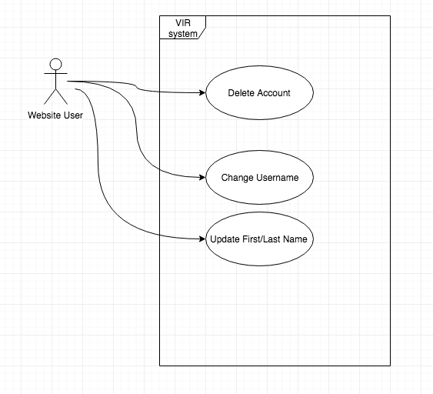

#### 

#### **User Account Management Class Diagram**

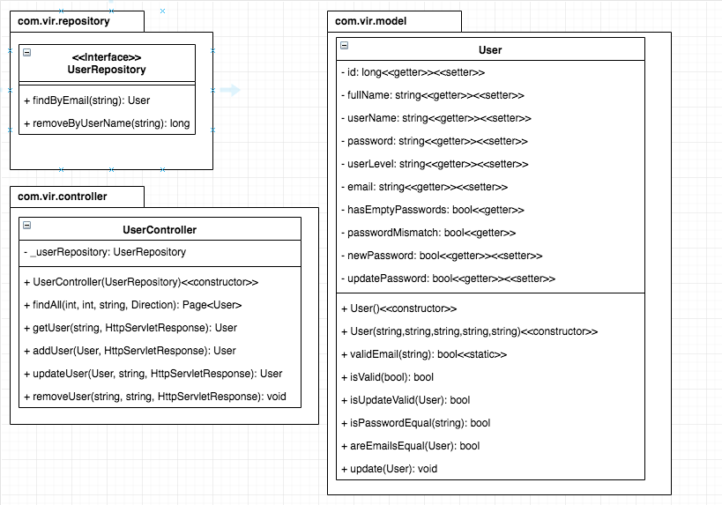

#### **OCR Image Reading Use Case Diagram**

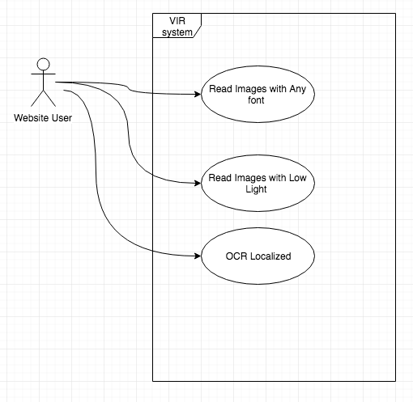

#### **OCR Image Reading Class Diagram**

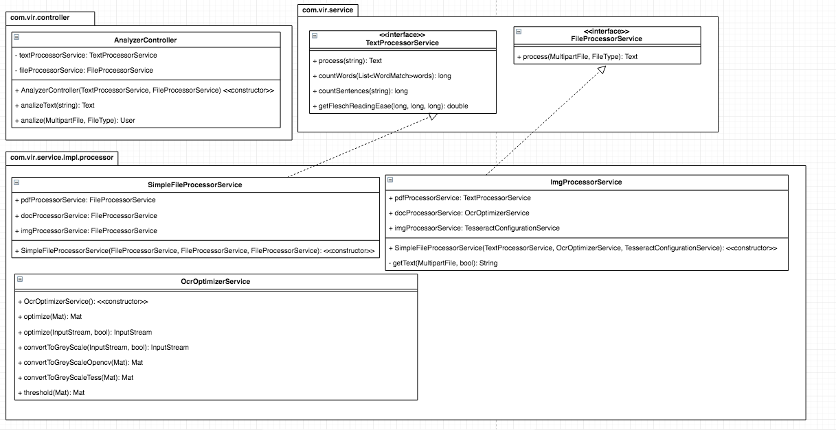

### 

#### **Invalid Username Use Case Diagram**

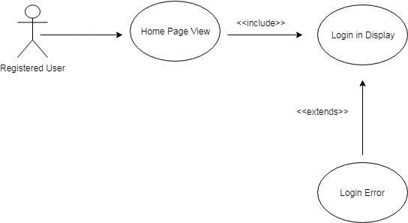

#### **EWL Access, Category, Search, Definition Use Case Diagram**

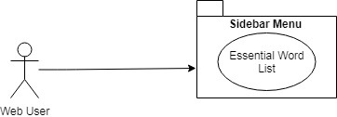

#### **EWL Access, Category, Search, Definition UML Class Diagram**

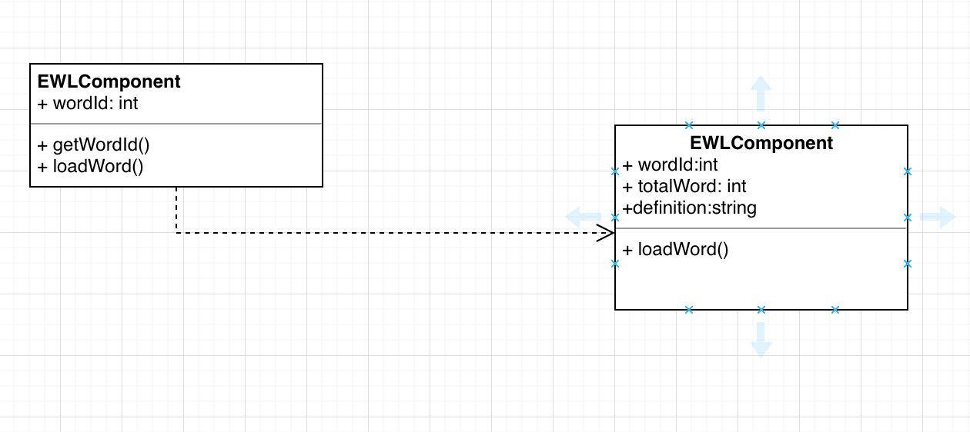

#### **Login After Registration Use Case Diagram**

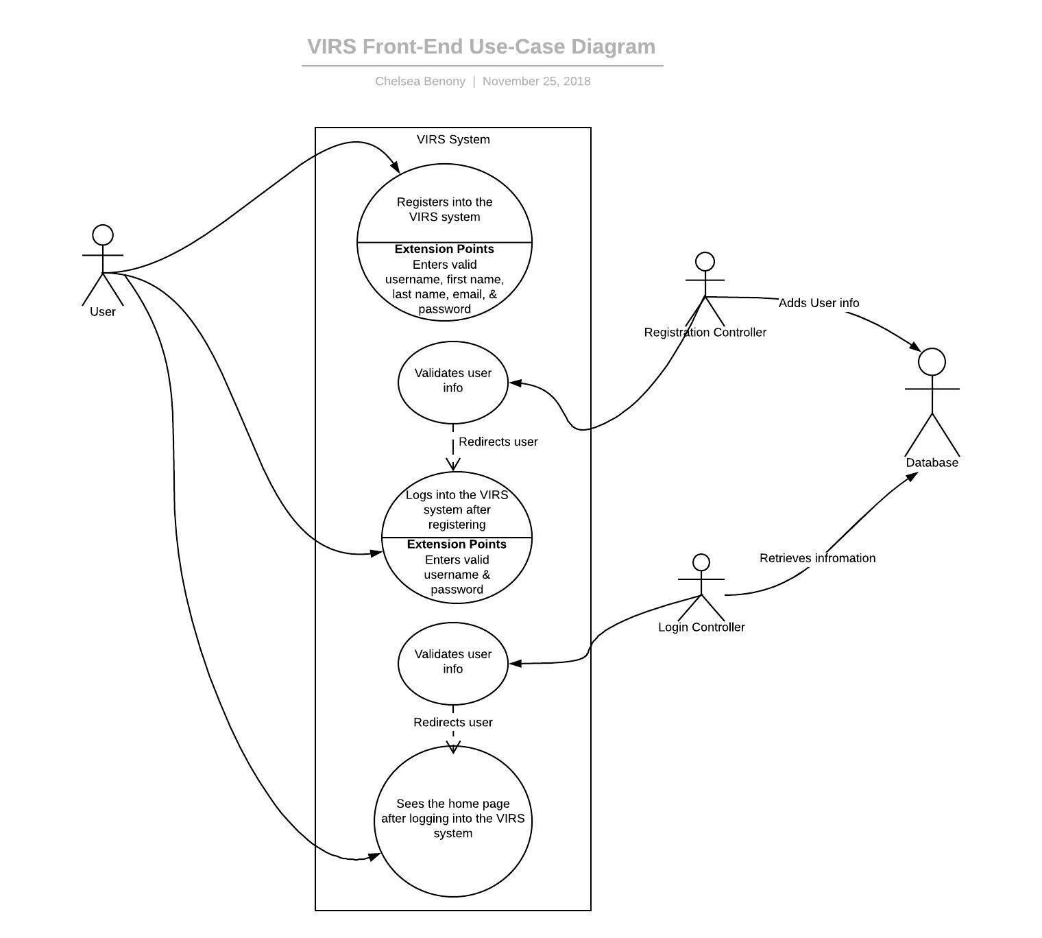

#### **Login After Registration Class Diagram**

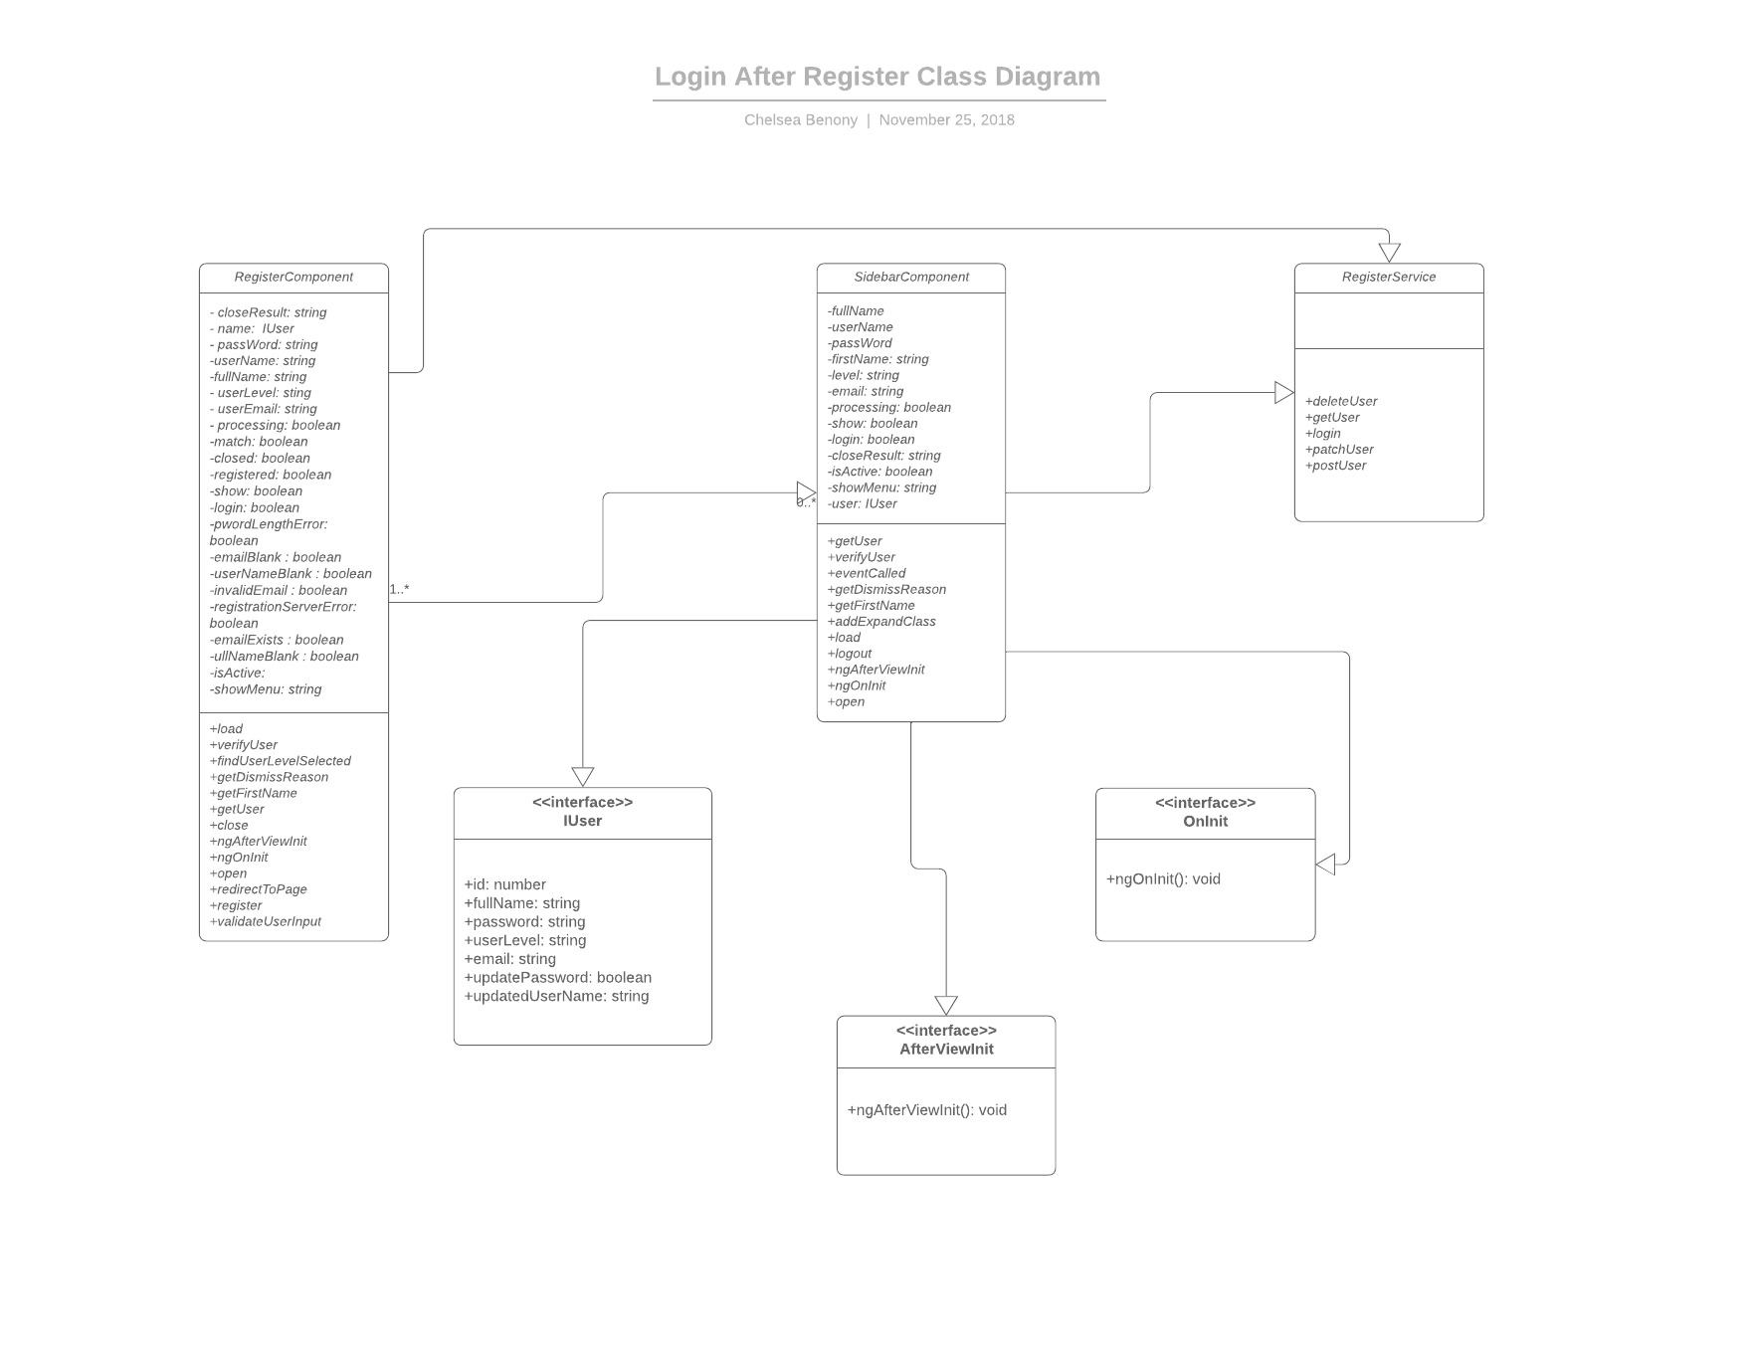

#### **Change Password**

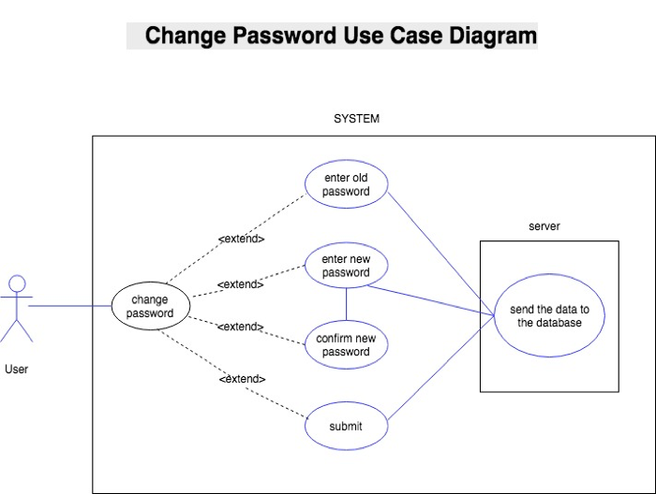

#### **UML Class Diagram for Backend: Change Password**

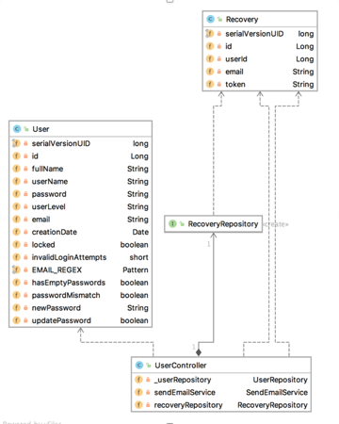

#### **UML Class Diagram for Frontend: Change Password**

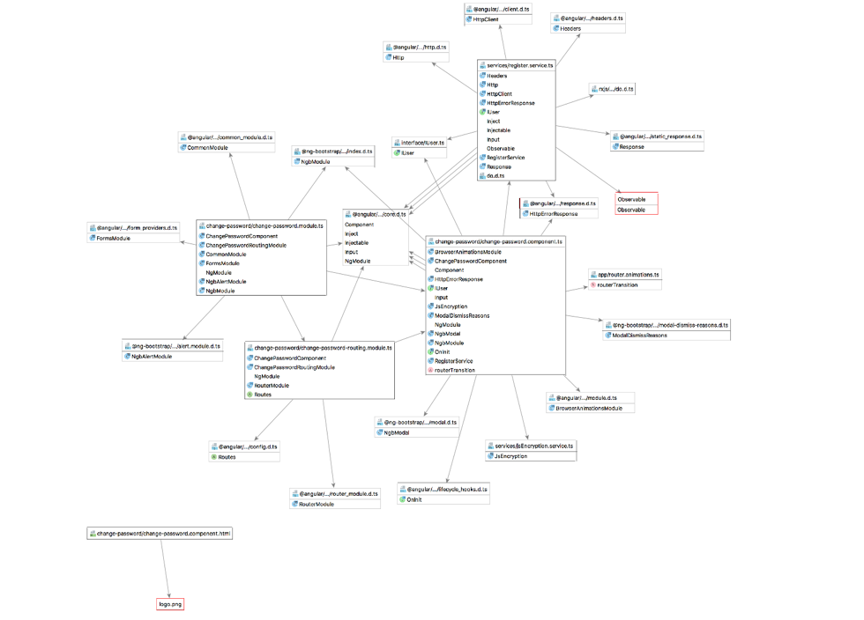

#### **Enter Username Use Case**

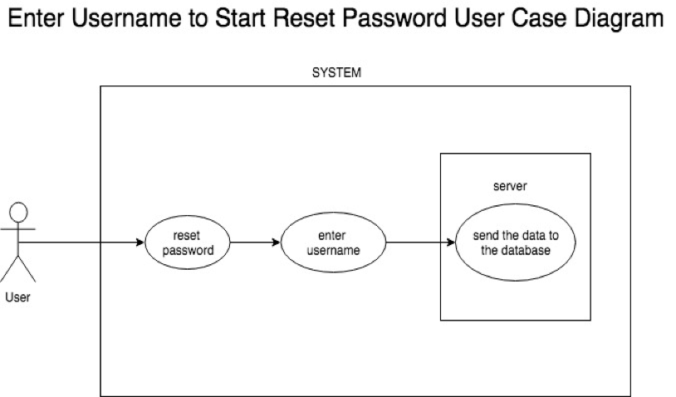

#### **Enter Username Class Diagram**

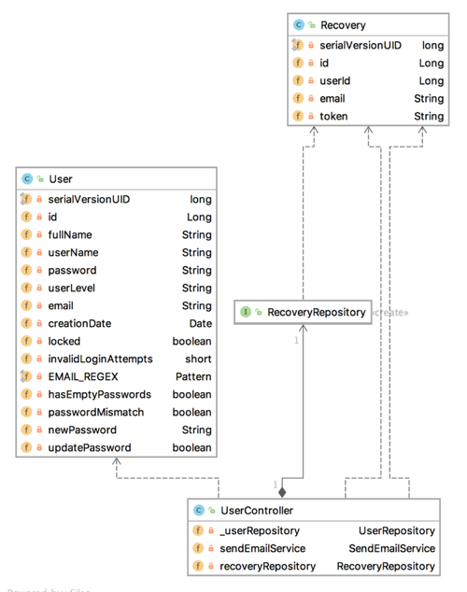

#### **Enter Username to Star Reset password Class Diagram**

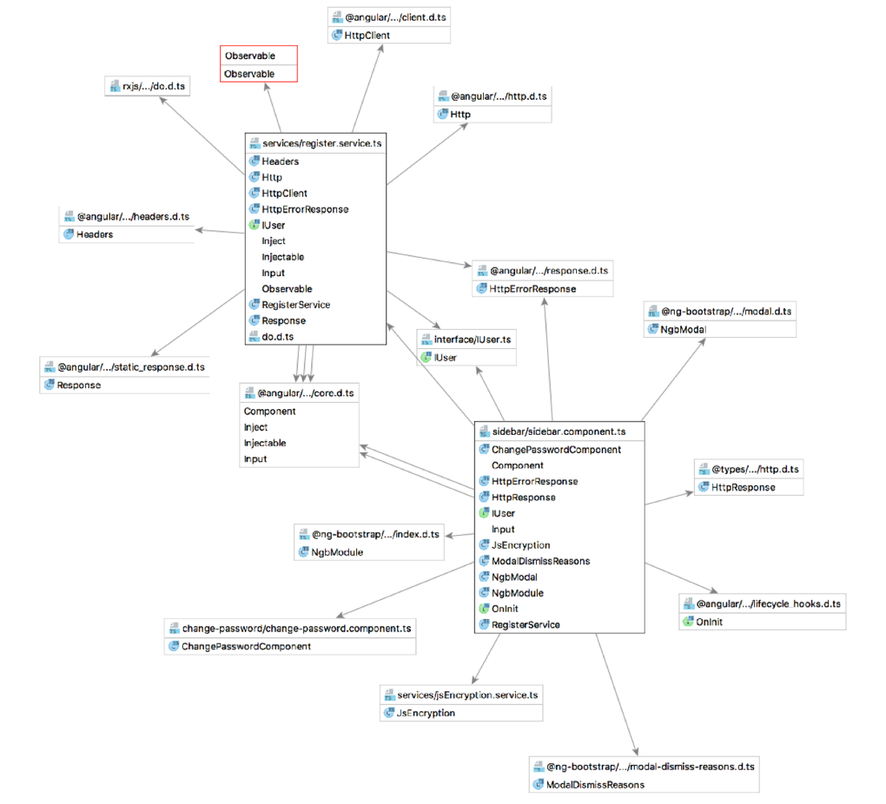

#### **Email Link Use Case**

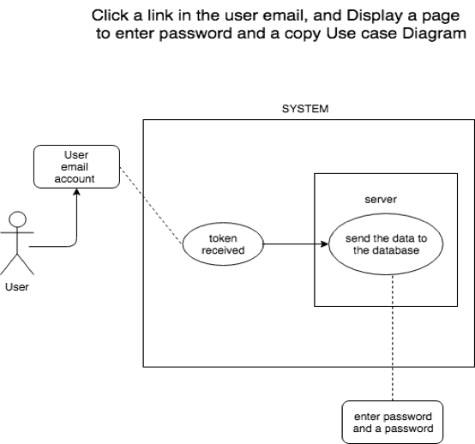

#### **Email Link Class Diagram**

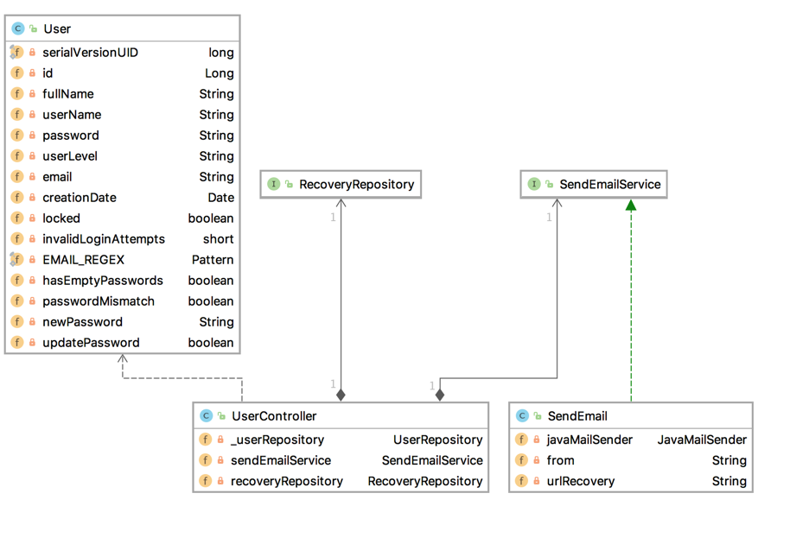

#### **Submit Password Use Case**

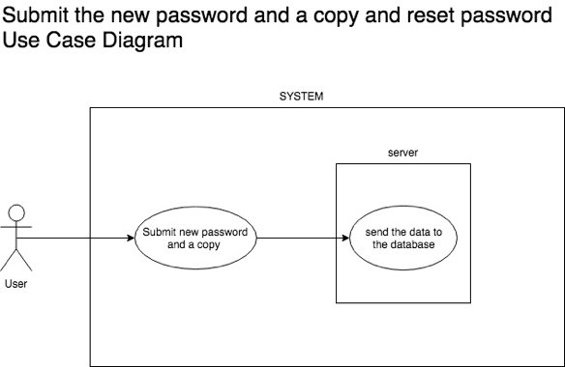

#### **Submit Password Class Diagram**

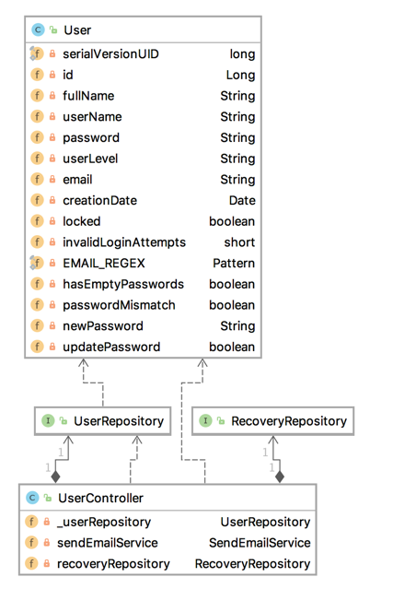

#### **Submit New Password & Copy UML Class Diagram for Frontend**

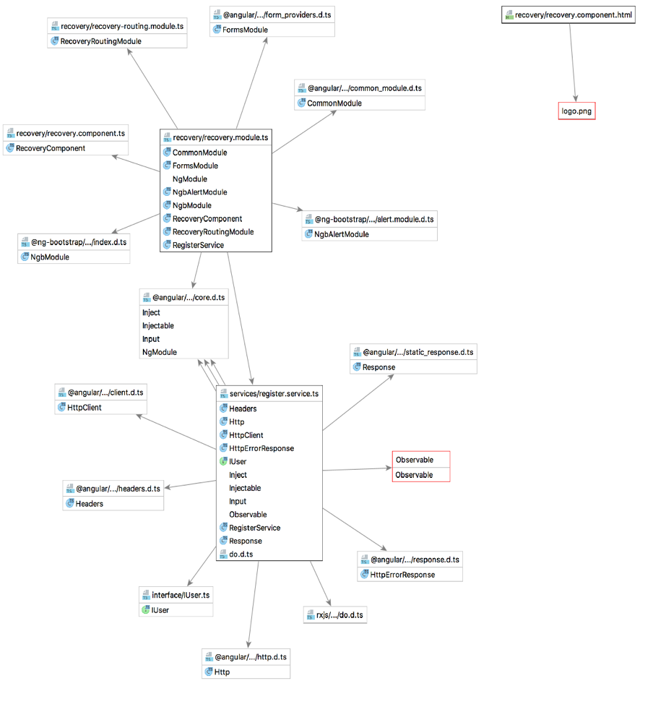

#### **Enter Email Use Case Diagram**

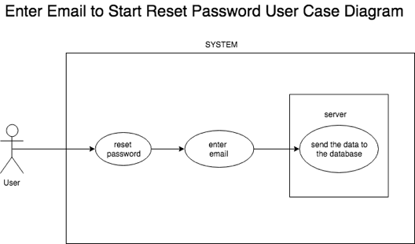

#### **Enter Email & Start Reset Password UML Class Diagram for Frontend**

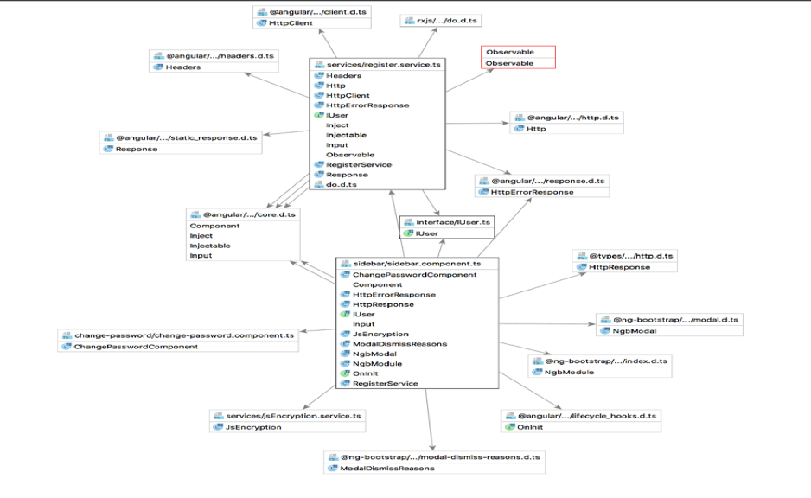

#### **Enter Email & Start Reset Password UML Class Diagram for backend**

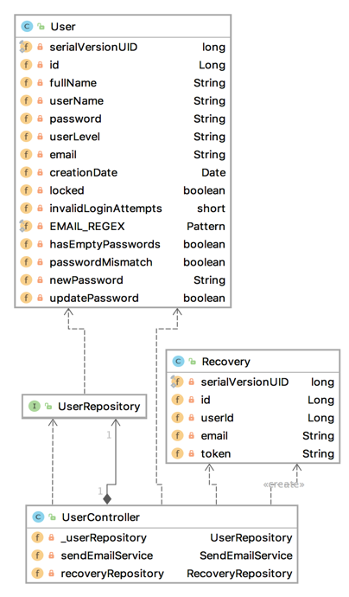

#### **Email Use Case**

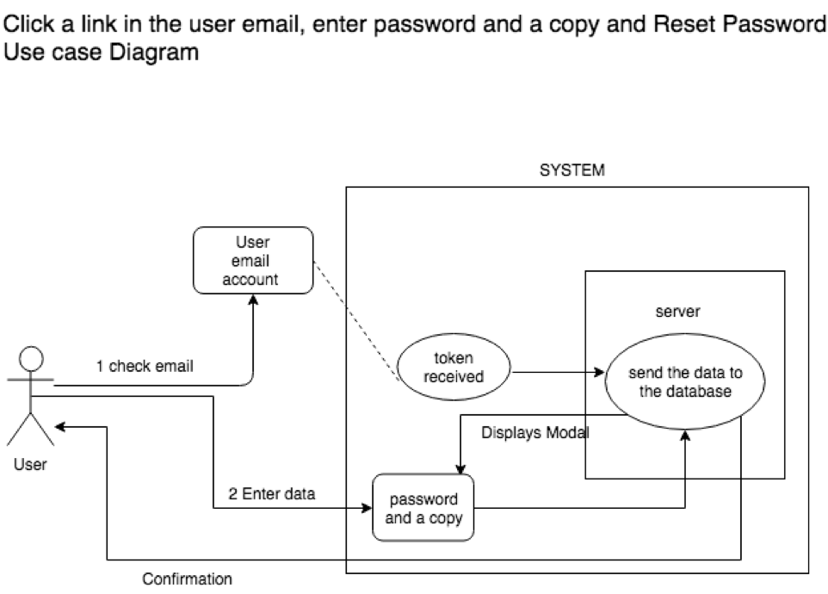

#### **UML Class Diagram for Backend: Clicks Link & Enter Password with Copy**

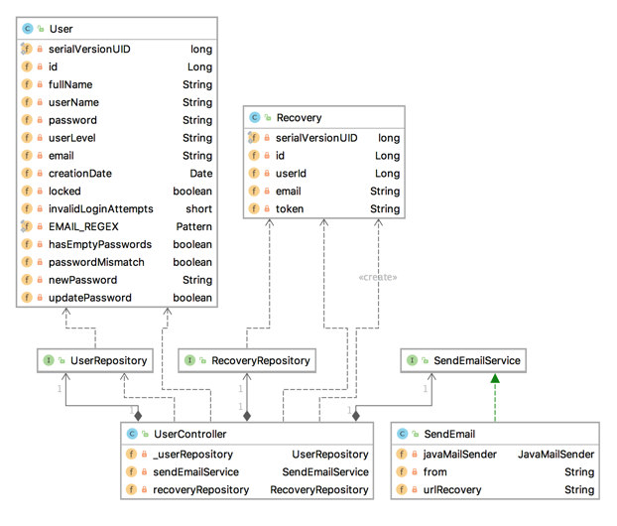

#### **UML Class Diagram for Frontend: Clicks Link & Enter password with Copy**

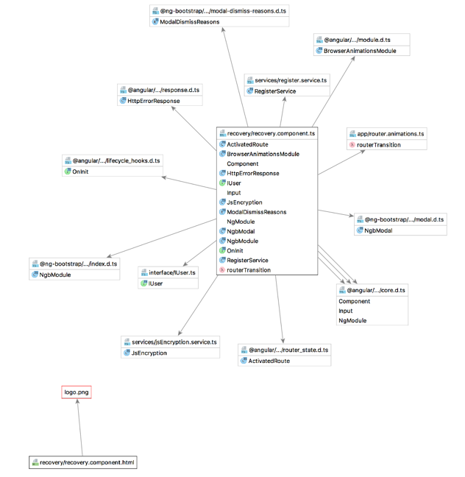

#### **UML Use Case Diagram**

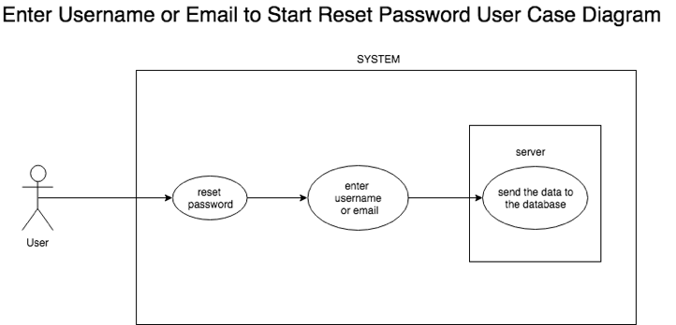

#### **UML Class Diagram for Frontend: Enter Username or Email to Star Reset Password**

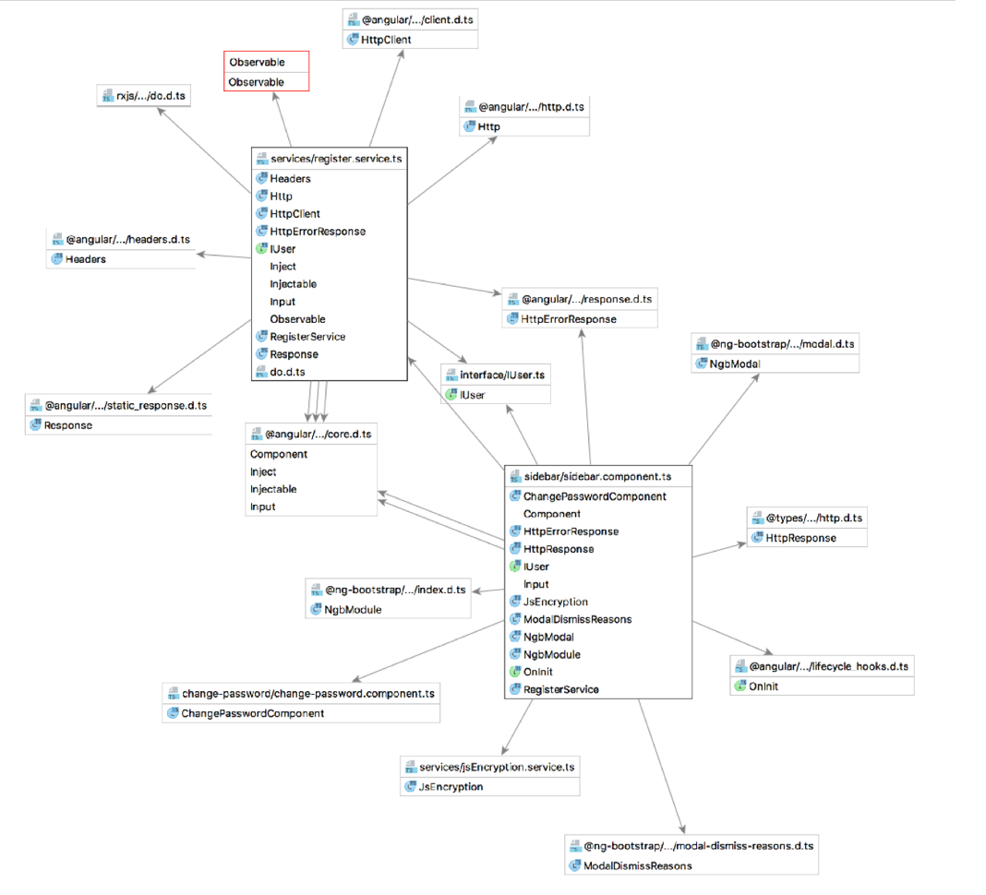

### 

#### **Dictionary Reference Update Use Case Diagram**

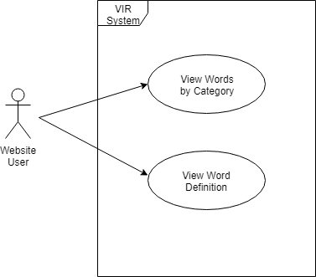

#### **UML Class Diagram for Backend: Dictionary Reference Update**

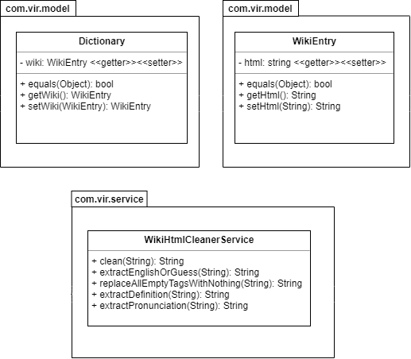

#### **Invalid Password Use Case Diagram**

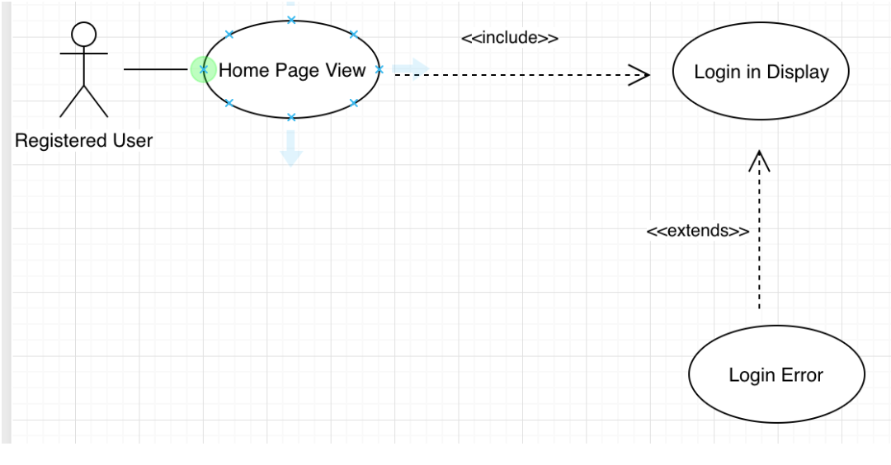

#### **Statistics Improvement Use Case Diagram**

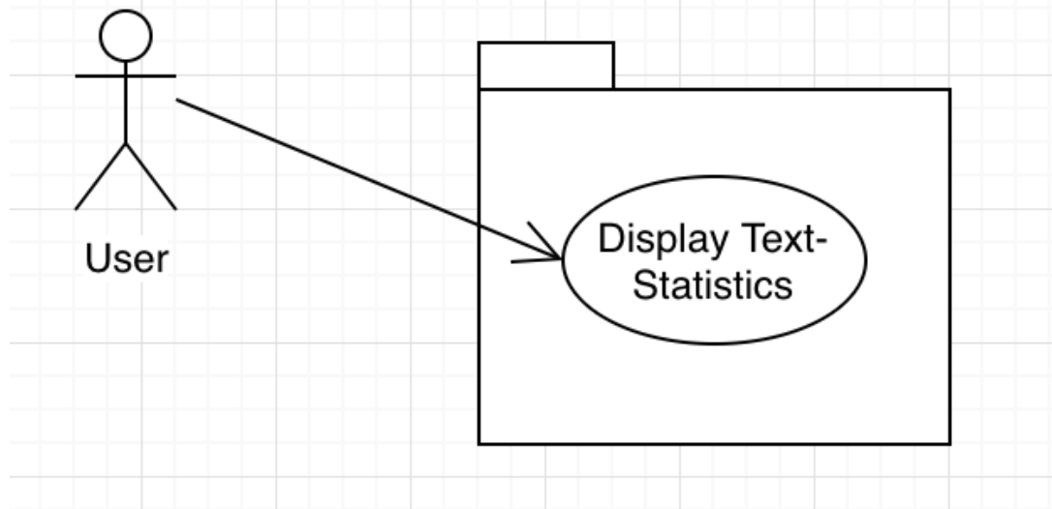

#### **EWL Use Case Diagram**

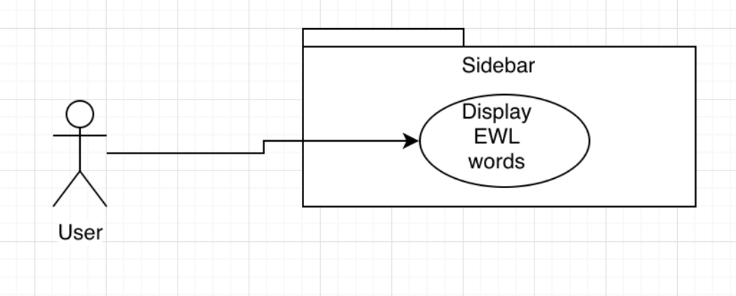

#### **Statistics Class Diagram**

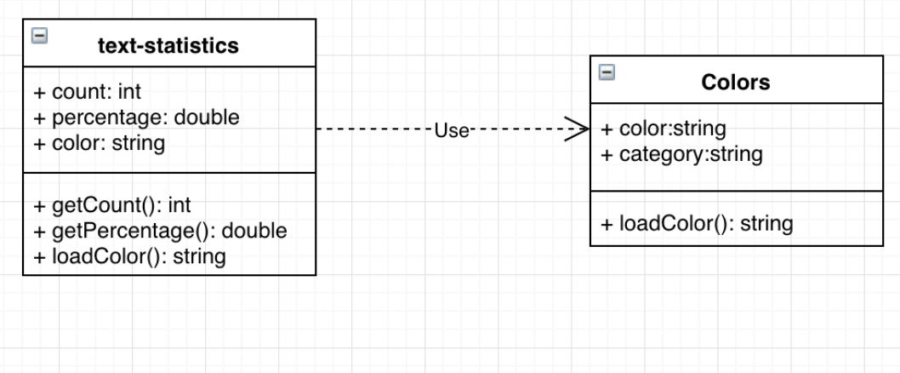

#### **EWL Class Diagrams**

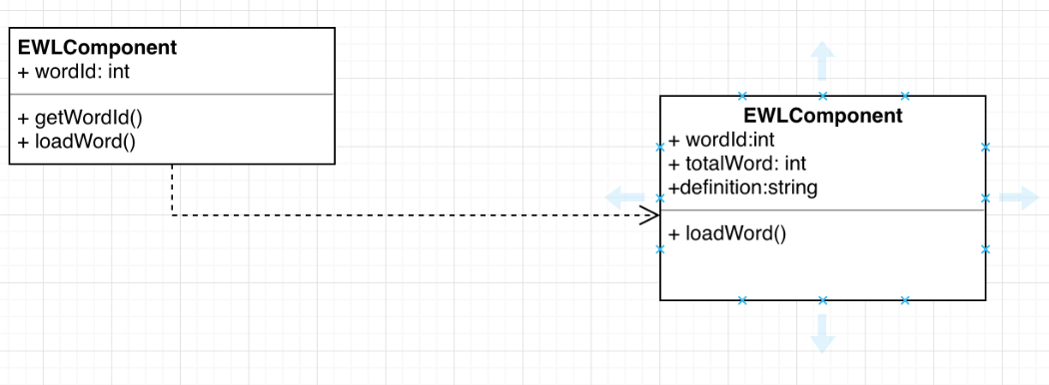

#### **Enhanced Text Use Case Diagram**

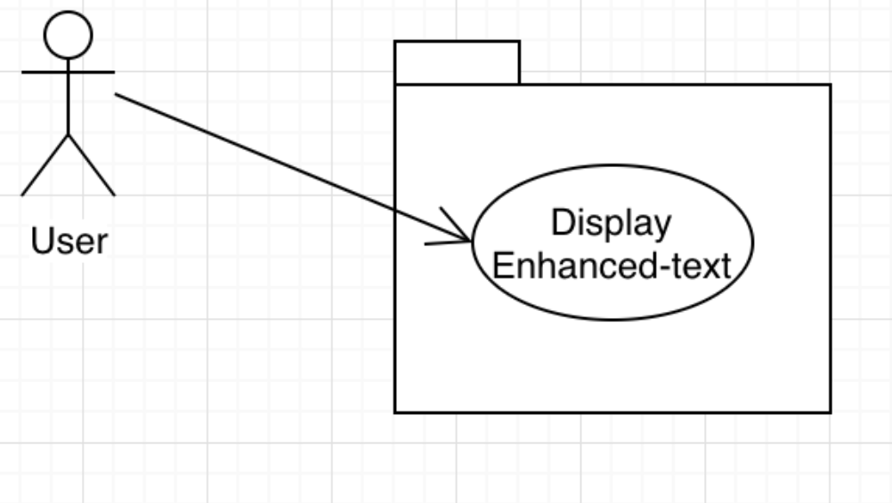

#### **Enhanced Text Class Diagram**

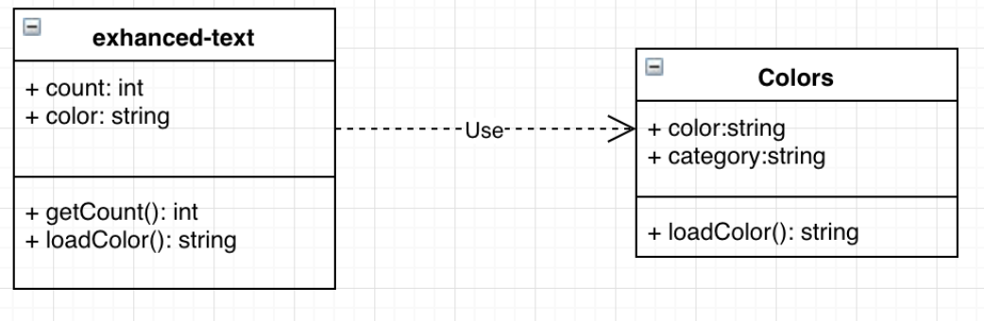

### **Dynamic UML Diagrams**

#### **Delete Account Sequence Diagram**

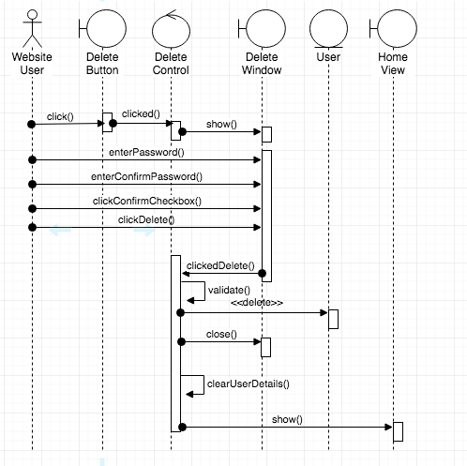

#### 

#### **OCR Localization Sequence Diagram**

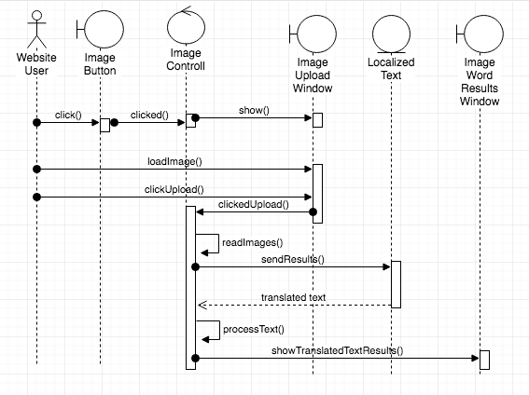

## 

#### **OCR Image Reading Sequence Diagram**

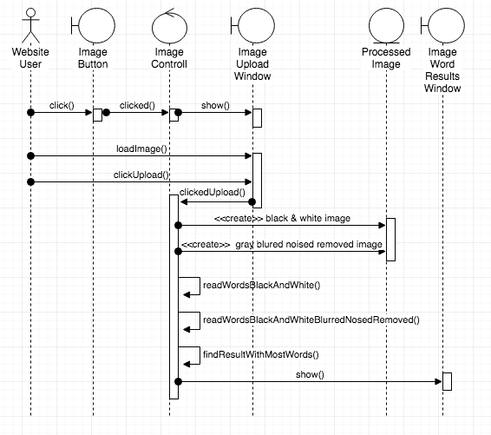

#### **Update Account Sequence Diagram**

#### 

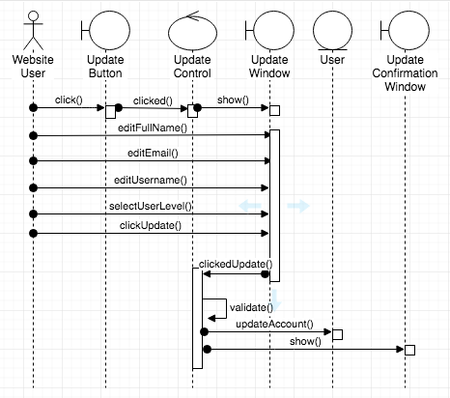

#### **Invalid Username Sequence Diagram**

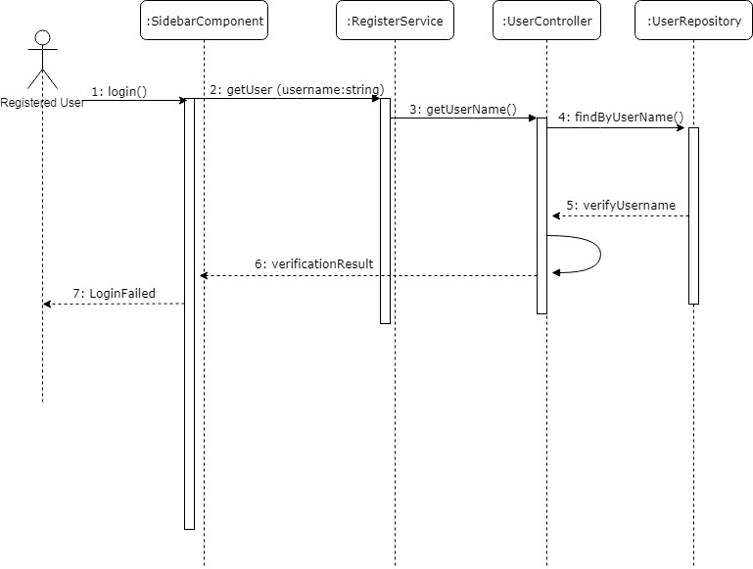

#### **EWL Access, Category, Search, Definition Sequence Diagram**

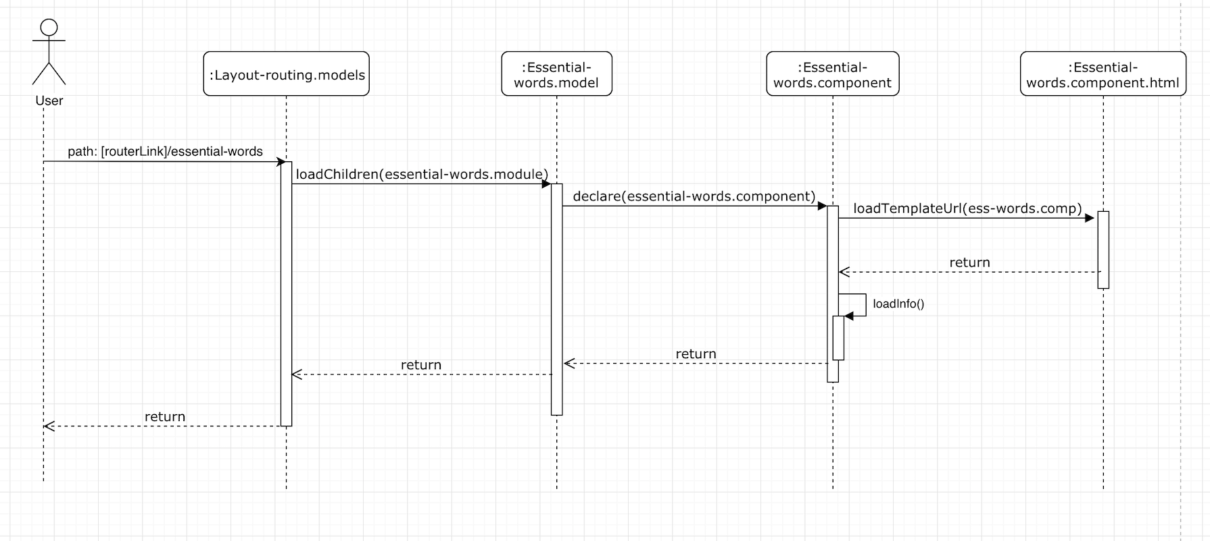

#### **Invalid Password Sequence Diagram**

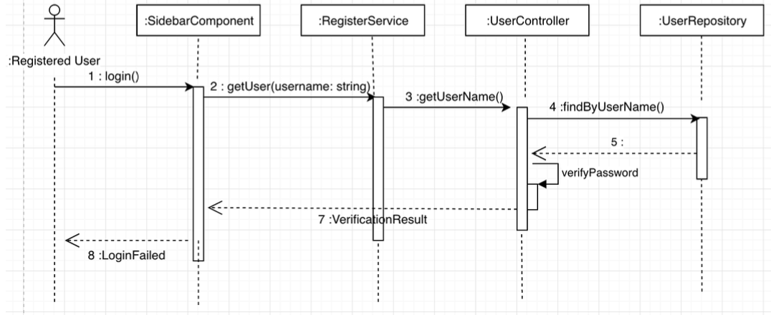

#### **Statistics Sequence Diagram**

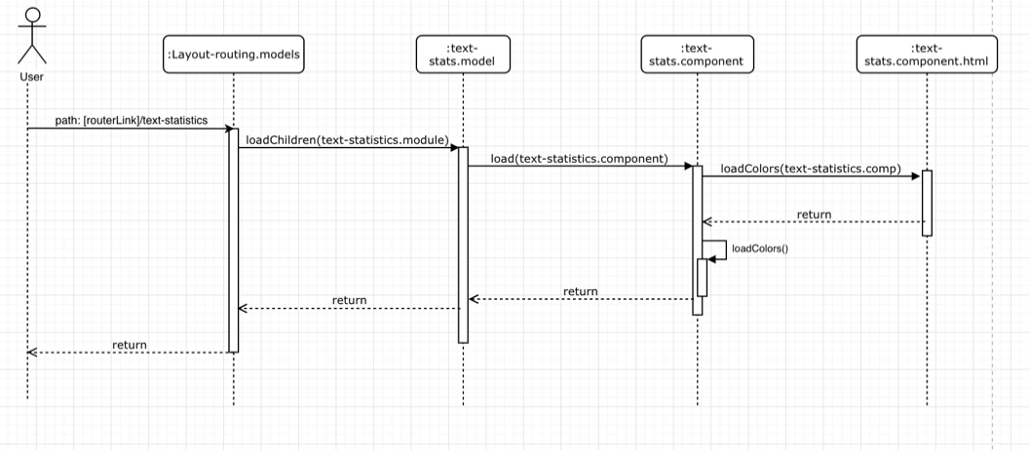

#### **EWL Sequence Diagram**

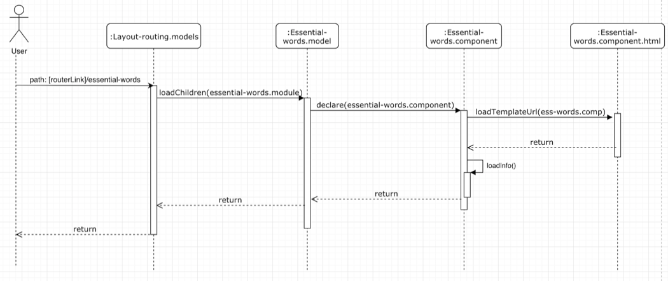

#### **Enhanced Text Sequence Diagram**

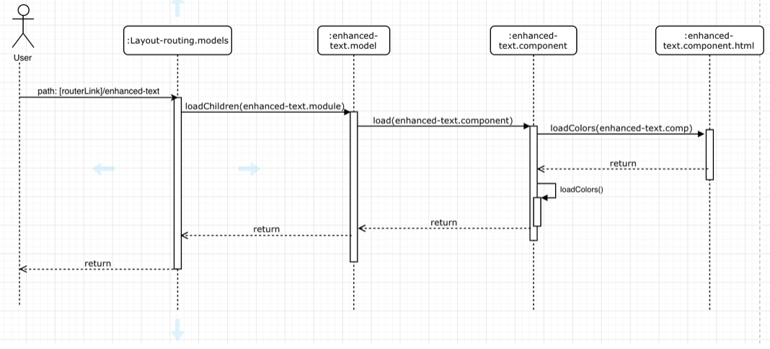

#### **Change Password Sequence Diagram**

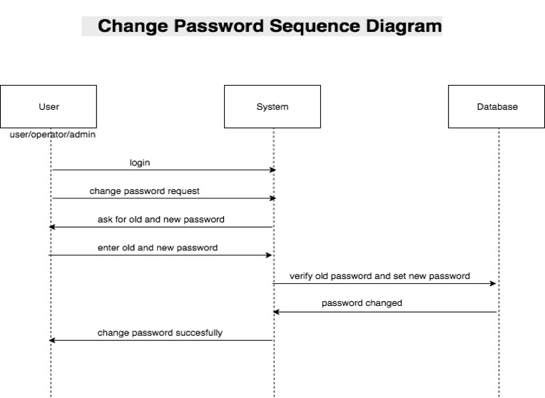

#### **Enter Username Sequence Diagram**

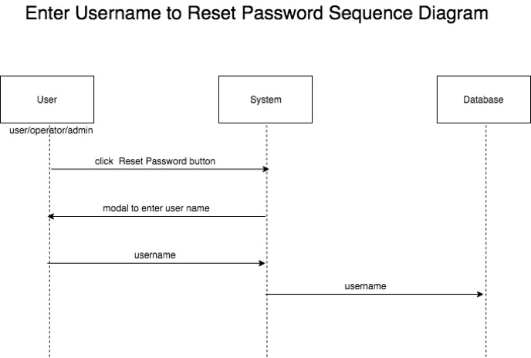

#### **Click Link Sequence Diagram**

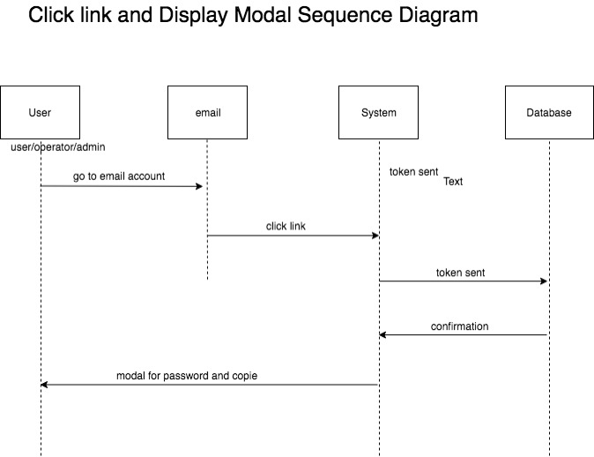

#### **New Password Sequence Diagram**

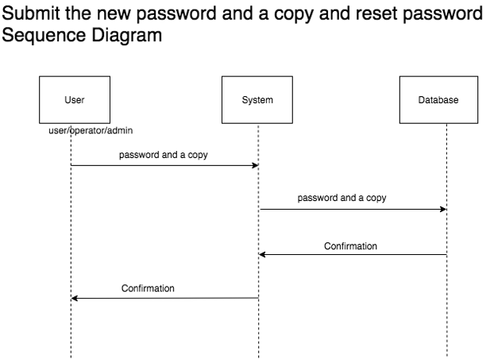

#### **Email Password Reset Sequence Diagram**

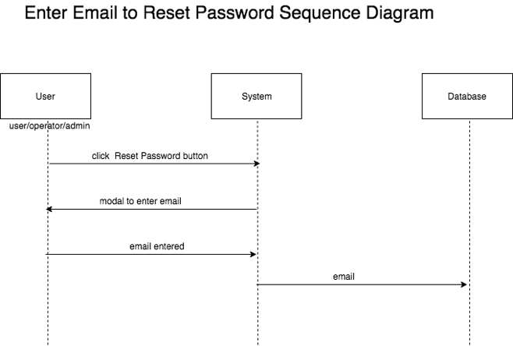

#### **Click Link Sequence Diagram**

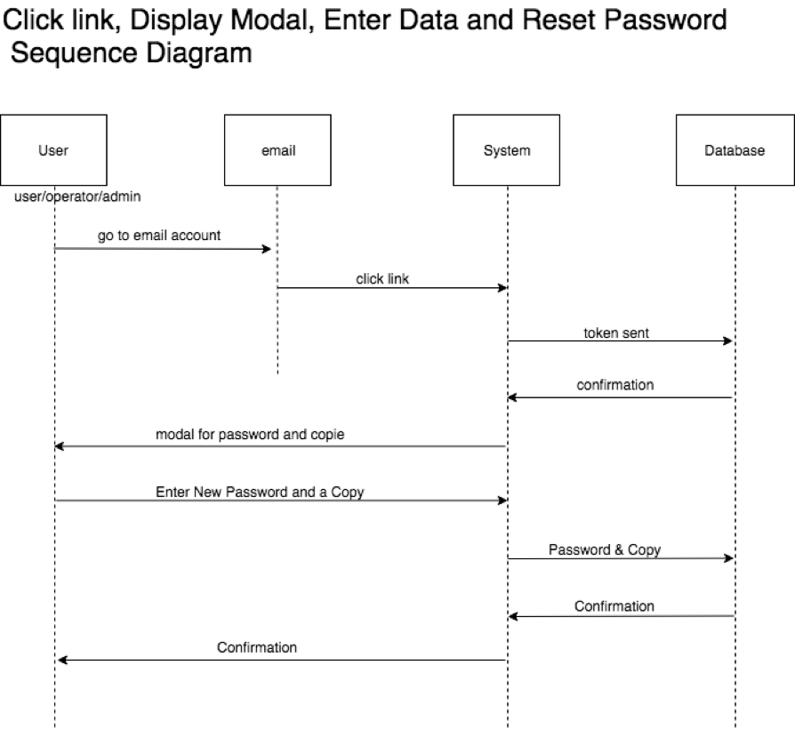

#### **Enter Username Sequence Diagram**

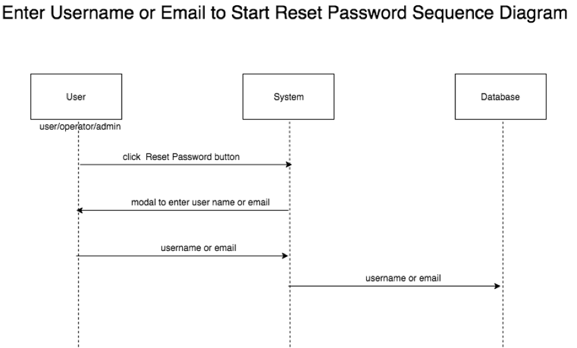

#### 

#### **Login After Registration Sequence Diagram**

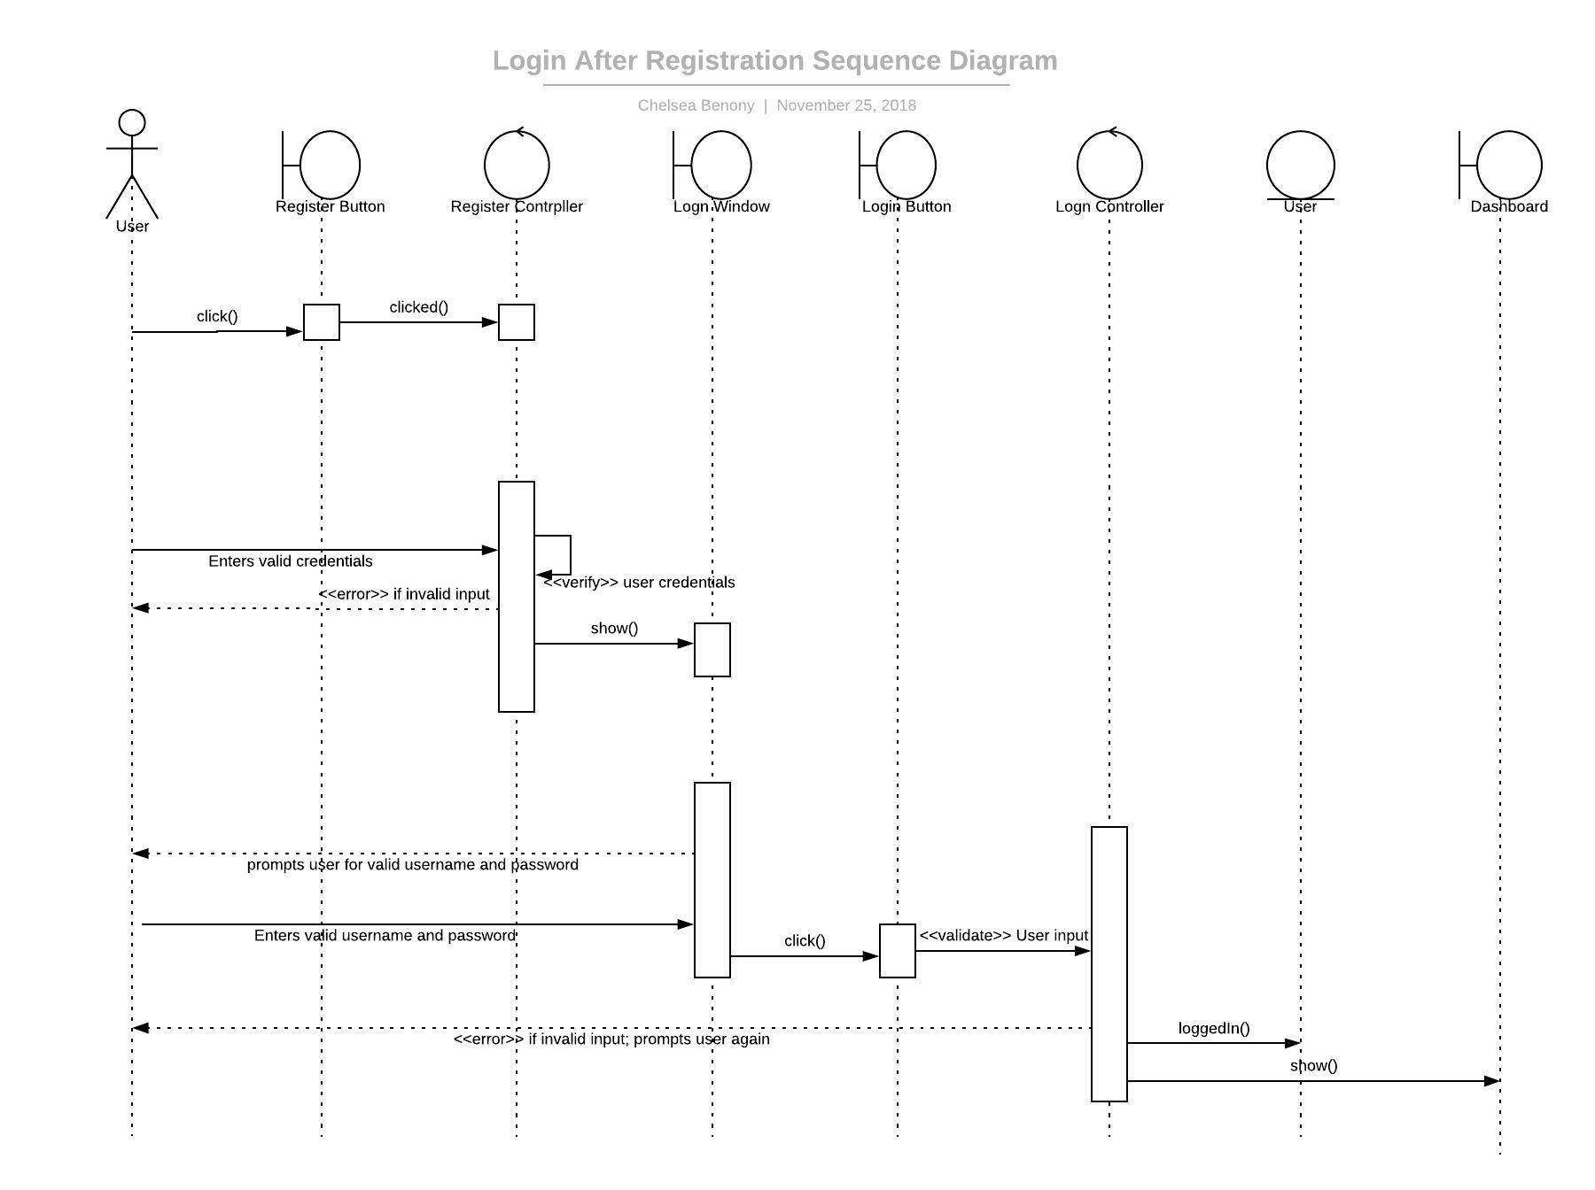

#### **Dictionary Reference Update Sequence Diagram**

#### **Dictionary Reference Update Sequence Diagram**

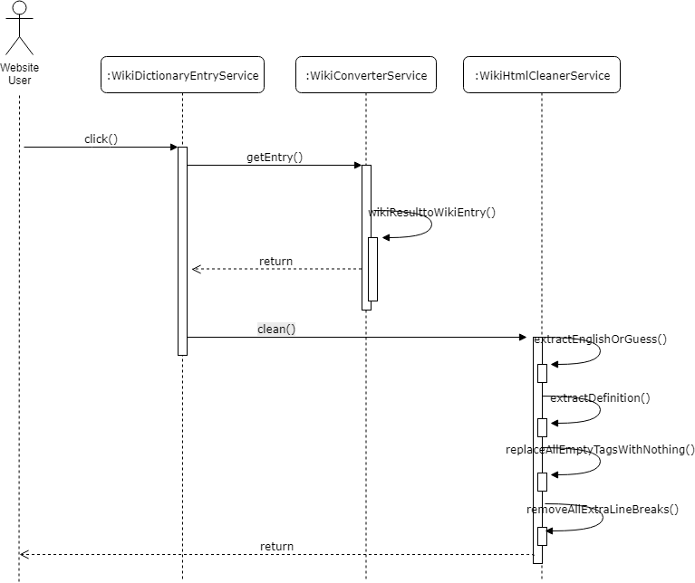

## Appendix B - User Interface Design

### **Delete Account**

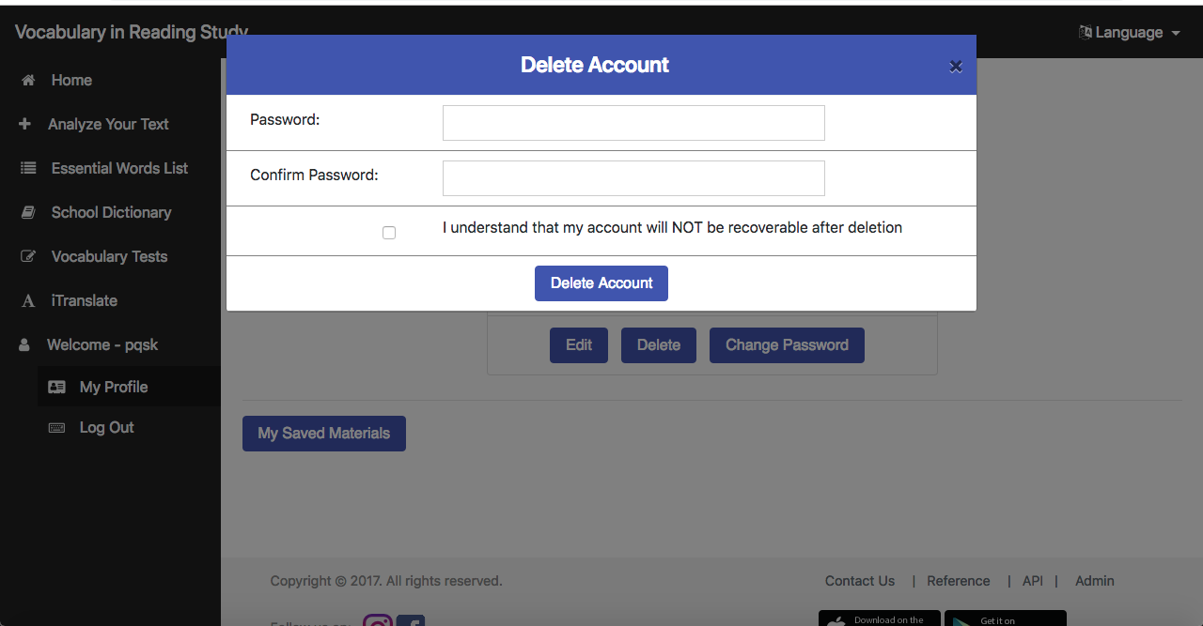

## 

### **OCR Localization**

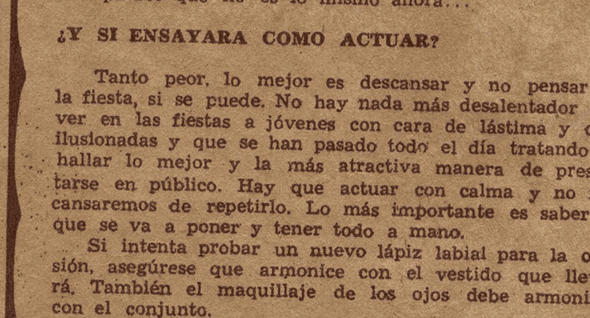

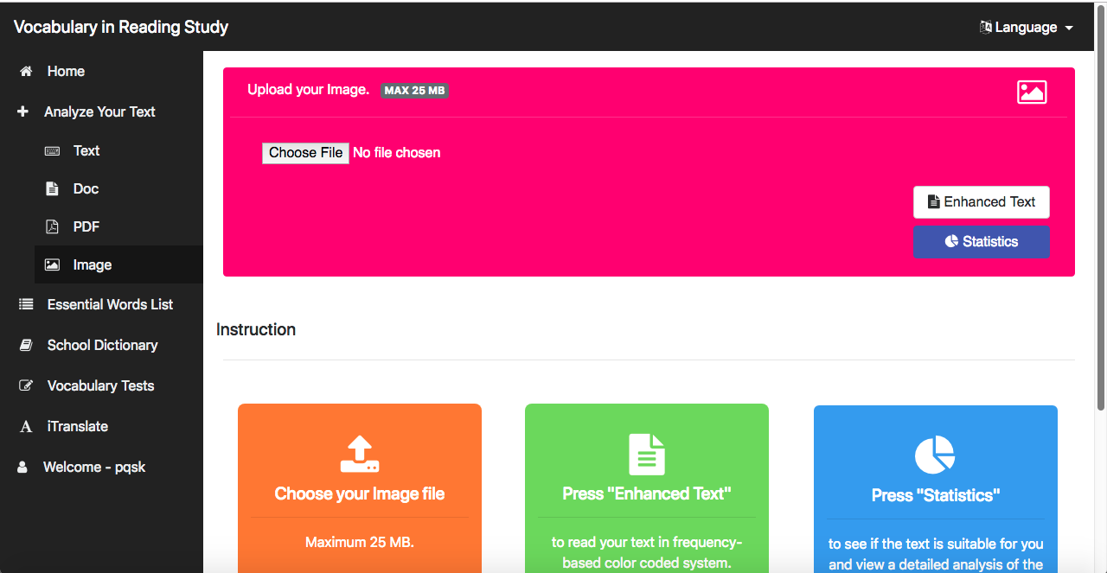

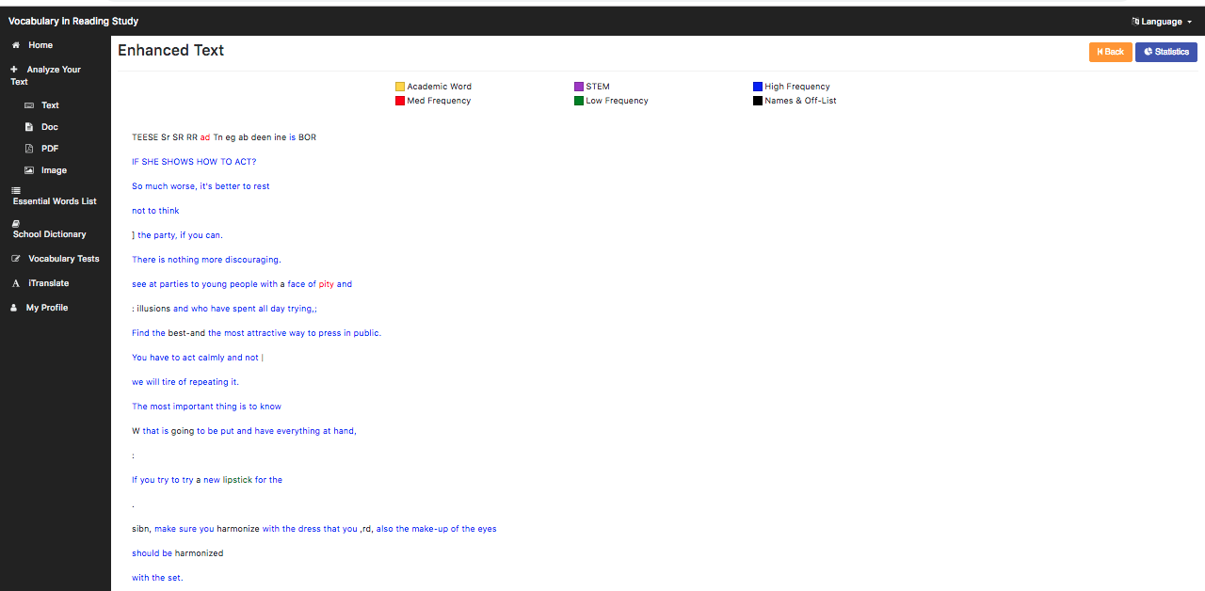

### **OCR Image Reading**



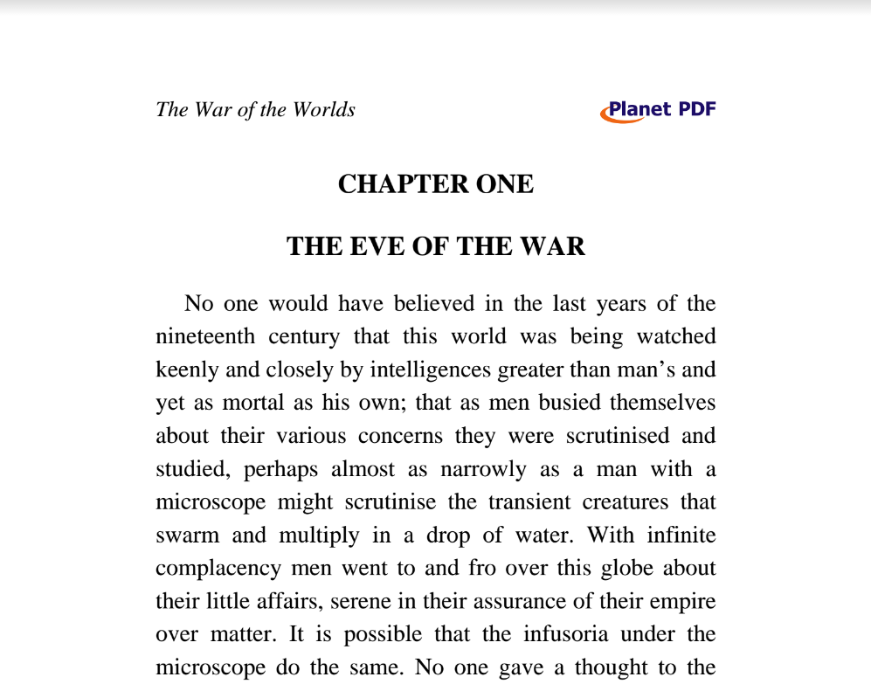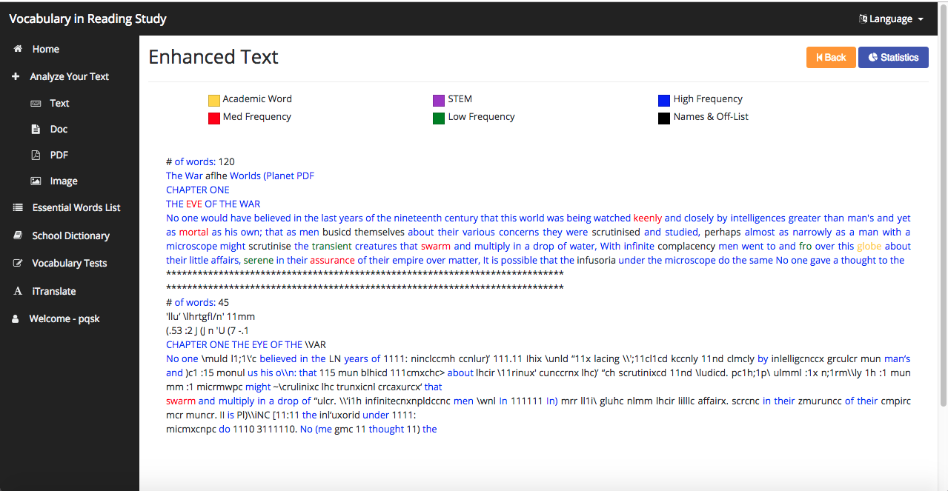

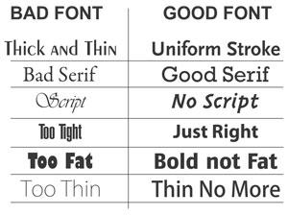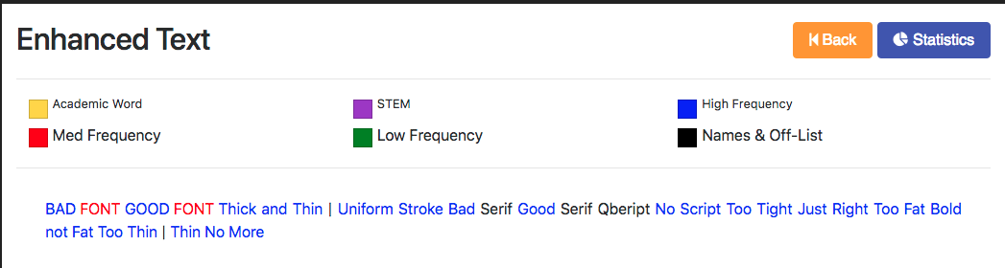

### **Update Account**

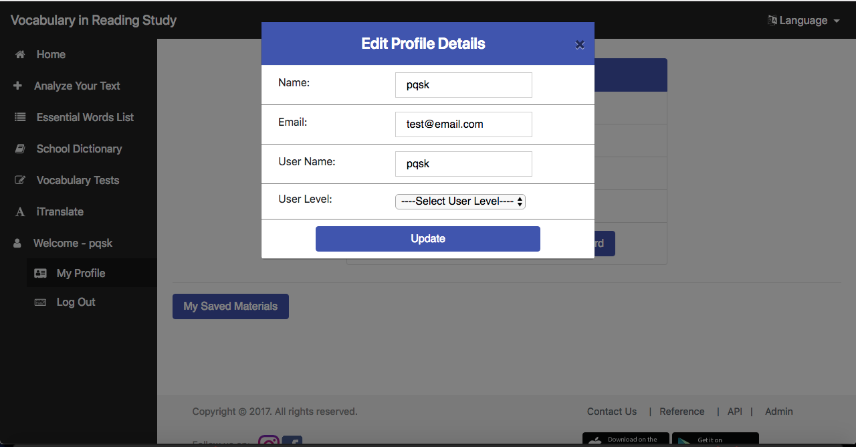

### **Invalid Username**

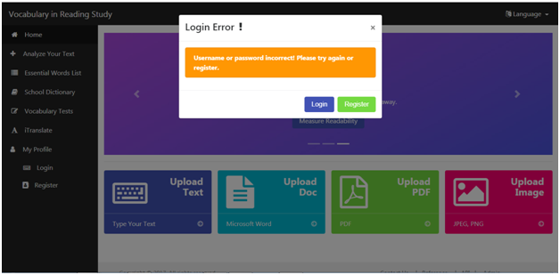

### **EWL Access**

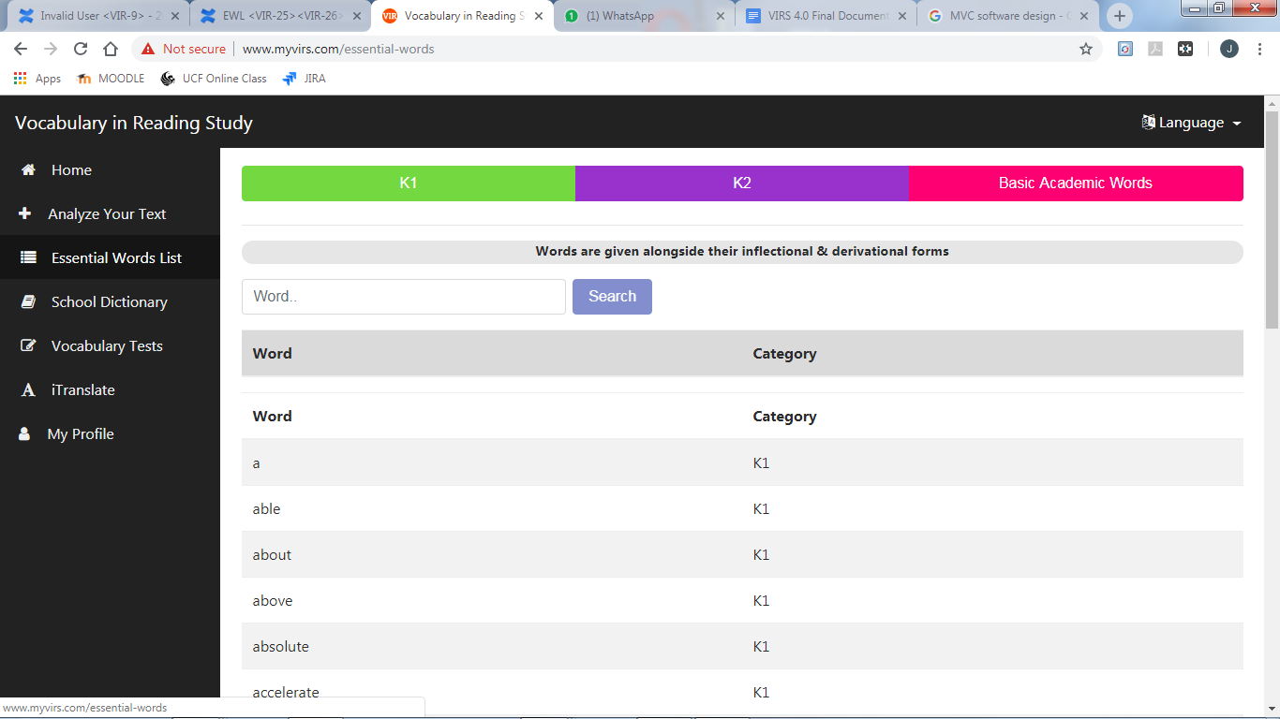

### 

### **EWL Categories**

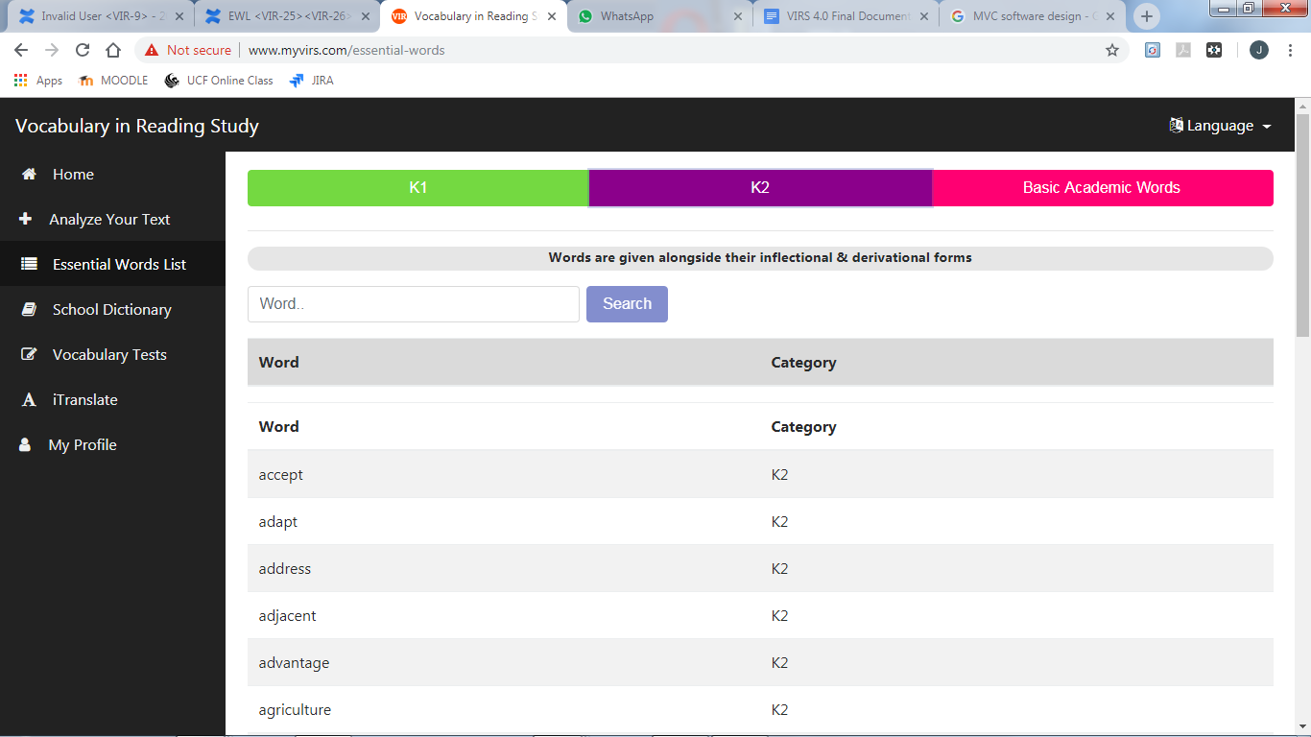

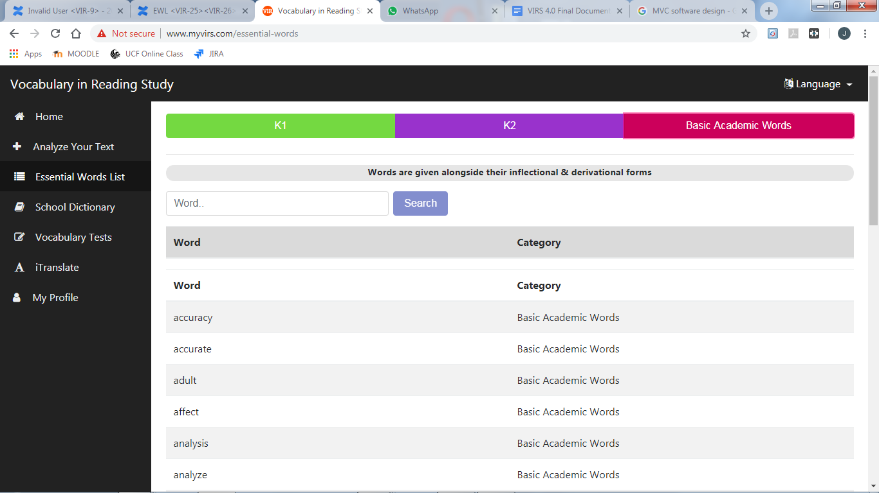

### **EWL Search**

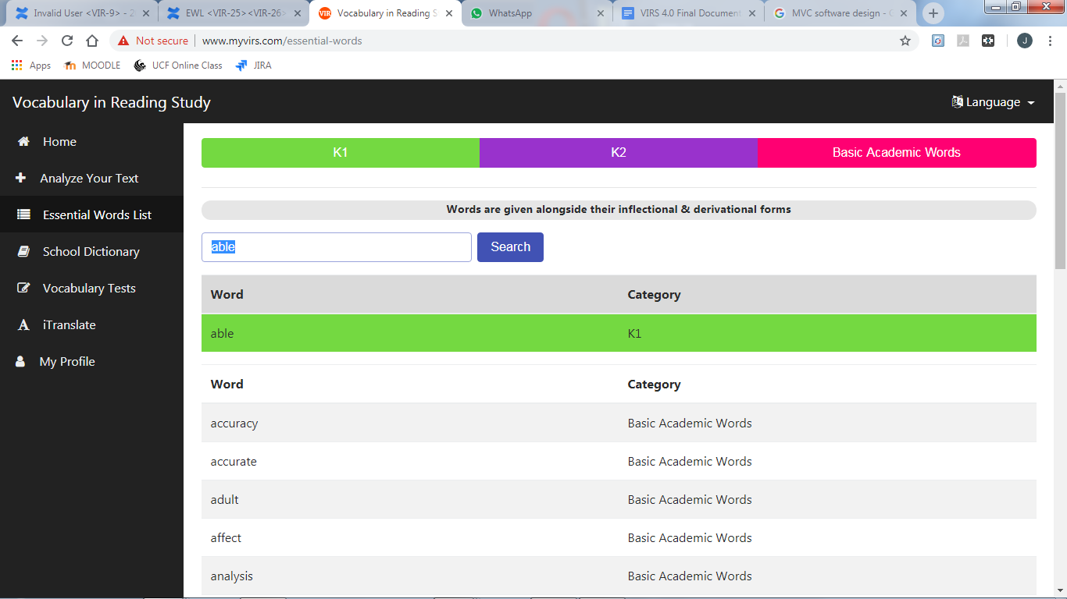

### 

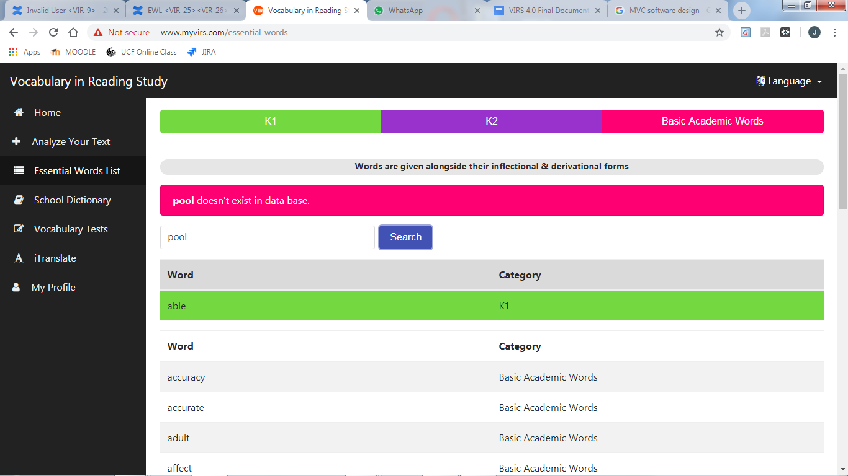

### **EWL Definition**

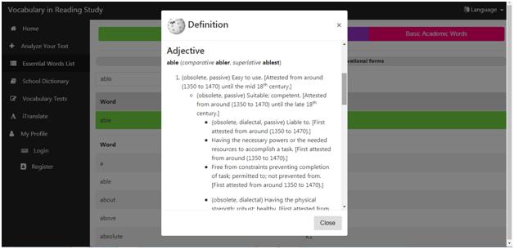

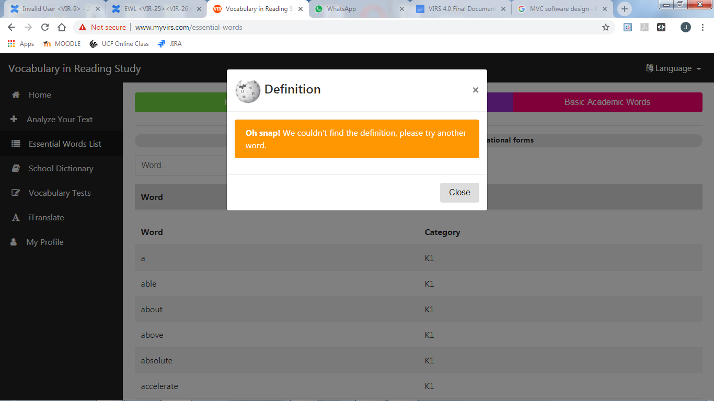

### **Output Text Only**

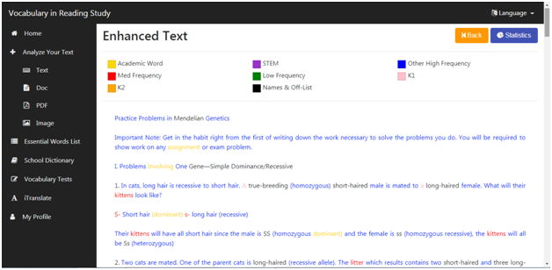

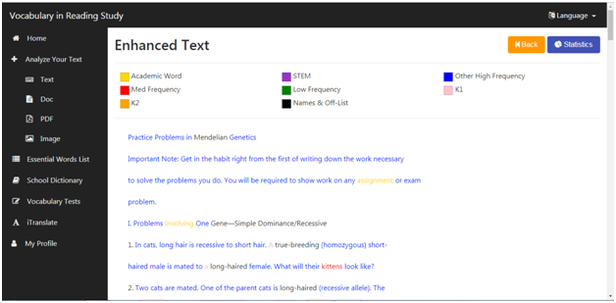

### **Login error**

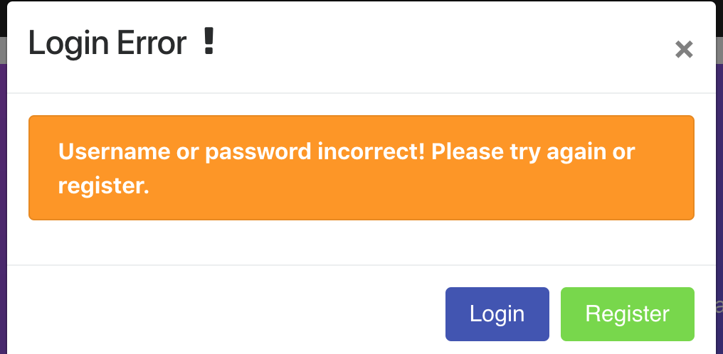

**Enhanced Text**

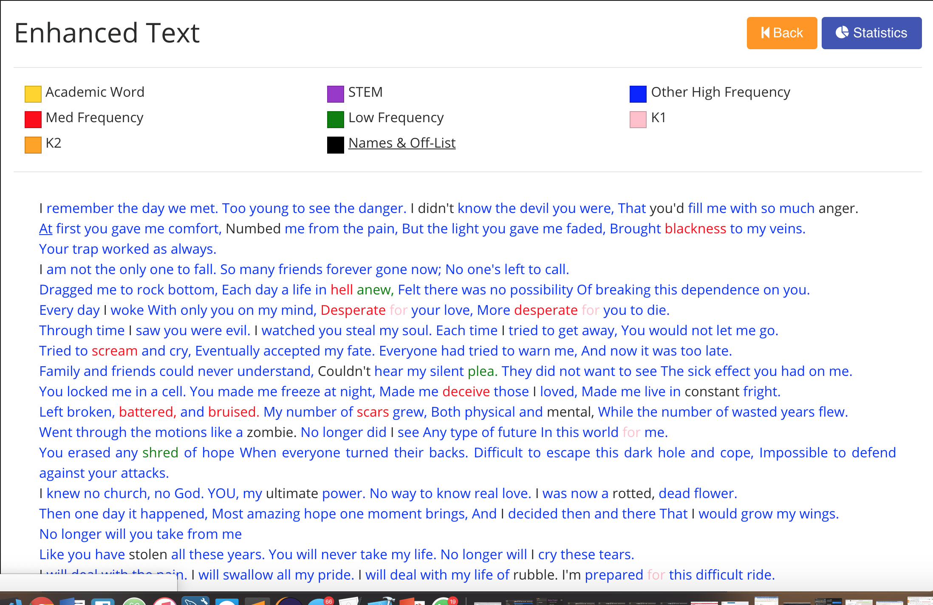

### **Statistics**

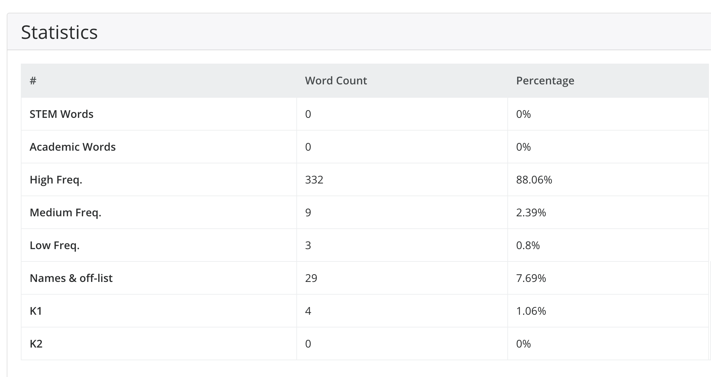

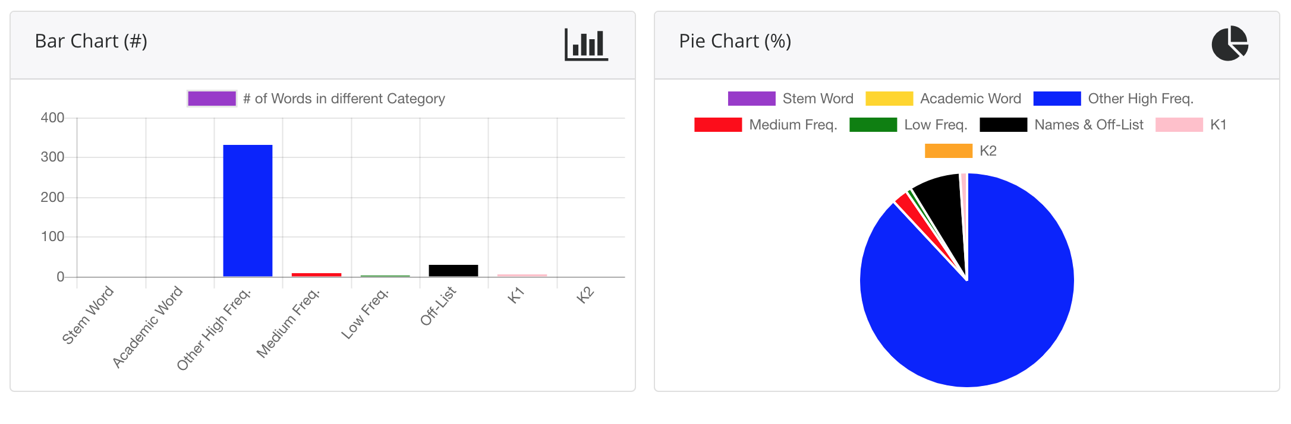

### **Login After Registration**

Dashboard Screenshot

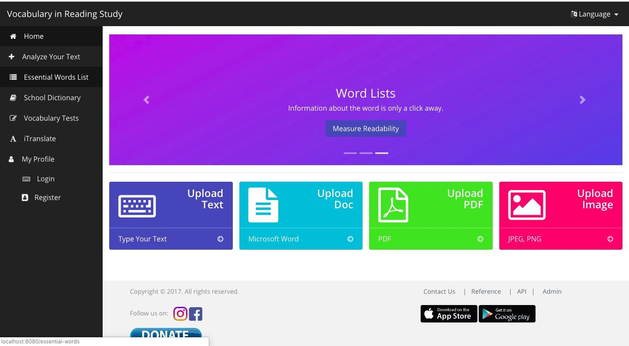

Registration Form Screenshot

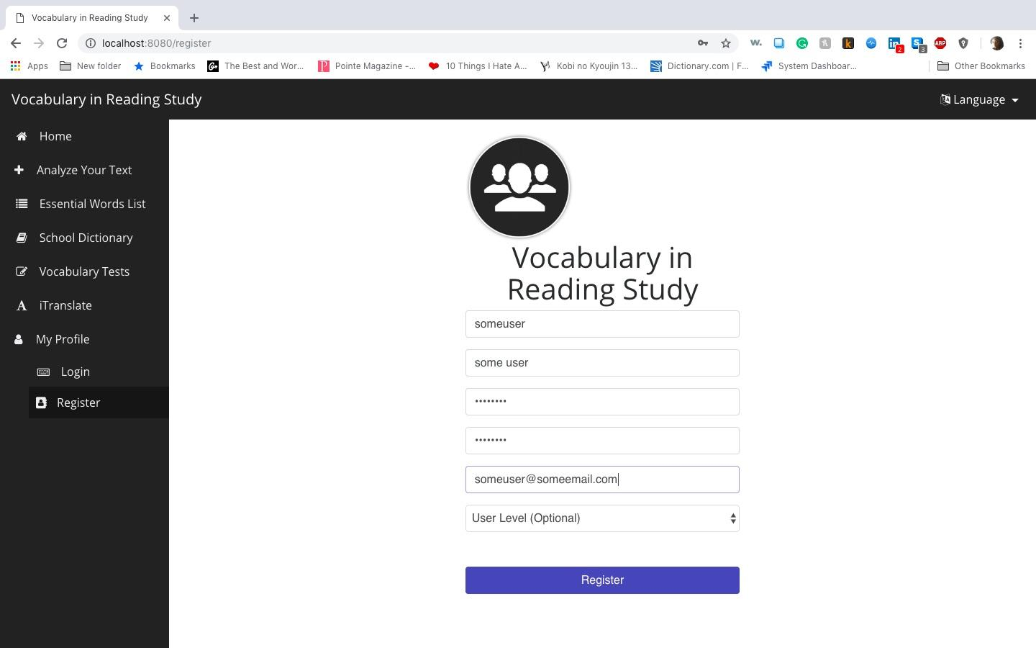

#### 

Login Screenshot

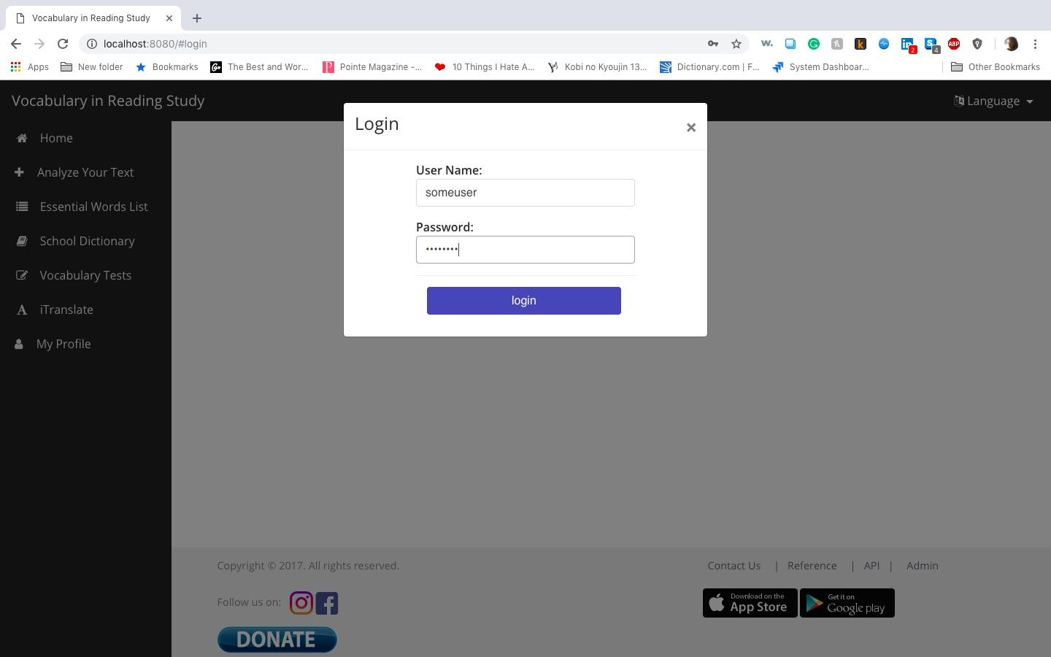

Dashboard After Login Screenshot

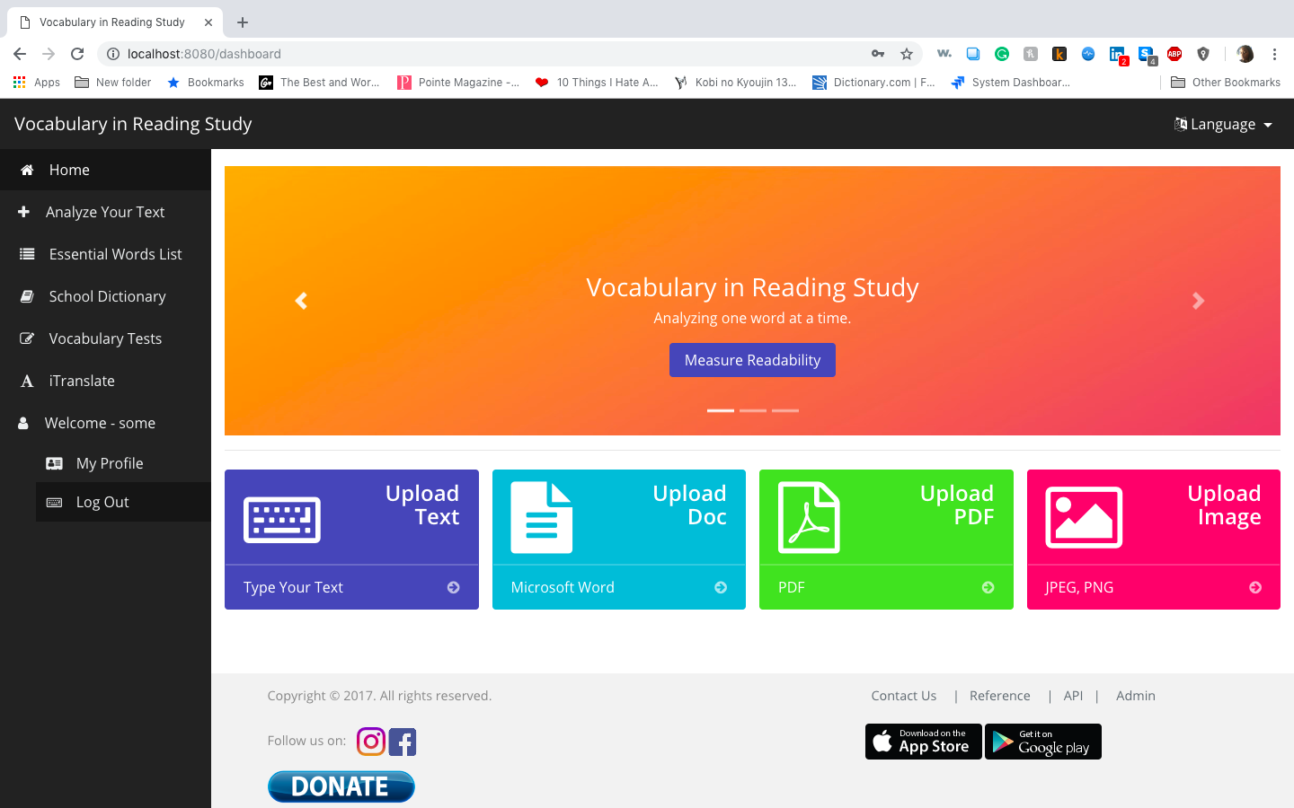

### **Email Required Screenshot**

Invalid Email Entered Screenshot

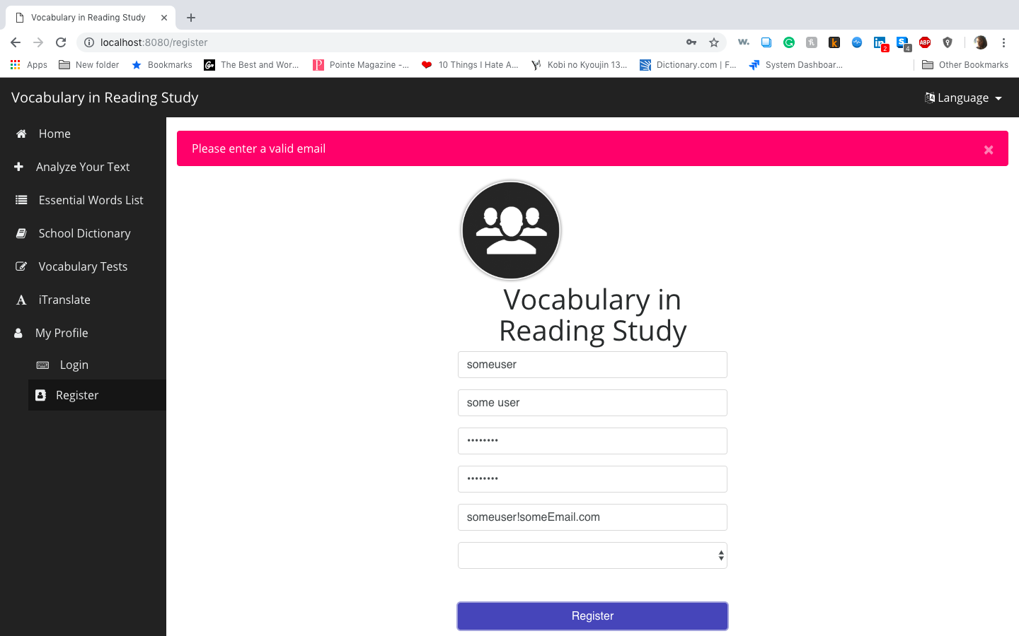

Blank Email Screenshot

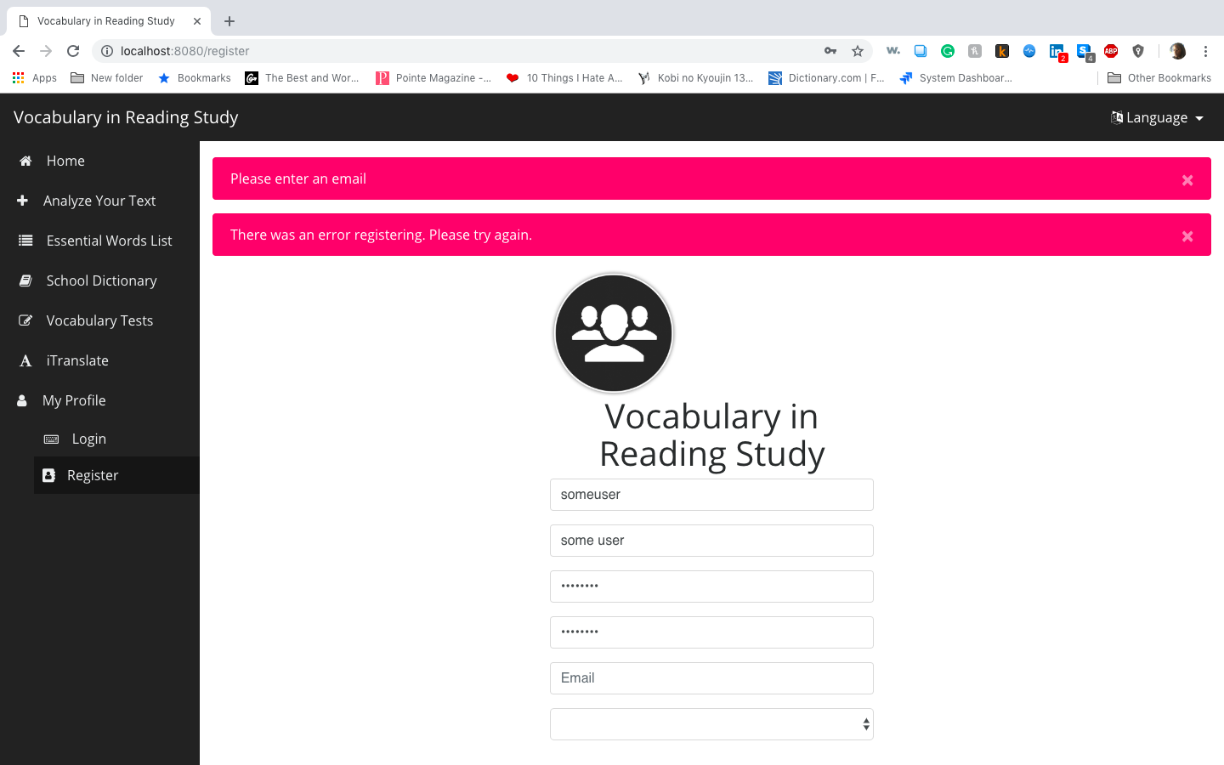

### **Password Reset**

**Showing the Reset Password Button in the Dashboard in the User account**

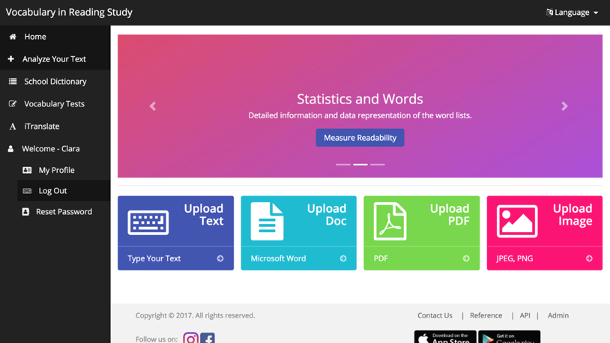

**Showing the Page to enter Current Password, New Password and a Copy Encrypted with Successful Password Changed**

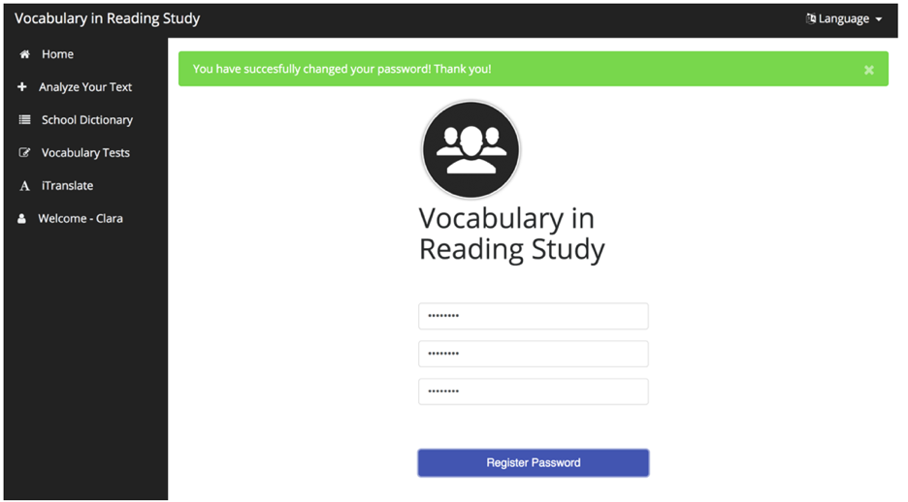

**Showing the Page to Enter Current Password, New password and a Copy Error Message**

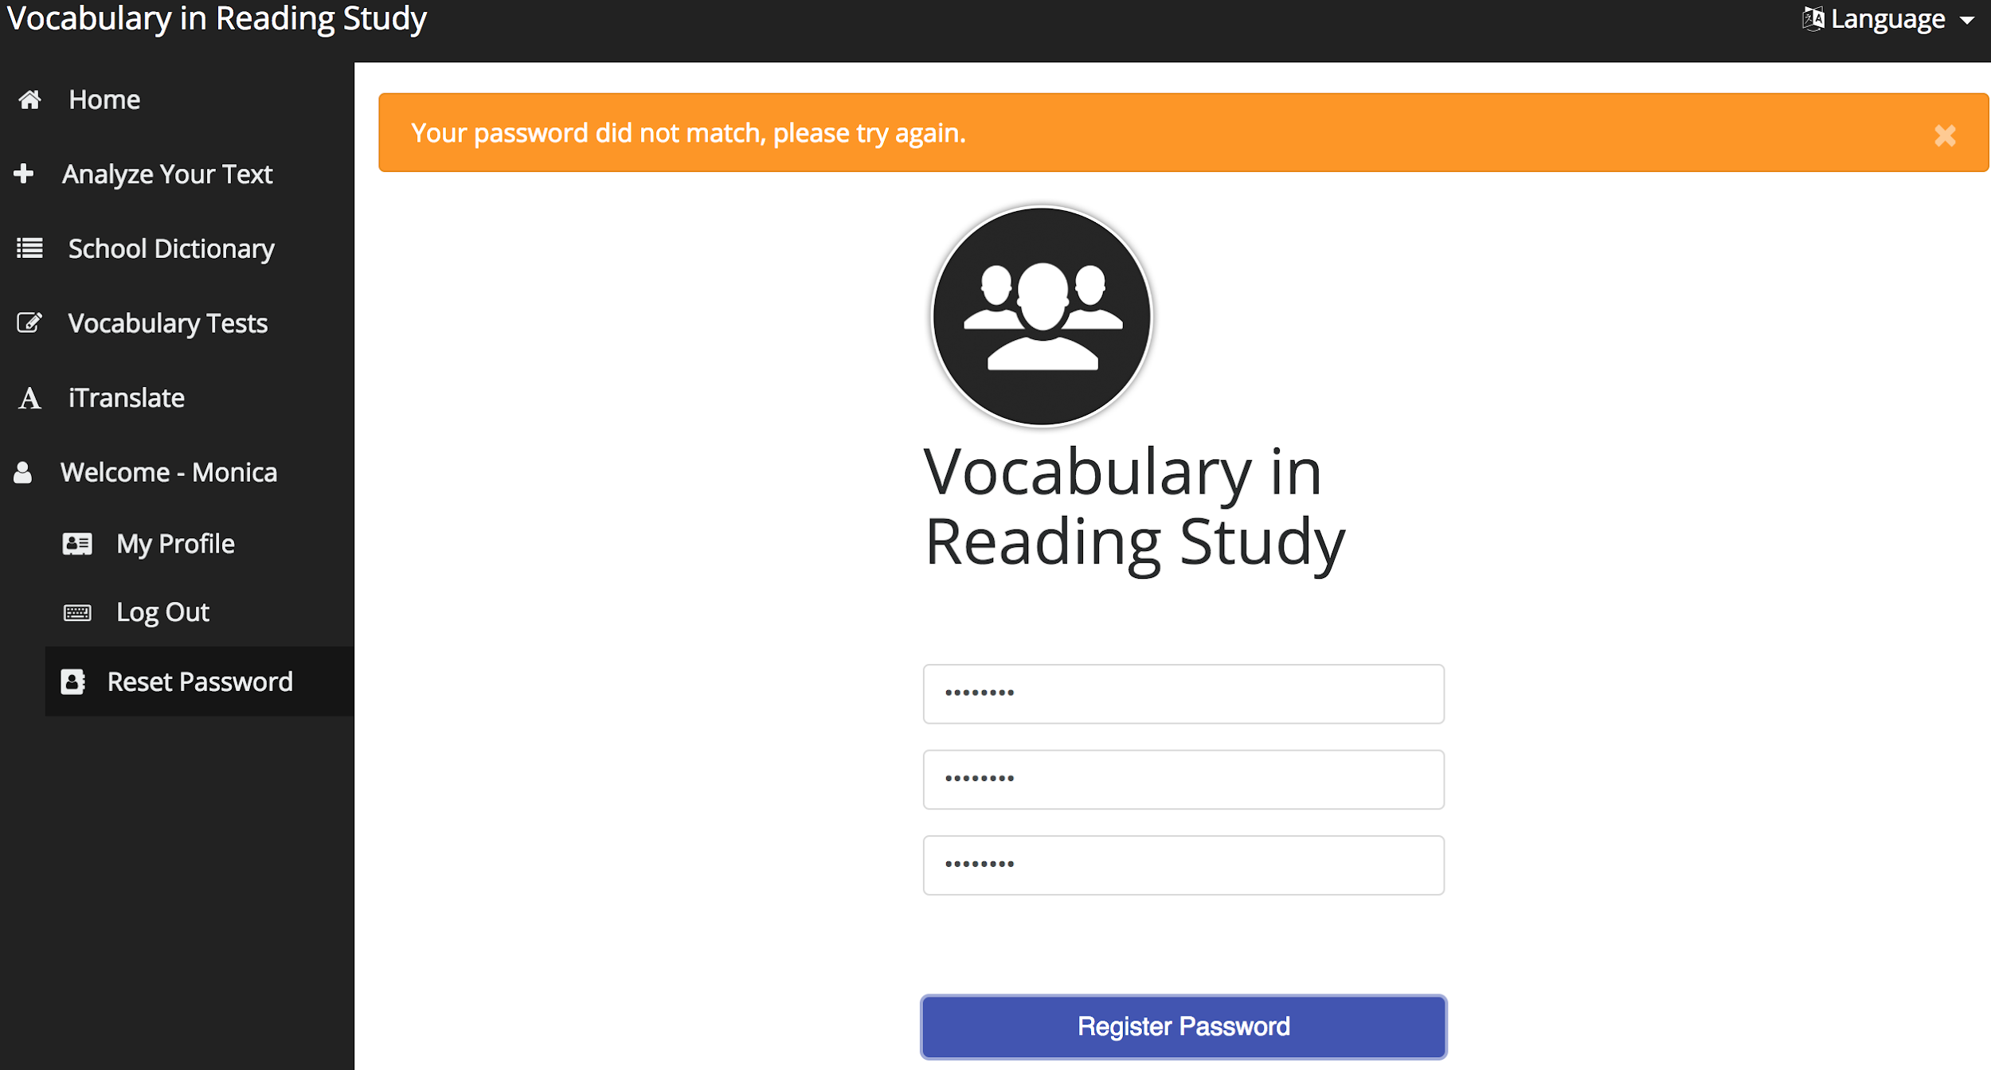

**Showing the Reset Password Button in the Dashboard and the Modal to Enter Username**

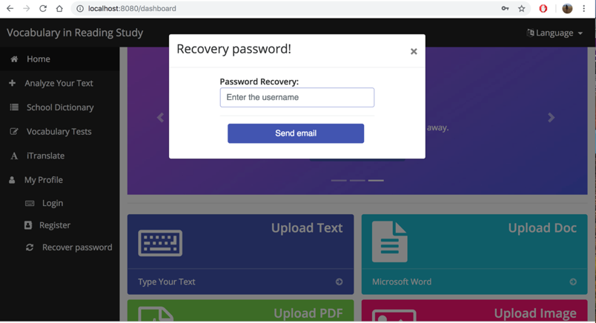

**Showing the Reset Password Button in the Dashboard and the Modal to Enter Username**

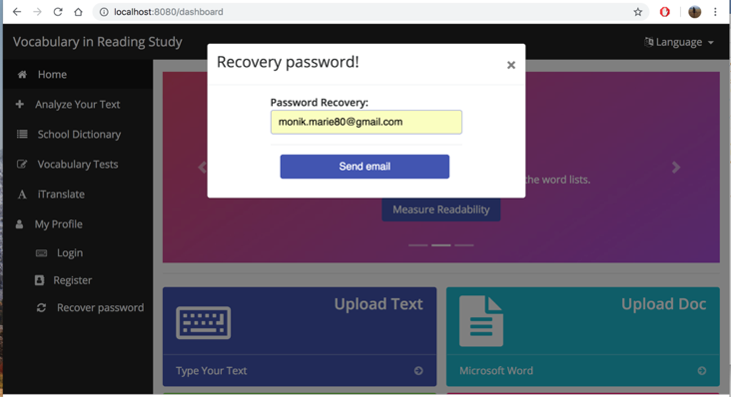

**Confirmation of the Email Sent to the User Email Account**

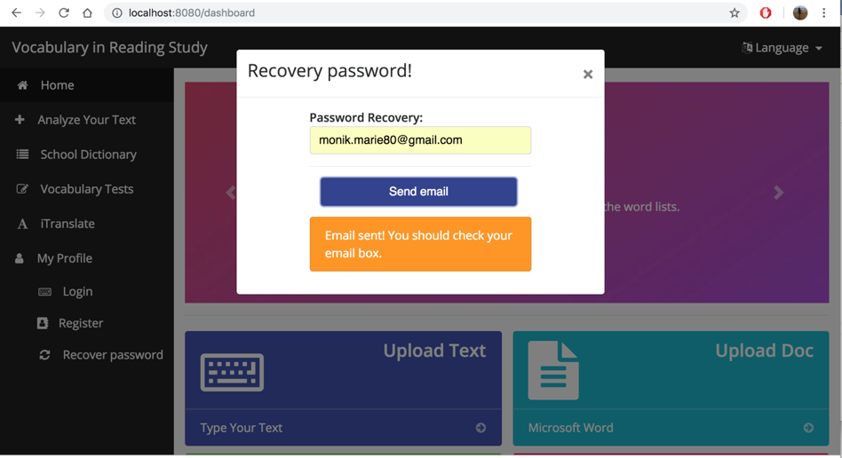

**Email Received with a Link**

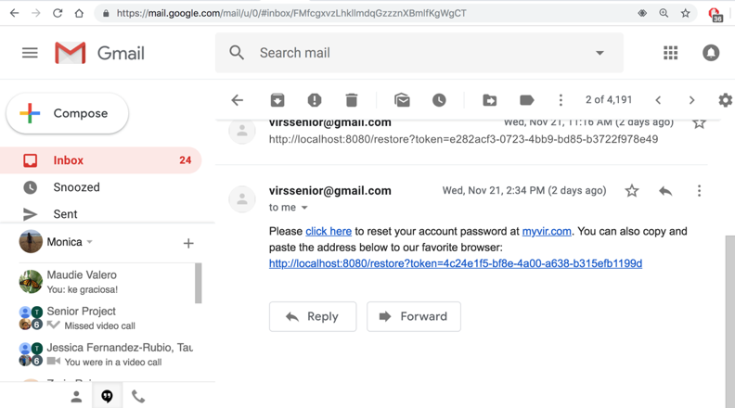

**Page Displayed to Enter the Password and the Copy**

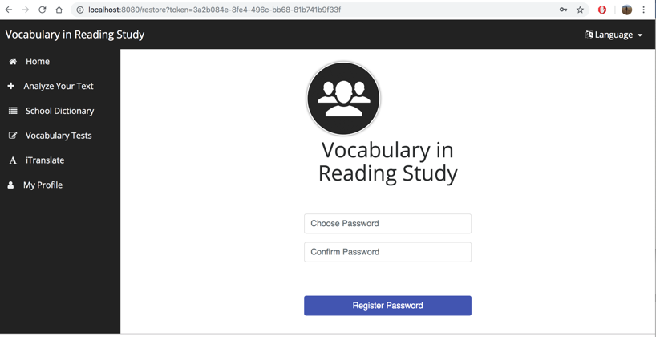

**Showing Password Reset Successfully**

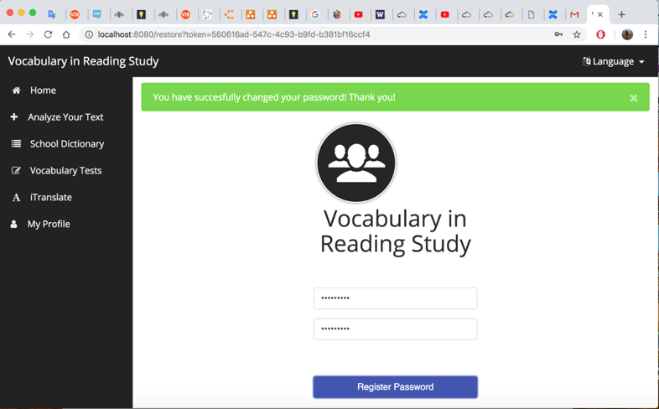

**Showing Password Reset Link Was Already Used**

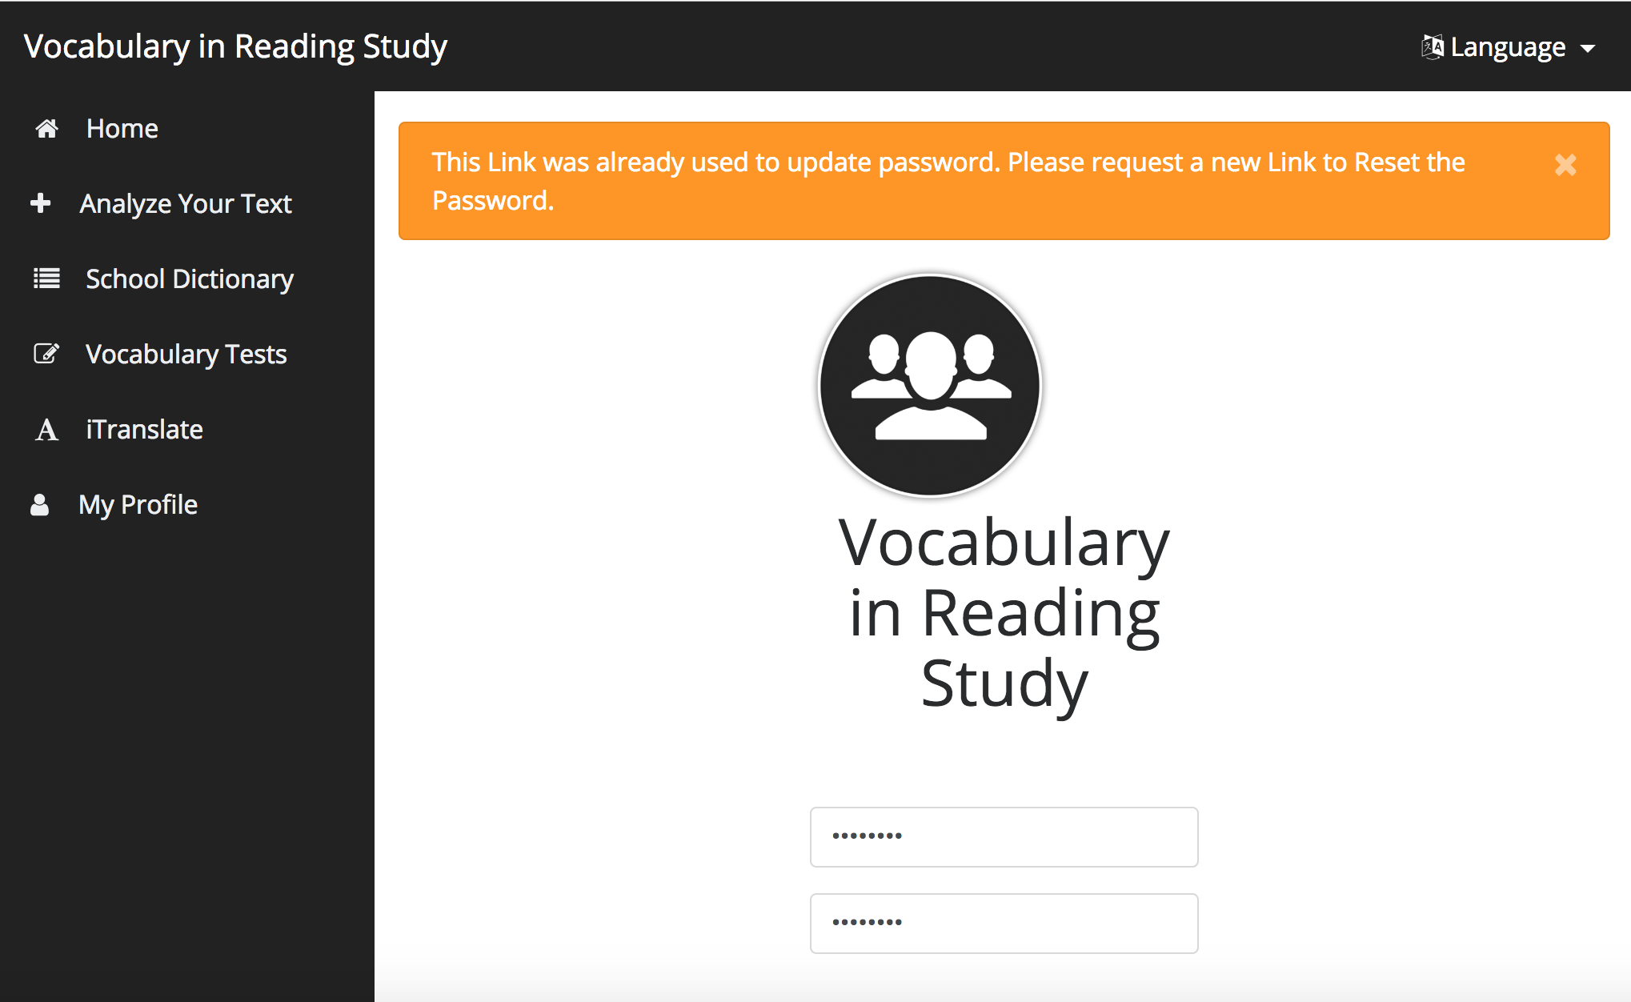

**Showing Modal to Enter Username or Email with Message of User Not Found**

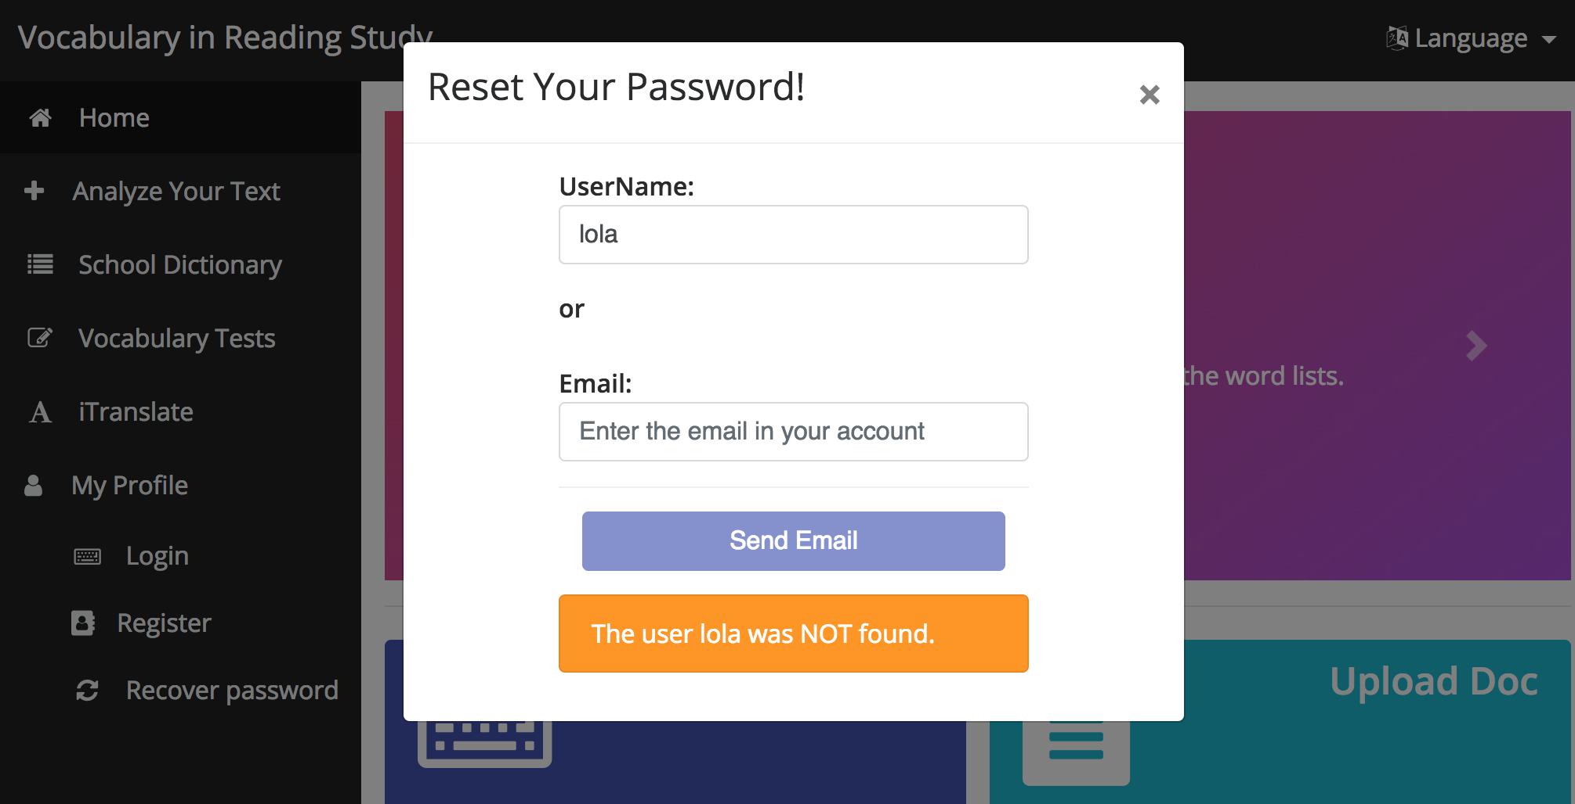

**Showing Working Modal to Enter Username or Email**

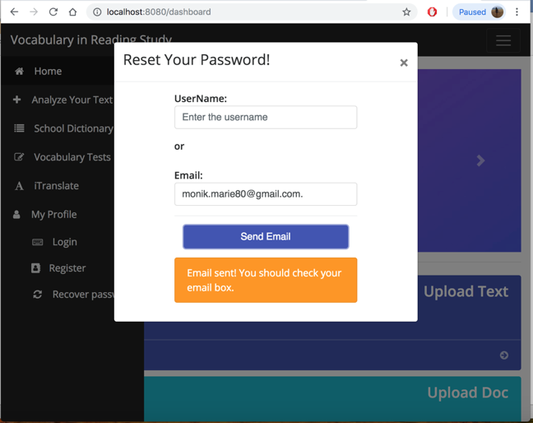

### **Dictionary Definition**

**Working Dictionary View**

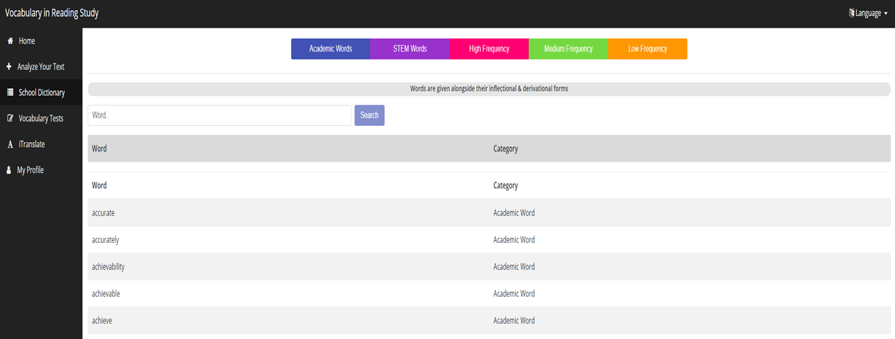

**Previous Dictionary Definition View**

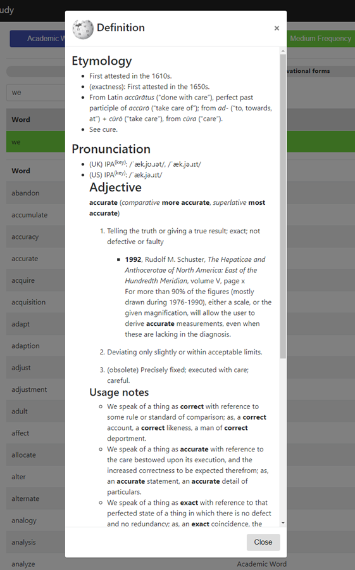

**Current Dictionary Definition View**

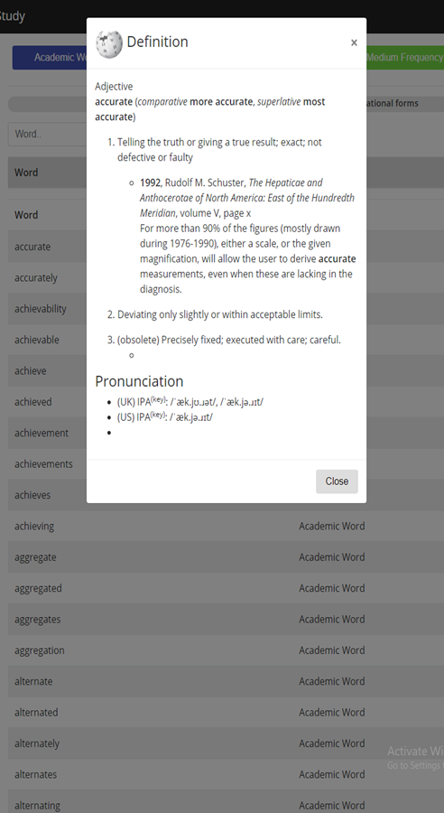

## Appendix C - Sprint Review Reports

### **Sprint 2 Review Meeting Minutes**

20180930

|  |  |  |
| --- | --- | --- |
| **Start Time** | 20:00 | |
| **End Time** | 21:00 | |
| **Accepted User Stories** | **Summary** | **Assignee** |
|  | Update Email | Taufiq |
|  | Add Email | Chelsea |
|  | Change Username | Pablo |
|  | Change Password | Monica |
|  | Invalid Password | Samantha |
|  | Invalid User | Jessica |
| **Unfinished User Stories** | **Summary** | **Assignee** |
|  | N/A | N/A |

### **Sprint 3 Review Meeting Minutes**

20181014

|  |  |  |
| --- | --- | --- |
| **Start Time** | 21:20 | |
| **End Time** | 22:00 | |
| **Accepted User Stories** | **Summary** | **Assignee** |
|  | Registration No Longer Works | Chelsea |
|  | Add EWL Data | Samantha |
|  | EWL Entries Per Page | Samantha |
|  | EWL Sorting | Samantha |
|  | EWL Paging | Samantha |
|  | EWL Word Definition | Jessica |
|  | Search EWL | Jessica |
|  | EWL Categories | Jessica |
|  | Access the EWL | Jessica |
|  | Delete Account | Pablo |
| **Unfinished User Stories** | **Summary** | **Assignee** |
|  | Reset Account | Monica |
|  | Dictionary Reference Update | Taufiq |
|  | Login After Registration | Chelsea |

### **Sprint 4 Review Meeting Minutes**

20181029

|  |  |  |
| --- | --- | --- |
| **Start Time** | 20:00 | |
| **End Time** | 20:30 | |
| **Accepted User Stories** | **Summary** | **Assignee** |
|  | EWL 3rd category | Samantha |
|  | Read Images with Low Light | Pablo |
|  | Read Images with Any font | Pablo |
| **Unfinished User Stories** | **Summary** | **Assignee** |
|  | Fix browser quirks/compatibility problems | Samantha |
|  | Train tesseract | Chelsea |
|  | Reset Account | Monica |
|  | Dictionary Reference Update | Taufiq |
|  | Output Text Only | Jessica |
|  | Login After Registration | Chelsea |
|  | Add Security | Taufiq |

### **Sprint 5 Review Meeting Minutes**

20181113

|  |  |  |
| --- | --- | --- |
| **Start Time** | 20:00 | |
| **End Time** | 20:30 | |
| **Accepted User Stories** | **Summary** | **Assignee** |
|  | Enhanced text Improvement | Samantha |
|  | Output Text Only | Jessica |
|  | Reset Account | Monica |
|  | OCR Localized | Pablo |
| **Unfinished User Stories** | **Summary** | **Assignee** |
|  | Statistics Improvement | Samantha |
|  | Dictionary Reference Update | Taufiq |
|  | Fix browser quirks/compatibility problems | Chelsea |
|  | Read images that need correction | Pablo |
|  | Login After Registration | Chelsea |
|  | Create Proof of Concept | Pablo |
|  | Add Security | Taufiq |
|  | Application Security | Pablo |

### 

### **Sprint 6 Review Meeting Minutes**

20180930

|  |  |  |
| --- | --- | --- |
| **Start Time** | 20:00 | |
| **End Time** | 20:15 | |
| **Accepted User Stories** | **Summary** | **Assignee** |
|  | Display a form to Reset Password Either Using the Username or the Email | Monica |
|  | The User Receives an Email with a Link to clicked for Enter the New Password and Reset his Password | Monica |
|  | Start Reset Password Using Email | Monica |
|  | User Enters New Password a Copy and Reset Password | Monica |
|  | User receives an email with a link to reset password | Monica |
|  | Enter Username to Reset Password | Monica |
|  | Enhanced text is NOT showing the EWL changes | Samantha |
|  | Password reset email body should be fixed | Pablo |
|  | Token missing in datastore shows confusing error message | Monica |
|  | Popup displays when resetting by email | Monica |
|  | Password Reset hangs and gives no indication of work to user | Monica |
|  | Empty Modal When User Logged In | Monica |
|  | Dictionary Reference Update | Taufiq |
|  | Statistics Improvement | Samantha |
|  | Login After Registration | Chelsea |
| **Unfinished User Stories** | **Summary** | **Assignee** |
|  | Spacing on PDF alters the actual text | Jessica |
|  | Create Proof of Concept | Pablo |
|  | Application Security | Pablo |
|  | Read images that need correction | Pablo |
|  | Fix browser quirks/compatibility problems | Chelsea |
|  | Add Security | Taufiq |
|  | Friendlier Translate Experience |  |

## 

## Appendix D - User Manuals, Installation/Maintenance Document, Shortcomings/Wishlist Document and other documents

### Manuals

These are all the manuals for the system.

#### Creating AWS Environment From Scratch

Elastic Beanstalk Dashboard

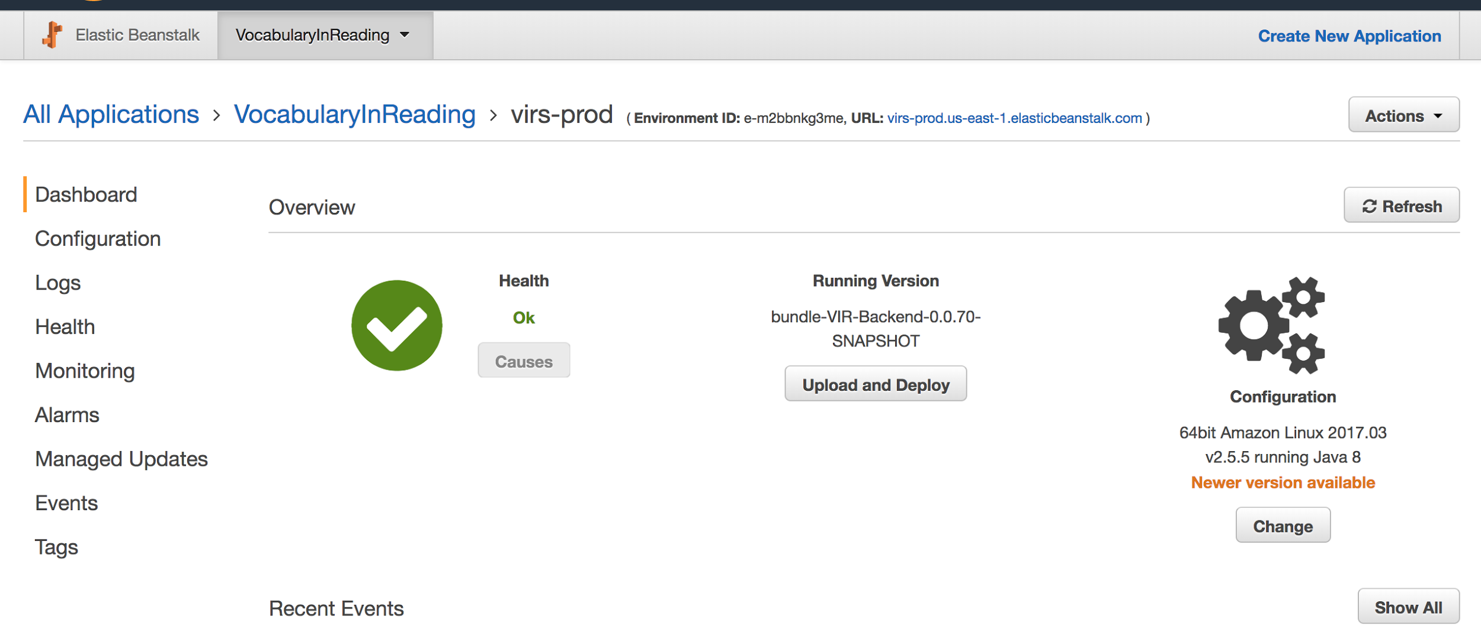

*Figure 53 - AWS Deployment Dashboard*

* If needed create a new Application.
* Create a new environment with all the default configurations and the sample application.
* Under Config got ahead and create a database with the "username" and "password" (Note the password has to be long, keep in mind that this password will be encrypted later on)
* Under Config/Software Configuration add a new Property name with the name used in the java EncryptorConfig.java for the name and the value.

RDS Dashboard

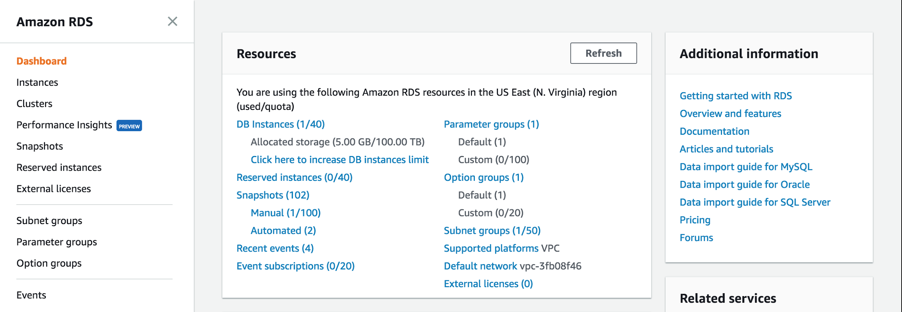

*Figure 54- RDS Dashboard*

* Go to the database associated with the beanstalk above.
* Select it and click Instance Details.
* Click on the security groups: the one that starts with "rds-aws...."
* There go to the "InBound" tab at the bottom and add a new TCP protocol with port 3306 and pick your ip address. (This will allow to connect using workbench)

Workbench

* Login with the credentials and the connection string listed on the RDS dashboard.
* Create a new database.
* Populate any data needed.

Java IDE

* Add properties for the database, encryptor place holder, and port 5000 (needed for production)
* Compile and generate JAR.

Elastic Beanstalk Dashboard

* Upload the new version of the application.

EC2 Dashboard

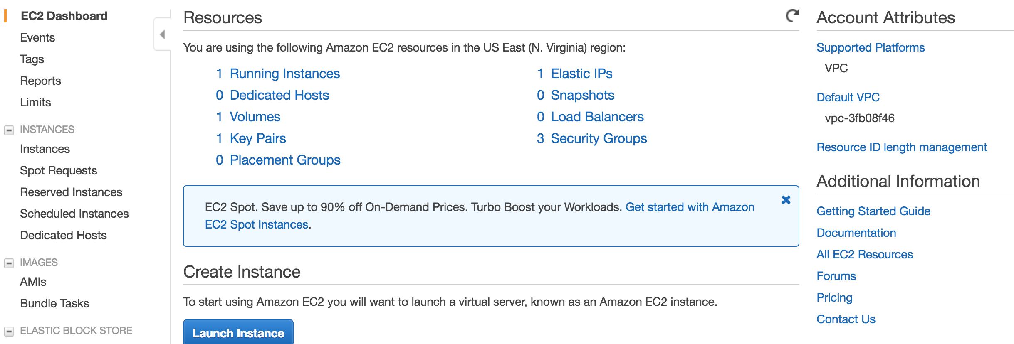

*Figure 55- EC2 Dashboard*

* If you do not have a .pem file. Create a key to login via ssh.
* Click 'Key pairs' to go to the section of the keys.
* Delete the old key pair (This is required to unlink the old VM)
* Create a copy of the current VM instance
* Locate the EC2 instance and right click on it to get the ssh connection information. (for the key to work it has to be associate with the BeanStalk instance, this should be already done, but you can do this in the 'Instance settings' of the Beanstalk)

#### 

### **Building and Deploying the application**

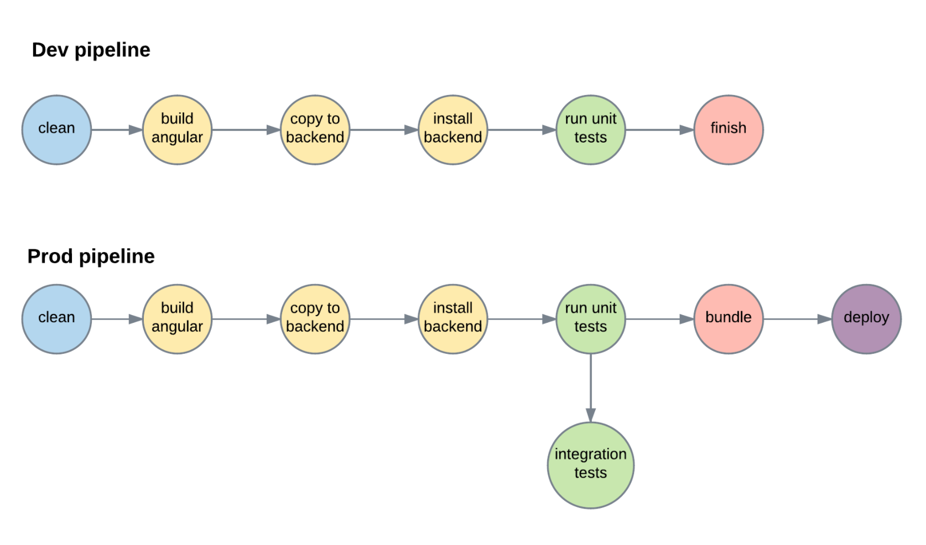

*Figure 56- Development pipeline - Production pipeline*

* Run ./build.sh test
* If everything passes run ./build.sh integration-test
* If everything passes then run ./build.sh prod
* Upload the generated zip bundle file located /<project root>/Code/VIR-Backend/release

### **Installation/Maintenance**

* Clone the repo
* Create a local MySQL account with credentials
  + Username: root
  + Password: root
* Create schema called: vir
* Run:
  + ./virs.sh install (virs.cmd install for Windows)
  + ./virs run (virs.cmd for Windows)
* Access the application at: localhost:8080

Note: If you are using a Unix like system make sure you give execution permissions to the files. chmod +x build.sh

### **Shortcomings/Wishlist**

* Add security to application (http to https)
* Move password security from frontend to backend (Instead of encrypting we should use a SHA512 hash with a salt)
* Add a library for faculty material

# References

• Begeny, J. C. and Greene, D. J. (2014), CAN READABILITY FORMULAS BE USED TO SUCCESSFULLY GAUGE DIFFICULTY OF READING MATERIALS?. Psychol. Schs., 51: 198–215. doi:10.1002/pits.21740  
  
• Flesch, Rudolf. “How to Write Plain English.” Guide to Academic Writing Article - Management - University of Canterbury - New Zealand, [www.mang.canterbury.ac.nz/writing_guide/writing/flesch.shtml](http://www.mang.canterbury.ac.nz/writing_guide/writing/flesch.shtml).

• “Tesseract-Ocr/Tesseract.” GitHub, 10 Nov. 2017, github.com/tesseract-ocr/tesseract.  
  
• “OpenCV library.” OpenCV library, opencv.org/.  
  
• R. Guo, Q. Dai and D. Hoiem, "Single-image shadow detection and removal using paired regions," CVPR 2011, Providence, RI, 2011, pp. 2033-2040. doi: 10.1109/CVPR.2011.5995725 URL: 'http://ieeexplore.ieee.org/stamp/stamp.jsp?tp=&arnumber=5995725&isnumber=5995307'  
  
• Zucker, Matt. “Page dewarping.” Needlessly complex, 14 Aug. 2016, mzucker.github.io/2016/08/15/page-dewarping.html.  
  
• “Wiktionary” Wiktionary, the free dictionary, en.wiktionary.org/wiki/Wiktionary:Main_Page.